History Focus - Threshold Concepts | Y4 Roman Britain | Art and Design - Threshold Concepts
Understand Chronology  Order a timeline of events in Roman Britain.  Use existing knowledge of history to place the time of Roman Britain chronologically.  Interpret Historically / Historical Enquiry  Identify main sources of evidence about Roman Britain.  Identify the significant events and give reasons for historical change in Britain and wider world influences.  Communicate Historically  Ask and answer historically valid questions about the events during the time of Roman Britain.  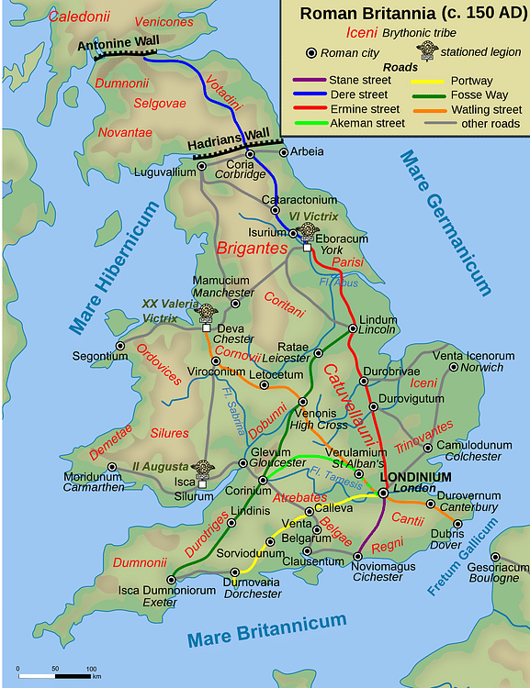  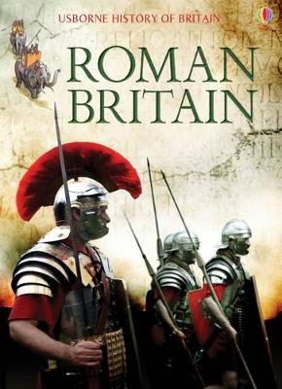 | Enquiry Question:  What happened when the Romans  came to Britain?  Class Text  Themes: Flavia Gemina is a natural at solving mysteries. The daughter of a ship's captain living in Ostia. She and her three friends, Jonathan, Nubia and Lupus must work together to discover who is beheading the watchdogs that guard people's homes, and why.  Extended Written Piece: Mystery Story  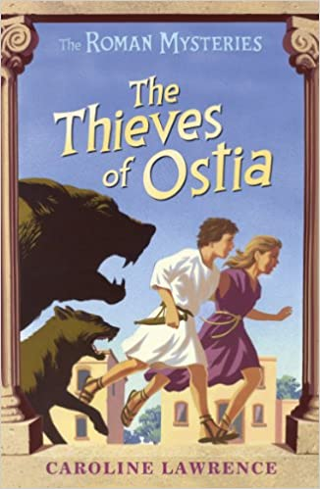  - Write with purpose.  - Use tension and suspense  - Create mysterious characters  - Create a description setting  - Use story boxes to support writing  Supporting Text  Themes: The pollution of our seas, lakes and rivers. Lucy wants to save her town from total devastation by the Iron Woman. The Iron Woman wants to avenge the creatures in the rivers, lakes and seas. Can they work together and understand each other to prevent a catastrophe? And who is coming to help them…  Supporting Written Piece: A persuasive letter  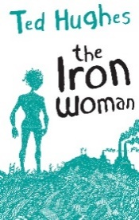  - Write with purpose  - Organise writing appropriately  - Use paragraphs  - Use sentences appropriately  R.E  Buddhism Buddha's Teaching. Key Question: Could the Buddha's teaching make the world a better place?  ICT  Information Technology - using email then on to Microsoft word: word processing creating a document.  SMSC and PSHE:  Healthy Me: Being and keeping safe and healthy  D&T Focus: Electrical systems – Programming and control. Control and monitor models using software designed for this purpose. | Exploring Art Deco  Develop Ideas  - Adapt and refine ideas as they progress.  Master Techniques  - Create and combine shapes to create  - Recognisable forms (e.g. shapes made from nets or solid materials).  - Include texture that conveys feelings, expression or movement.  - Use clay and other mouldable materials.  - Add materials to provide interesting detail.  - Take inspiration from the greats  Artist Spotlight: Tamara de Lempicka  - Create original pieces that are influenced by  studies of others.  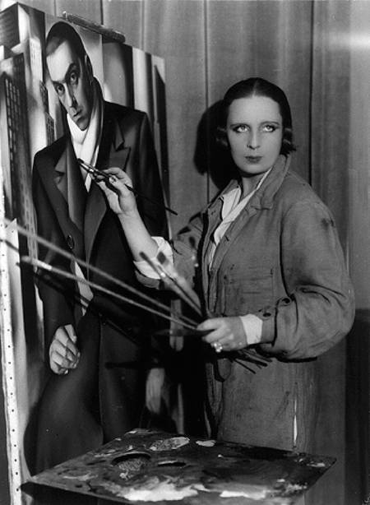  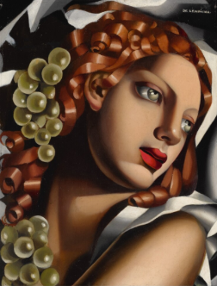
Science  Investigate sound and hearing:  - Identify how sounds are made, associating some of them with something vibrating.  - Recognise that vibrations from sounds travel through a medium to the ear.  Investigate Living Things:  - Recognise that living things can be grouped in a variety of ways.  - Identify how plants and animals, including humans, resemble their parents in many features.  - Recognise that living things have changed over time and that fossils provide information about living things that inhabited the Earth millions of years ago.  - Identify how animals and plants are suited to and adapt to their environment in different ways. |  | Cross Curricular Opportunities  English:  Use, read and select books that are structured in different ways for appropriate purposes (information books on Roman Britain). Develop understanding of etymology (modern words derived from Latin)  Maths:  Develop further understanding of Roman numerals and how they were used in Roman Britain.  History:  Prehistoric England – Stone, Bronze and Iron age.  Ancient Civilizations – Ancient Egypt

