Focus: History  The First World War | Planning around a text:  Archie’s War (Fictional Diary) | Year 4 Medium Term Plan – Summer 2019
Cross Curricular Objectives:  History  To investigate and interpret the past  Suggest causes and consequences of some of the main events and changes in history.  Build and overview of world history  Describe the characteristic features of the past, including ideas, beliefs, attitudes and experiences of men, women and children.  Understand chronology  Use dates and terms to describe events  Communicate historically  Use appropriate historical vocabulary to communicate including:  • dates • time period • era • change • chronology  Science – Physics  Understand light and seeing  This concept involves understanding how light and reflection affect sight  Investigate sound and hearing  This concept involves understanding how sound is produced, how it travels and how it is heard.  Understand movement, forces and magnets  This concept involves understanding what causes motion.  Geography  Investigate places  1. This concept involves understanding the geographical location of places and their physical and human features.  2. Use maps, atlases, globes and digital/computer mapping to locate countries and describe features.  3. Name and locate the countries of Europe and identify their main and physical and human characteristics. | 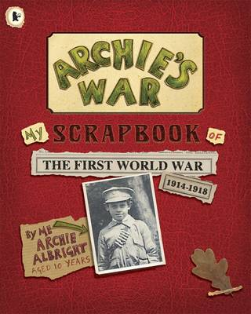  Synopsis: In 1914, just before the outbreak of the First World War, 10-year-old Archie is sent a scrapbook in the post from his Uncle Colin. In the years that follow, until the war ends in 1918, we experience life through Archie's eyes and learn about his world and family.  Supporting Texts:  The story recounts the experiences of Joey, a horse purchased by the Army for service in World War I  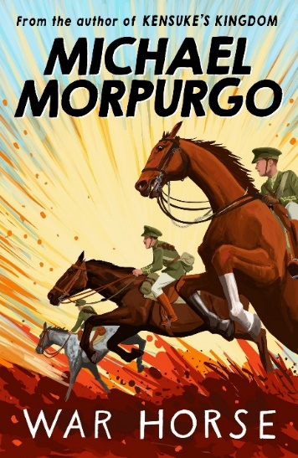  Poetry:  War Horse by Brenda Williams  In Flanders Fields by John McCrae  Themes (Opportunities for SMSC)  Loss, Separation, friendship, tolerance, resilience, respect and understanding relationships. | Art  Develop Ideas  Collect information, sketches and resources.  Master Techniques  Experiment with different colours, textiles and mediums.  Take inspiration from the greats  1. Replicate some of the techniques used by notable artists and designers.  2. Create original pieces that are influenced by studies of others.  Artist Study: Paul Nash WW1 Art.  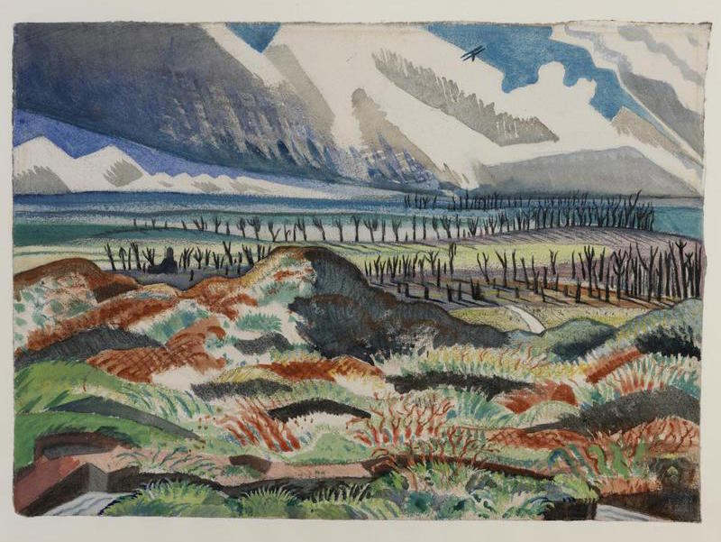  Design and Technology  To design, make evaluate and improve.  Design with purpose by identifying opportunities to design.  Reading and Writing  Anticipated Outcomes: Writing  Writing using a mini process (Reading to writing opportunities )  - Note-taking and Drawing inference from images  - Making predictions and summaries.  - Creating and answering questions.  Structured Writing (The Laceby Acres Writing Process)  Teacher modelling; deconstruction of model, planning (timeline structure); drafting; proofreading; editing; peer/self-assessment.  - Descriptive Writing (setting)  - Diary Entry  - Informal letter  - Newspaper Report  Non-fiction writing opportunity  - Non chronological report  - Biography

