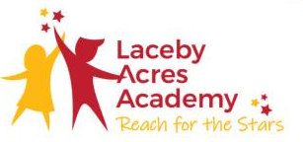
"Once you learn to read, you will be forever free." — Frederick Douglass
Intent
At Laceby Acres, our reading curriculum is designed to stimulate the children’s natural curiosity, foster a love of reading in every child in every classroom, and ensure that every child leaves their primary journey as a confident reader. This process begins with early reading and phonics. We understand that this involves the children developing listening skills, concentration, being able to use rhyme and rhythm and be confident in grapheme-phoneme correspondences. Our aim is that once children are in KS2 they have all the phonic knowledge and skills they need to continue their journey as fluent readers with a love of reading. We ensure children have a comprehensive understanding of grapheme-phoneme correspondences and both the basic and complex code, the ability to blend and segment with confidence, to be able to recognise on sight words that are not decodable and eventually to become fluent readers. Leaders have carefully selected the knowledge and skills that children at Laceby Acres require to fulfil the aims of the subject. The phonic content is mapped across the year for Reception, Year 1 and Year 2. It is broken down into half termly blocks and shows the sounds and words that the children will be learning week by week, as well as the activities that go alongside to support this. The half-termly phonic blocks are also used to map out the books that children will take home; these books have been carefully selected to match the phonics sounds that have been taught. In addition, the children also take home a book band reading book they can ‘grapple’ with which exposes them to new sounds. This is to be read by the parents to the child to model fluency and reading with expression.

Implementation

At Laceby Acres we have selected to use Essential Letters and Sounds to deliver our phonics sessions. This is a systematic synthetic phonics programme designed to get all children to read well quickly. We teach the children that the sounds in our language are represented by ‘code’ or letters on the page. ELS teaches children to:
- Decode (to read0 by identifying each sound within a word and blending them together to read fluently
- Encode (to write) by segmenting each sound to write words accurately
Every ELS lesson has been designed to ensure that the minimum cognitive load is placed on the learner. The structure of the lesson allows children to predict what is coming next, what they need to do, and how to achieve success. We follow a progression that includes weeks of teaching and periods of review to ensure that all children are confident in applying their phonic knowledge and understanding independently. ELS is a whole-class teaching model that incorporates both an in-the-lesson interventions as well as additional support for children that may need more practise and support.
ELS is based on simplicity and consistency, and the programme is delivered through whole class lessons. During our phonics sessions we use the same teaching sequence- Show, copy, repeat- until each child is independent. The teaching sequence is the same in all stages of the lesson, from whole-class teaching to one-to-one intervention. Children are given the opportunity to hear and say each sound, first in isolation, and then within words and sentences. When introducing a new GPC, we use a mnemonic or rhyme with an accompanying picture to ensure that children understand. Children then hear this sound in the context of a word, and a picture and/or definition is given to support their understanding. Practice and repetition are key. We also base this on give, give, give.
- Give the GPC- share the new sound or spelling being taught
- Give the word- put it into context
- Give the meaning- ensure children can use the vocabulary
In our lessons we follow several key teaching features.
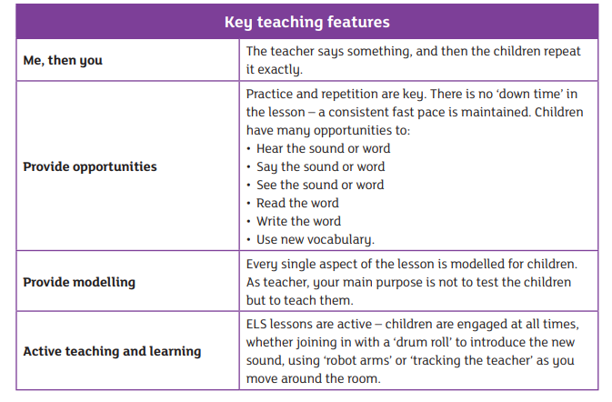
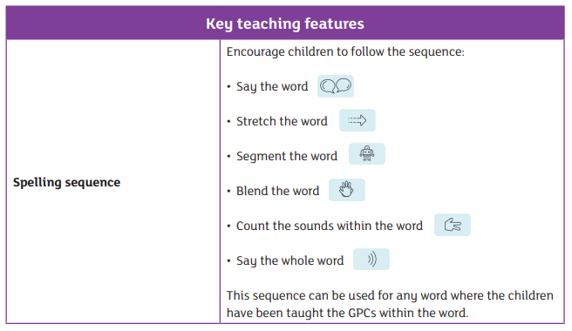
Our lessons also follow a weekly structure:
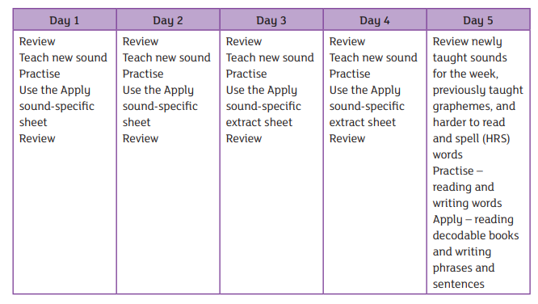
And follow this structure for a review week
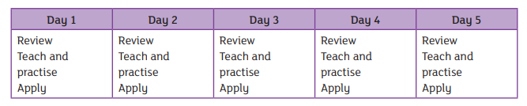
The principles of ELS are based upon:
- The delivery of whole-class, high-quality teaching with well-structured daily lesson plans
- The use of consistent terminology by teachers, children and parents
- The use of consistent resources that support effective teaching
- Repetition and reinforcement of learning
- Regular and manageable assessment to ensure that all children ‘keep up’ rather than ‘catch up’
The ‘E’ model (Embed, Enact, Enable, Execute, Evolve) training to ensure that all members of staff understand how to teach phonics and early reading with confidence. We annually have full staff training in phonics and ensure members of staff are given full phonics training upon their induction. We also hold annual phonics workshops for parents to attend to help them support their child at home with phonics and early reading.
It is important that children practice their phonic knowledge by reading fully decodable books. These help to consolidate their understanding and build their fluency for reading words that include the GPCs that they have been taught. These books will not contain sounds or words children do not know yet and can be read independently.
In Year 2, the children will move onto No-Nonsense (Babcock) Spelling which introduces the children to common exception words and concepts such as contracted words.
We encourage our children to be independent in using and applying their phonics, therefore all classrooms from

Impact
Our phonics curriculum is high quality, well thought out and is planned to demonstrate progression. We measure the impact of our phonics curriculum through the following methods:
- Assessing phonics the 5th week of each term. This allows teachers to identify a gap in children’s knowledge and understanding to ensure the children are supported to make rapid progress. During these assessment we will assessing children’s recall of GPCs, recall of harder to read and spell words and children’s ability to blend to read and segment to spell.
- Assessments involve using the grapheme cards to test the child’s recall of each taught grapheme and its corresponding sound. Children then read the associated words immediately after completing the grapheme recognition . Children then read pseudo words to assess their knowledge out of context
- Tracking the children inline with our half termly milestones to ensure all children are making good progress
- Listening to children read both 1:1 and in group guided reading sessions.
- Interviewing the pupils about their learning (pupil voice).
- Annual reporting of standards across the curriculum.
- Phonics screening check results. Our three year trend shows we are consistenly above national level… (add in results).

Supporting children with SEN
ELS is designed on the principle that children should ‘keep up’ rather than ‘catch up’. Since interventions are delivered within the lesson by the teacher, any child who is struggling with the new knowledge can be immediately targeted with appropriate support, usually during the Apply activity. We know that children – especially those with educational difficulties – learn better in a mixed-ability environment where their learning is scaffolded not only by the teacher and support staff but also by their peers. In this most fundamental area of learning – learning how to read – this support is even more vital, not only to their success but also to the outcomes of the programme as a whole. Over-learning, alongside a range of Apply activities, helps children who acquire phonic knowledge more slowly to succeed. Children’s phonemic awareness supports them when learning how to read, and our rigorous and robust teaching methods ensure that all children build phonemic awareness. If children require further support to achieve the outcomes of the lesson and keep up with the pace of the programme, ELS has three interventions that are to be delivered on a one-to-one basis: oral blending, GPC recognition and blending for reading. These are intended to be short and concise and last no longer than five minutes. They can be delivered in isolation, or different interventions can be used together to support children each day. This helps ensure that children do not spend excessive time outside of the classroom or in group intervention sessions where they are removed from the rest of the curriculum.

