Geography – Enquiry Question  Study of an Alphine Region | Y5 – Study of an Alpine Region | The Curriculum – Threshold Concepts
Working goegraphically to:  - Locational knowledge: locate the world’s countries, using maps to focus on Europe concentrating on their environmental regions, key physical and human characteristics  - Place knowledge: understand geographical similarities and differences through the study of human and physical geography of a region in a European country.  - Human and physical geography: describe and understand key aspects of: mountains, climate zones, types of settlement and land use, economic activity  - Geographical skills and fieldwork: use maps, globes and digital/computer mapping to locate countries and describe features studied.  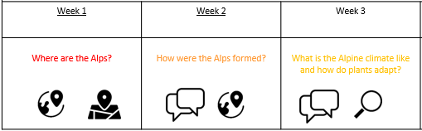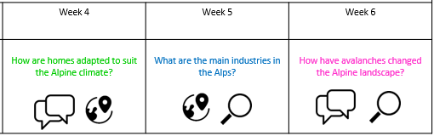  Science: Living Things and their habitats Biology  Expectations for essential knowledge:  Know the life cycle of different living things, e.g. Mammal, amphibian, insect bird.  Know the process of reproduction in plants.  Know the process of reproduction in animals.  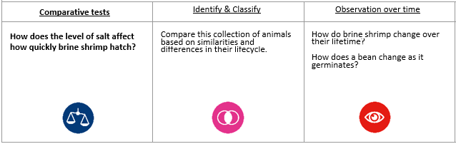  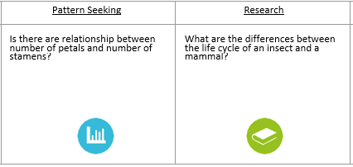 | English Focus text:  Jess Butterworth – When the Mountains Roared  Writing Outcomes:  Main: Persuasive text (hotel advertisement)  Mini process: Fact file (snow leopard)  Poetry: Colour poem  Reading Outcomes:  Reading skills: predicting, clarifying, questioning and summarising.  Grammatical Skills:  Rhetorical questions, Superlatives, Subjunctive forms, Facts v opinions, Expanded Noun Phrases, Hyperbole, Adverbials (cohesion), Metaphors, Similes, Personification, Abstract nouns.  Contextual Knowledge:  To understand that we all face loss and changes in our lives, (some of which may be unexpected). To appreciate the need to adapt and look for positives in our surroundings (nature, friends, hobbies). Also, to learn to work with our new environment in order to thrive ourselves but also to help the wider community we are a part of.  Link Reading:  Banner in the Sky – James Ramsay Ullman  Maths  Decimals and Percentages  - identify, name and write equivalent fractions of a given fraction, represented visually, including tenths and hundredths  - read and write decimal numbers asfractions (e.g. 0.71 = / 71/100)  - recognise and use thousandths and relate them to tenths, hundredths and decimal equivalents  - recognise the per cent symbol (%) and understand that per cent relates to “number of parts per hundred”, and write percentages as a fraction with denominator 100 as a decimal fraction  - multiply proper fractions and mixed numbers by whole numbers, supported by materials and diagrams  - solve problems involving numbers up to three decimal places  - solve problems which require knowing percentage and decimal equivalence  Statistics  - complete, read and interpret information in tables, including timetables  - solve comparison, sum and difference problems using information presented in a line graph  Perimeter and Area  - Measure and calculate the perimeter of composite rectilinear shapes in centimetres and metres  - Calculate and compare the area of rectangles (including squares) including using standard units, square centimetres (cm2 ) and square metres (m2 ) and estimate the area of irregular shapes | P.E  Football - To develop skills (controlling, dribbling, turning, passing, and receiving). Pupils will also develop, tackling, marking, and shooting.  ICT  E-safety: Managing Online information  Computer Science: Computer Science: Scratch – Simple Game creation  PSHE Jigsaw: Healthy Me  The health risks of smoking  The health risks of misusing alcohol  How to get help in an emergency  The different roles food can play in people’s lives  R.E  Theme: Easter Religion: Christianity  Key Question: How significant is it for Christians to believe that God intended for Jesus to die?  MUSIC  Unit 4: Healthy Eating  Exploring beat at different tempi  Singing syncopated melodies  Developing rhythm skills through singing, playing, and moving  Singing and playing scales and chromatic melodies  MFL  Unit: The Olympics (I)  to listen attentively to longer passages in Spanish, decoding using cognates. to understand more of what I hear and read using story ordering to help me decode unknown language.  I will learn 10 nouns for Olympic sports with their correct determiners.  I will learn how to say ‘I play’ and ‘I do not play’ a particular sport using the verb ‘practicar’ (to do) in Spanish.  I will learn that adjectives can change spelling in Spanish depending on the gender of the object being described.  Art  Pathway: Mixed Media Land and City Scapes  -That we can use a variety of media often combining it in inventive ways, to capture the energy and spirit of land or city scapes.  -That we can often work outside (plein air) so that all our senses can be used to inform the work.  -To be able to experiment with materials, combining them to see what happens.  -To use our sketchbooks to focus this exploration and understand that we do not always need to create an “end result” – sometimes the exploratory journey is more than enough.  DT Unit Focus: Electrical Systems: Circuits and Switches  That mechanical and electrical systems have an input process and output  Constructed a simple series electrical circuit in science.

