Characteristics of Scientists

- The ability to think independently and raise questions about working scientifically and the knowledge and skills that it brings.
- Confidence and competence in the full range of practical skills, taking the initiative in, for example, planning and carrying out scientific investigations.
- Excellent scientific knowledge and understanding which is demonstrated in written and verbal explanations, solving challenging problems and reporting scientific findings.
- High levels of originality, imagination or innovation in the application of skills.
- The ability to undertake practical work in a variety of contexts, including fieldwork.
- A passion for science and its application in past, present and future technologies.

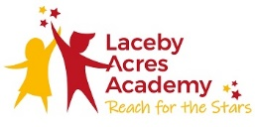
Science Intent and Implementation
🔩
🏹

Intent
Science teaching at Laceby Acres Primary Academy aims to give all children a strong understanding of the world around them whilst acquiring specific skills and knowledge to help them to think scientifically, to gain an understanding of scientific processes and also an understanding of the uses and implications of Science, today and for the future (Murray & Reiss, 2002).
At Laceby Acres Primary Academy, scientific enquiry skills are embedded in each topic the children study and these topics are revisited and developed throughout their time at school. Topics, such as Plants, are taught in Key Stage One and studied again in further detail throughout Key Stage Two. This model allows children to build upon their prior knowledge and increases their enthusiasm for the topics whilst embedding this procedural knowledge into the long-term memory (Millar, 2011).
All children are encouraged to develop and use a range of skills including observations, planning and investigations, as well as being encouraged to question the world around them and become independent learners in exploring possible answers for their scientific based questions (Cronin-Jones, 1991). Specialist vocabulary for topics is taught and built up, and effective questioning to communicate ideas is encouraged. Concepts taught should be reinforced by focusing on the key features of scientific enquiry, so that pupils learn to use a variety of approaches to answer relevant scientific questions (Education Endowment Fund, 2017).
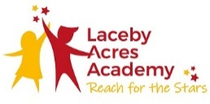
Ultimately, a strong understanding of Science will allow children to understand concepts, recognise the importance of rational explanation, develop their ability to explain the world around them, predict, analyse and broaden their vocabulary, all while developing a sense of curiosity and excitement for the natural world. Here at Laceby Acres Academy our belief is that science is vital to the world’s future prosperity, and as educators, our role is to develop key scientific skills and knowledge alongside a sense of curiosity and excitement and in doing so we will be creating the scientists of the future.
Science Intent and Implementation
🔩
🏹

Implementation
In Science, we seek to develop a broad, rich and rigorous curriculum that stretches and challenges all our students (Gott & Duggan, 1995). Our clear and precise progression framework outlined below, allows teachers to plan for progression and ensure they are aware of the continuity across year groups and topics. The framework documentation highlights the key teaching points as well as making explicit links to the enquiry skills and approaches being alluded to in each task.
Ofsted's 2013 report, Maintaining Curiosity, recommends that school leaders and governing bodies should provide sufficient weekly curriculum time [for science] so that individual pupils develop good scientific enquiry skills as well as the knowledge they need. The Wellcome Trust's 2018 report, A review of Ofsted inspection reports: in relation to science and maths, states that schools should deliver sufficient weekly curriculum time for science. Children need regular, enquiry-based learning to develop the practical skills necessary for future work in science, technology or engineering. At Laceby Acres, science is taught on a weekly basis for the duration of half a day, this can be an A.M or P.M slot.
Children should have the opportunity to carry out practical investigations in science that help them to develop their scientific skills. These are the skills that scientists need to carry out research and are sometimes referred to as a cycle of plan, do, review. Our children will be given the opportunity explore practical experiments as well as having access to equipment, providing them with a sense of ownership to be able plan their own scientific investigation.
Our curriculum design allows for the inclusion of all learners, achieved through differentiation and wide range of assessment opportunities.
The ‘Big Questions’ outlined within the progression documentation, allow for AFL to take place and enables teachers to plan the topic in response to the children’s specific needs (P.S.S.T, 2013).
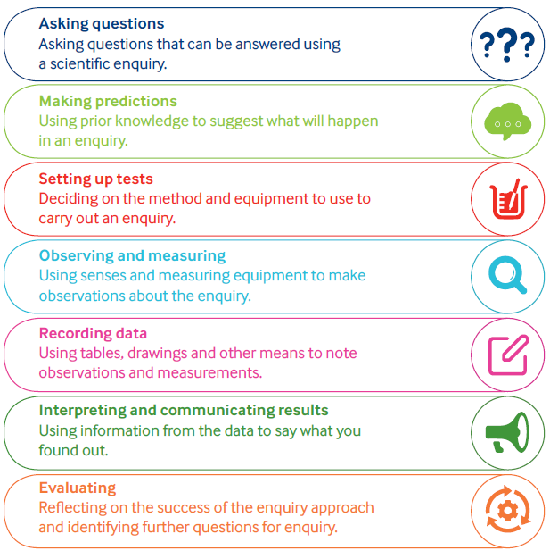
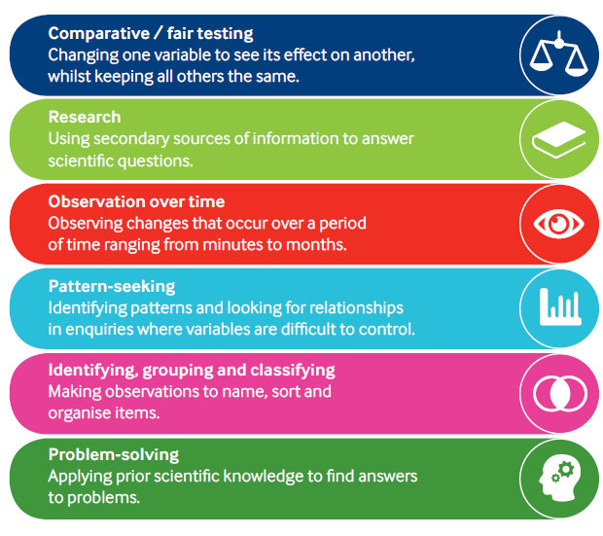
Enquiry Approaches Enquiry Skills
🔩
🏹

