Geography - Threshold Concepts | Y1 People and their Communities (Class Texts) | Art and Design/DT - Threshold Concepts
Geography  Investigate places  This concept involves understanding the geographical location of places and their physical and human features.  - Ask and answer geographical questions about the physical and human characteristics of a location.  - Explain own views about locations, giving reasons.  - Use maps, atlases, globes and digital/computer mapping to locate countries and describe features.  - To know that the World is made up of 7 continents  Investigate patterns  This concept involves an appreciation of the characteristic features of maps and an understanding that the environment is different for different parts of the World.  - Understand geographical similarities and differences through studying the human and physical geography of their local area and 4 different World locations  - Identify weather patterns of the 4c different World locations compared to their local area  Communicate geographically  This concept involves using geographical vocabulary and techniques to convey information about the environment.  - Use appropriate geographical vocabulary to communicate key physical and human features.  - Use compass directions, locational and directional language  Science  Work Scientifically  This concept involves learning the methodologies of the discipline of science  - To perform simple tests  - Ask simple questions  - Observe closely, using simple equipment  - Gather and record data  Investigate materials  This concept involves becoming familiar with a range of materials, their properties, uses and how they may be altered or changed  - Distinguish, identify and name the properties of a variety of everyday materials | 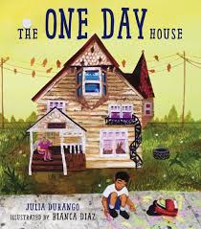  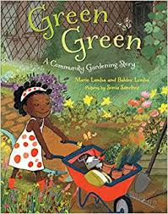  PSHE: Dreams and Goal (Jigsaw SoW)  R.E.:  Theme: Jesus as a friend  Key Question: Was it always easy for Jesus to show friendship?  Religion: Christainity (Concept: Incarnation)  Music: Charanga In the Groove  P.E. To develop practical skills in order to participate, compete and lead a healthy lifestyle.  - Gymnastics 1  ICT: Digital Literacy:  Using a computer/device  Using technology purposefully to create, store and retrieve digital content.  D&T: To create products using levers, wheels and winding mechanisms. | To develop ideas  This concept involves understanding how ideas develop through an artistic process  - Explore ideas and collect visual information  - Explore different methods and materials as ideas develop  To master techniques  This concept involves developing a skill set so that ideas may be communicated  - Use thick and thin paint brushes  - Mix primary colours to make secondary  - Add white to colours to make tints and black to colours to make tones  To take inspiration from the greats  This concept involves learning from both the artistic process and techniques of great artists and artisans throughout history  - Describe the work of notable artists  - Use some of the ideas of George Seurat to create a piece of art work
Maths: To understand the properties of shapes
This concept involves recognizing the names and properties of geometric shapes and angles
- To be able to identify and describe 2D shapes ,
- Identify 2D shapes on the surface of 3D shapes
- Describe properties and name 3D shapes
- Number and place value will be incorporated daily into maths lessons.
English: To be able to present neatly
This concept involves developing an understanding of handwriting and clear punctuation (through daily/weekly handwriting sessions)
To be able to spell correctly ( CEW and harder to read and spell words)
The concept involves understanding the need for accuracy Children will be learning the phase 5 graphemes and phonemes covered in Essential Letters and Sounds scheme.
To be able to punctuate accurately
This concept involves understanding that punctuation adds clarity to writing.

