Geography Focus - Threshold Concepts | Y6 – Protecting the Environment | Art and Design - Threshold Concepts
Geography  Investigate Places  - Collect and analyse statistics and other information in order to draw clear conclusions about locations.  - Identify and describe how the physical features affect the human activity within a location.  - Use a range of geographical resources to give detailed descriptions and opinions of the characteristic features of a location.  - Use different types of fieldwork  - Analyse and give views on the effectiveness of different geographical representations of a location  - Name and locate the countries of North and South America and identify their main physical and human characteristics.  Investigate Patterns  - Understand some of the reasons for geographical similarities and differences between countries.  - Describe how locations around the world are changing and explain some of the reasons for change.  Communicate Geographically  - physical geography, including: climate zones, biomes and vegetation belts, rivers, mountains, volcanoes and earthquakes and the water cycle.  - human geography, including: settlements, land use, economic activity including trade links, and the distribution of natural resources including energy, food, minerals, and water supplies. | Enquiry Question:  Are we damaging our world?  In this unit, the children will consider if we are damaging our world and how we can protect it. The children will investigate energy production, the oceans and minerals, as well as conducting an enquiry into how the school can become more sustainable.  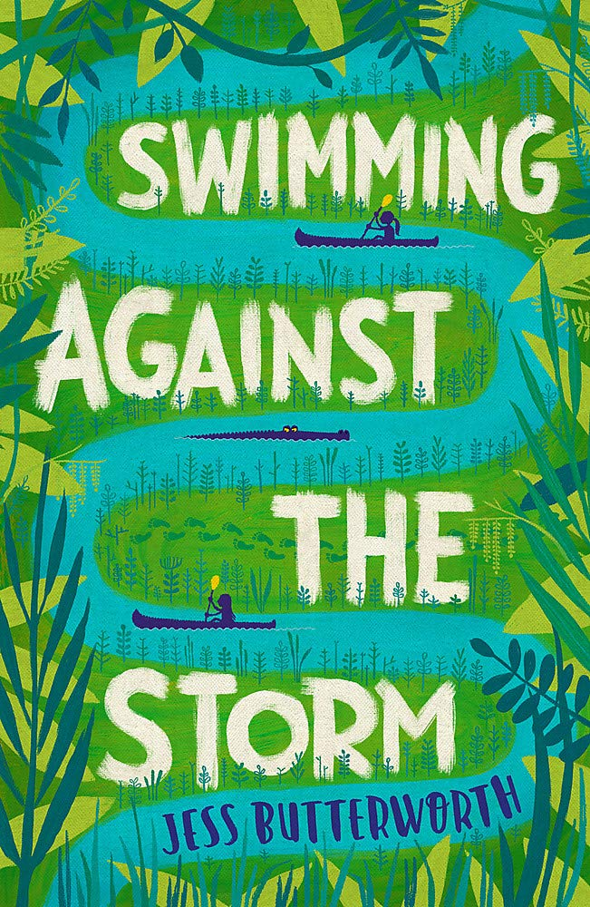  Class Text  Choice Rationale  Ultimately, learning about sustainability challenges us to consider our relationship with nature. Celebrating the extraordinary and wonderful diversity of creation is a good starting point and will lay the foundations for an ethic of caring in later life.  R.E  Theme: Beliefs and Meaning  Concept: Salvation  Key Question: Is anything ever eternal?  Religion: Christianity Add Humanism if appropriate  SMSC and PSHE:  DG (Dreams and Goals)  Aspirations, how to achieve goals and understanding the emotions that go with this  I know my learning strengths and can set challenging but realistic goals for myself (e.g. one in-school goal and one out-of- school goal)  D&T  Focus: Mechanical Systems: Pulleys and Gears.  P.E  Dance: movement, balance, sequencing | A study of Surrealism  Develop Ideas  - Develop and imaginatively extend ideas from starting points throughout the curriculum.  - Collect information, sketches and resources and present ideas imaginatively in a sketch book.  - Use a range of quality materials to enhance ideas.  - Comment on artworks with a fluent grasp of visual language.  Master Techniques  - Sketch before painting to combine line and colour.  - Create a colour palette based upon colours observed in the natural or built world.  - Use the qualities of watercolour and acrylic paints to create visually interesting pieces.  - Combine colours and tones to enhance the mood.  - Develop a personal style of painting, drawing upon ideas from other artists.  Take inspiration from the greats  Artist Spotlight: Salvador Dali  - Give details including own sketches about the style of some notable artists, artisans and designers.  - Show how the work of those studied was influential in both society and to other artists  - Create original pieces that show a range of influences and styles
Science – Physics  Work scientifically  This concept involves learning the methodologies of the discipline of science.  Understand electrical circuits  This concept involves understanding circuits and their role in electrical applications.  - Associate the brightness of a lamp or the volume of a buzzer with the number and voltage of cells used in the circuit.  - Compare and give reasons for variations in how components function, including the brightness of bulbs, the loudness of buzzers and the on/off position of switches.  - Use recognised symbols when representing a simple circuit in a diagram. |  | Cross Curricular Opportunities  English: speaking and listening; poetry; research skills, note-taking, non-chronological reports.  Extended Writing Process – Writing a script (Week 1); producing a factsheet (Week 3); formal letter writing and persuasive texts (Weeks 3 and 5); report writing (Week 4)  Mini Process – (Reading to writing) note taking, summaries, questioning and predictions.  Science: habitats and adaptation, states of matter – properties of liquids  Computing: Understanding, creating and using spreadsheets  History: Changes over time

