Geography Focus-Threshold concepts | Year 2- Journeys | Art and Design – Threshold Concepts
Geography-  Journeys- Food.  Where does our food come from?  Milestones-  • understand geographical similarities and differences through studying the human geography of their local shops, and physical geography through studying nearby food growing or production  • use locational and directional language (e.g. near and far) to describe the location of features and routes on a map  • name, locate and identify characteristics of the four countries and capital cities of the UK, and its surrounding seas  • use world maps, atlases and globes to identify the UK and its countries, as well as the countries, continents and oceans studied at this key stage.  Science  Living Things and their habitats.  Identify and name a variety of plants and animals in their habitats, including micro-habitats.  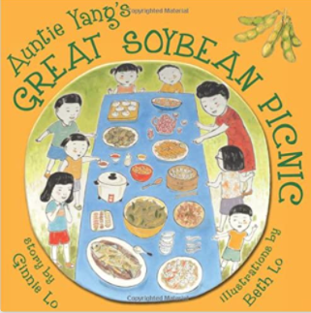  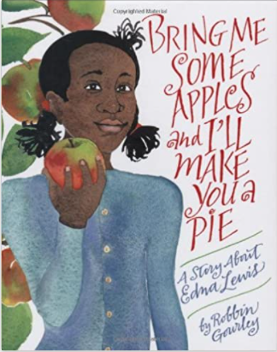  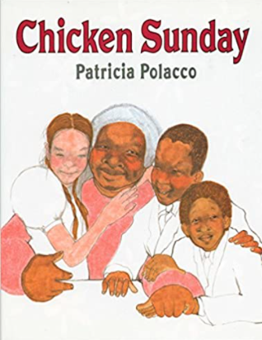  Linked texts: | English Focus.  English focus text: Writing Instructions and Recount.  Extended writing outcomes:  Writing instructions of food preparation and recount from personal experience of making their own food.  Shorter writing outcomes:  -Instructions for how to make a sandwich.  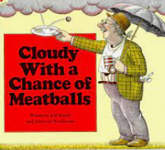  Supporting Texts | Artist Spotlight: Paul Cezanne  Art Period: 19th/20th Century  Art Style: Post Impressionism  To develop ideas:  - Still life painting  - Working on canvas  To master techniques: large, thick brush strokes  Sketching fruit/flowers  Applying layers of colour.  Take inspiration from the greats:  - Pablo Picasso  - Henri Matisse  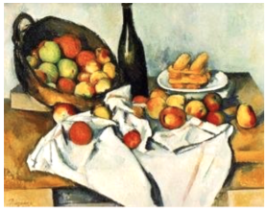
Curriculum coverage:
DT: Food. Preparing fruits and vegetables.
PSHE: Jigsaw- Dreams and Goals.
RE: Religion: Judaism
Theme: Passover
Key Question: How important is it for Jewish people to do what God asks them to do?
Music: Charanga. I wanna play in a band.
I.C.T: Digital Literacy: Using a computer.
P.E: Gymnastics 2. Striver.

