History Focus - Threshold Concepts | Y6 – The Ancient Greeks | Art and Design - Threshold Concepts
History  - Develop a chronologically secure knowledge and understanding of British, local and world history.  - Develop the appropriate use of historical terms.  - Address and devise historically valid questions about change, cause, similarity, difference and significance.  - Understand how knowledge of the past is constructed from a range of sources.  - Construct informed responses that involve thoughtful selection and organisation of relevant historical information.  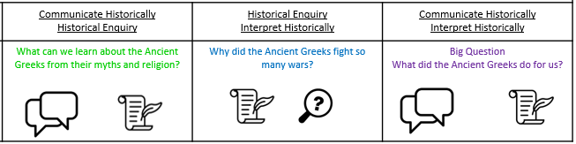  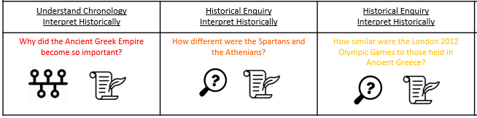  - Learn about the Greeks and the significant developments during this period. | Enquiry Question:  What is the legacy of the Ancient Greeks?  In this unit, the children will learn about aspects of political, social and cultural Ancient Greek life. They will focus on some areas in depth, such as the systems of government, religion and the importance of the Olympic Games. They will examine the legacy of the Ancient Greeks, and will have opportunities for further study of areas of interest. While they will gain an overview of the time period, the main focus will be on the Classical period. Elements of the unit can also be used in a study of post-1066 British history and the legacy of Greek culture.  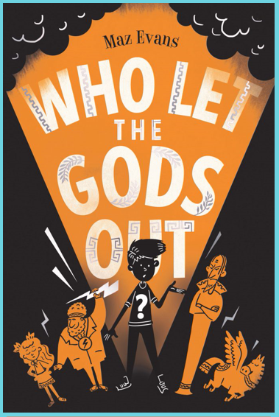  Class Text  Choice Rationale  THEMES  • Greek Mythology  • Humour & wordplay  • Young carers & family illness  • Reimagining  • Friendship & acceptance  • Heroism & quest  A new, exciting and brilliantly British adventure –centered on the Olympian gods.  Linked Texts  ‘Greek Myths’ by Marcia Williams  ‘The Odyssey’ by Gillian Cross  ‘Ancient Greece’ by Rachel Minay (The History Detective Investigates)  ‘Ancient Greece’ by Anita Ganeri (Writing History)  R.E  Theme: Easter Religious Festival  Concept: Salvation  Key Question: Is Christianity still a strong religion 2000 years after Jesus was on earth?  Religion: Christianity Add Humanism if appropriate  SMSC and PSHE:  HM (Healthy Me)  Being and keeping safe and healthy  Taking responsibility for my health and well-being  D&T  Focus: Mechanical Systems: Pulleys and Gears.  P.E  Gymnastics Unit 2 | Keeping It Real: A study of realism  Develop Ideas  - Develop and imaginatively extend ideas from starting points throughout the curriculum.  - Collect information, sketches and resources and present ideas imaginatively in a sketch book.  - Use a range of quality materials to enhance ideas.  - Comment on artworks with a fluent grasp of visual language.  Master Techniques  - Sketch before painting to combine line and colour.  - Create a colour palette based upon colours observed in the natural or built world.  - Use the qualities of watercolour and acrylic paints to create visually interesting pieces.  - Combine colours and tones to enhance the mood.  - Develop a personal style of painting, drawing upon ideas from other artists.  Take inspiration from the greats  Artist Spotlight: Gustave Courbet: Keeping it Real  - Give details including own sketches about the style of some notable artists, artisans and designers.  - Show how the work of those studied was influential in both society and to other artists  - Create original pieces that show a range of influences and styles
Science – Biology  Work scientifically  This concept involves learning the methodologies of the discipline of science.  Investigate living things  This concept involves becoming familiar with a wider range of living things, including insects and understanding life processes.  - Describe the differences in the life cycles of a mammal, an amphibian, an insect and a bird.  - Describe the life process of reproduction in some plants and animals.  - Describe how living things are classified into broad groups according to common observable characteristics.  - Give reasons for classifying plants and animals based on specific characteristics. |  | Cross Curricular Opportunities  • Art and Design: constructing an Archimedes screw, investigating the design of Greek buildings with columns, making Greek pottery and decorating in a traditional style, mask making for Greek theatre  • Computing: researching online  • Drama: Greek mythology and comparative links to others  • English: Aesop’s Fables • Geography: settlements, maps, land use, physical geography and its impact on humans  • Greek language: learning simple words and phrases  • Maths: dates, timelines impact of the Greek mathematicians (Pythagoras and Archimedes)

