History- Holidays | Year 2- Holidays | Art and Design – Threshold Concepts
History-  Holidays – How have holidays have changed over time?  Milestones-  • Learn about changes within living memory  • Understand historical concepts such as continuity and change, similarity and difference  • Ask historically valid questions  • Identify similarities and differences between ways of life in different periods  • Ask and answer questions  • Understand some of the ways in which we find out about the past  • Identify different ways in which the past is represented  • Use a wide range of everyday historical terms  • Use parts of stories and other sources to show they know and understand key features of events  • Use sources to show they know and understand the past  • Suggest reasons why changes took place.  Science  Living Things and their habitats.  Identify and name a variety of plants and animals in their habitats, including micro-habitats.  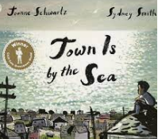  Linked texts:  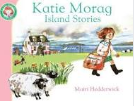  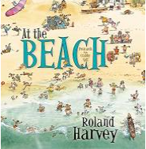 | English Focus.  English focus text: Non-fiction report.  Extended writing outcomes:  Using Pie Corbett’s Talk for Writing sequence the children will produce their own mini-leaflet or newspaper report with a focus of the Year 2 Class book ‘Meerkat Mail.’  Shorter writing outcomes:  To write a personal recount of a class trip to Yorkshire Wildlife Park.  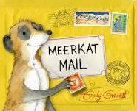  Supporting Texts | Artist Spotlight: Ivan Aivazovsky  Art Period: 15th Century  Art Style: Seascapes  To develop ideas:  - Using vivid colour  - Light and shadow to create powerful effects.  To master techniques:  To draw heavy horizons, Sketching some features such as clouds and cliffs before painting ships onto the seascape.  Take inspiration from the greats:  - Jacob van Ruisdael (c. 1628-82) Dutch Golden Age painter  - Katsushika Hokusai (1760-1849) Japanese printmaker and painter  - Joseph Turner (1775-1851) English Romantic painter  - Ivan Aivazovsky (1817-1900) Russian Romantic painter  - Gustave Courbet (1819-77) French Realist painter  - Claude Monet (1840-1926) French Impressionist painter
Curriculum coverage:
DT: Food. Preparing fruits and vegetables.
PSHE: Jigsaw- Healthy me.
RE: Religion: Islam- Prayer at home.
Key Question: Does praying at regular intervals help a Muslim in his/her everyday life?
Music: Charanga. Zootime
I.C.T: Digital Literacy: Word processing and presentations
P.E: Striver. Games 1

