Geography Focus - Animals and their Habitats. Where do our favourite animals live? | Y1 Animals and their habitats (Class Texts) | Art and Design/DT - Threshold Concepts
Geography  Investigate places  - Ask and answer geographical questions about the physical and human characteristics of a landscape.  - Explain own views about locations, giving reasons.  - Use maps, atlases, globes and digital/computer mapping to identify countries, continents and oceans.  - To name and locate the world’s 7 continents and 5 oceans.  - To know that some of the continents have significant hot and cold areas.  - To use specific place knowledge to describe the habitat of a significant animal.  Investigate patterns  - Understand geographical similarities and differences through studying the human and physical geography of their local area and 5 different World continents.  Communicate geographically  - Use appropriate geographical vocabulary to communicate key physical and human features.  - Use simple fieldwork and observational skills.  Science  Work Scientifically  - To perform simple tests  - Ask simple questions  - Observe closely, using simple equipment  - Gather and record data  Understanding animals and humans  - Identify and name a variety of common animals that are birds, fish, amphibians, reptiles, mammals and invertebrates. | 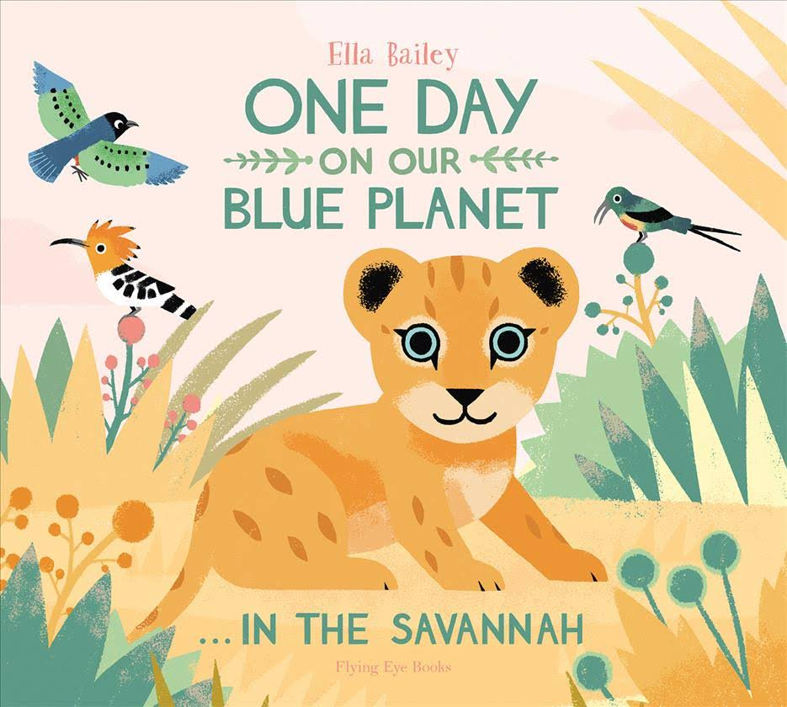  English focus text: One Day on our Blue Planet…in the Savannah  Extended writing outcomes:  Kenning poetry.  Short writing outcomes:  To write a description of the setting.  Link Reading:  The Dandelion Seed – Joseph Antony  Picture Book  Listen to our World -  Bill Martin Jr and Martin Sampson  Picture Book  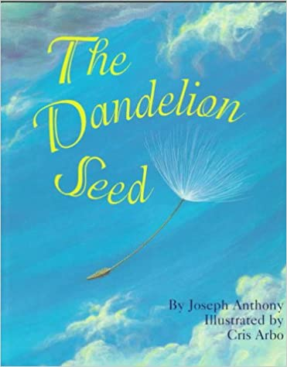  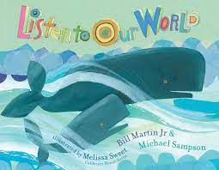 | Access Art:  Making Birds  This pathway aims to help children begin to understand the relationship between drawing and making, 2D and 3D. Pupils explore how to transform materials into sculpture, moving away from mark making to balance and structure.  D.T. Food Preparing fruit and vegetables.  Make a smoothie and fruit kebab.  PE: Games 2: Throwing and Striking.
Maths:
Multiplication and division
Fractions
Position and Direction
Place Value (within 100)
Money
Time

SMSC and PSHE:
Relationships: Families, making friends, Greetings, People who help us, being my own best friend, Celebrating my Special Relationships
R.E.:
What does it mean to belong to a faith community?

Music: Storytime
Our Bodies (Music Express)
Computing: Information Technology Potty Painters Digital Art and book design
Spanish: Seasons.

