Geography Focus – Volcanos and Earthquakes | Y4 Volcanos and Earthquakes | Art and Design – Exploring Naïve Art
Physical geography  Describe key aspects of volcanoes and earthquakes.  Communicate Geographically  Use geographical vocabulary give informed responses on the physical geography of volcanos and earthquakes.  Enquire Geographically  Know what earthquakes and volcanos are and how they are caused.  Understand that volcanoes can be active, dormant and extinct.  Discuss a recent example(s) of an earthquake and/or volcanic eruption.  Study Location / Mapping  Describe the location of some earthquakes and volcanos  Know about the distribution of Earthquakes and the Pacific Ring of Fire.  Describe examples where, and know the main reasons why, people live in the vicinity of volcanoes.  Know some of the hazards for people who live in earthquake and volcanic zones.  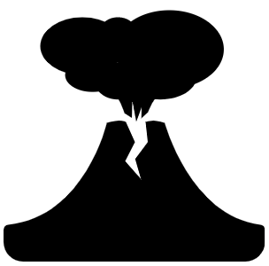  Describe how some of these can be/have been overcome, and life made safer for people. | Enquiry Question:  How does the Earth shake, rattle and roll?  Themes: A small island in the Pacific exists in perfect harmony, where all the plants, animals and people are interdependent. But, the islanders live with the knowledge that their mountain god sometimes grumbles and threatens to awake. When that happens, the people offer up prayers and garlands of flowers to coax the giant back to sleep.  Extended Written Piece: Information storybook for Year 1  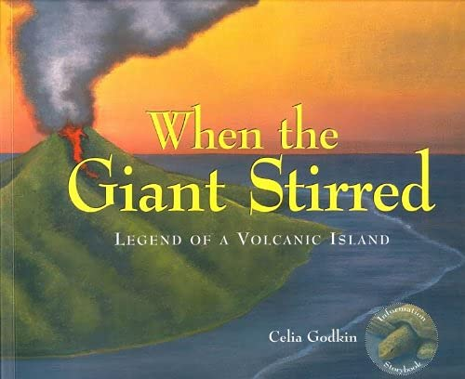  - Plan, write, edit and improve writing.  - Create characters, settings and plots.  - Organise paragraphs around a theme.  - Use a mixture of simple, compound and complex sentences.  - Using conjunctions, adverbs and prepositions to express time and cause.  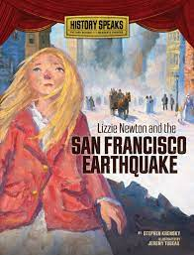  Supporting Text  - Identify how language, structure and presentation contribute to meaning.  - Identify main ideas drawn from more than one paragraph and summarise these.  - Ask questions to improve understanding of a text.  - Explain and discuss understanding of reading, maintaining focus on the topic.  R.E  Judaism: Practices and Beliefs Key Question: What is the best way for a Jew to show commitment to God?  ICT  Information Technology – Use software to create a perspective photograph. Use iMovie to create a movie trailer, stop motion animation.  Green screen replacement.  SMSC and PSHE:  Relationships: Building positive, healthy relationships.  D&T Focus: Food Healthy and varied diet. | Develop Ideas:  - Collect information, sketches and resources.  - Adapt and refine ideas as they progress.  - Explore ideas in a variety of ways.  - Comment on artworks using visual language.  Master Techniques:  - Create original pieces that are influenced by  studies of others.  - Create images, video and sound recordings and explain why they were created.  - Create original pieces that are influenced by  studies of others.  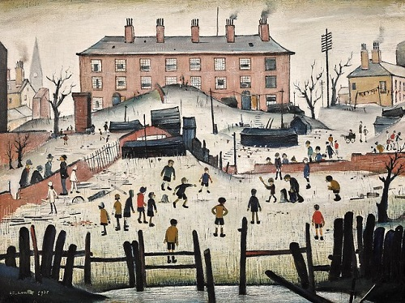  Artist Spotlight: L.S Lowry  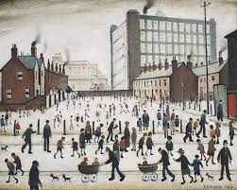
Science: Chemistry - Investigate States of Matter.  Work scientifically to:  - Compare and group materials together, according to whether they are solids, liquids or gases.  - Observe that some materials change state when they are heated or cooled, and measure the temperature at which this happens in degrees Celsius (°C).  - Identify the part played by evaporation and condensation in the water cycle and associate the rate of evaporation with temperature. |  | Cross Curricular Opportunities  English:  Use, read and select books that are structured in different ways for appropriate purposes (information books on Volcanos and Earthquakes). Use knowledge of volcanos and earthquakes to inform information storybook.  Maths:  Develop further understanding of measurement including time and distance during athletics (PE) and temperature during Science.  Geography:  The Americas – Mapping North and South America – use previous learning of the Americas to identify key features of landscapes particularly those with volcanos and earthquakes as aprt of their physical geography.

