History Focus – Enquiry Question  Did WWI or WW2 have the biggest impact on our locality? | Y6 – The impact of War  Did WWI or WW2 have the biggest impact on our locality? | The Curriculum – Threshold Concepts
Working historically to:  Historicaly Enquiry  Know that Traditional war memorials include crosses, plaques, statues and sculptures.  Know that in cemeteries, you will find memorials on graves for people who died in the wars but are buried elsewhere or who died of their injuries during or just after the war.  Know that they are known as war graves. There are over 300,000 war graves in the UK.  Interpret Historically  Know that during both wars the school curriculum reflected patriotism.  Know that in the Second World War, children had to prepare for gas attacks, air raids and invasions.  Know that in September 1939, around 3 million children between the ages of 5 and 14 were evacuated.  Understand Chronology  Know that in 1917, the Women’s Land Army was formed and during WW2, this campaign was known as Dig for Victory.  Know that rationing was introduced in February 1918 (WWOI) and in January 1940 (WW2).  Know that in 1919, an act was introduced for the Restoration of Pre-War Practices, meaning men got their old jobs back.  Communicate Historically  Know why the source was produced.  Know how to give details of the evidence the source provides about the event.  Know how to explain why you think the source is particularly useful.  Know if your source is reliable and explain why. | English Focus text:  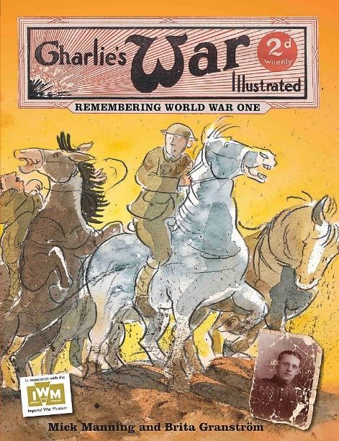  Narrative – the children will be introduced to writing short texts. Using a ‘postcard fiction’ format their stories will draw upon the retelling of events captured in diary entries, postcards and letters from soldiers fighting in WWI and WW2. This style of writing calls for carefully chosen words, succinct phrases and clever use of punctuation to tell a story in no more than 250 words.  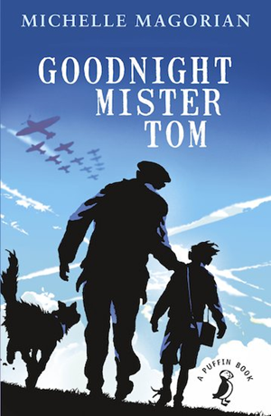  Link Reading:  Goodnight Mister Tom – This classic tale sees a young boy evacuated to the countryside where he is cared for by Tom, a kind gentle old man who helps Willie to flourish. But, when Willie is summoned back to London by his cruel mother, Tom finds himself going in search of the boy and realises that he is in grave danger.  Maths: White Rose  Consolidation:  - Place value  - Addition, subtraction, multiplication, division.  - Adding, subtraction, multiplying and dividing fractions.  - Measurement – converting units  - Ratio and algebra.  - Fractions, decimals and percentages  - Area, perimeter and volume.  - Statistics and shape. | P.E  Athletics  - Run with fluency and speed and sustain pace over longer distances.  - Compete in a variety of athletic events competitively.  - Combine athletics skills into a sport day event.  Rounders  - Understand and demonstrate the Key rules of rounders.  - Demonstrate the relevant skills within a rounders match  - Compete successfully as a team.  ICT  Computer Science: Swift Playgrounds  - Think Like a computer.  - Think like a Detective​​​​​​  - Think Efficiently  - The Incredible Code Machine  PSHE  Jigsaw - Changing Me  - Understand that everyone is unique and special  - Can express how they feel when change happens  - Understand and respect the changes that they see in themselves and others  - Know who to ask for help if they are worried about change  - Are looking forward to change  MUSIC  Year 6 Leavers Concert  - Perform a range of songs in front on an audience.  - Use instruments to accompany a musical performance.  MFL  Spanish - Las estaciones  - Learn the four seasons of the year along with a key feature for each season  - Say which is their favourite season and why.  Art  Shadow Puppets  - Explore traditional and contemporary artists and craftspeople using intricate cutouts to create artwork which is meaningful to the culture in which it is created.  - Take inspiration from other artists and craftspeople to create puppets working in collaboration.  DT  Food – celebrating culture and seasonality  - Know how to use utensils and equipment including heat sources to prepare and cook food.  - Understand about seasonality in relation to food products and the source of different food products.
Science
Biology - Understand Animals and Humans

Work scientifically
This concept involves becoming familiar with different types of animals, humans and the life processes they share.

- Identify and name the main parts of the human circulatory system, and describe the functions of the heart, blood vessels and blood.
- Recognise the impact of diet, exercise, drugs and lifestyle on the way their bodies function.
- Describe the ways in which nutrients and water are transported within animals, including humans.

