History Focus – Crime and Punishment | Y4 Crime and Punishment | Access Art – Festival Feasts
Understand Chronology:  To be able to order a timeline of events related to Crime and Punishment.  Historical Enquiry:  To be able to identify main sources of evidence about Crime and Punishment in Britain.  Communicate Historically:  To be able to ask and answer historically valid questions about the events that shaped crime and punishment in Britain.  Interpret Historically:  To be able to identify the significant events and give reasons for historical change in Britain and wider world influences.  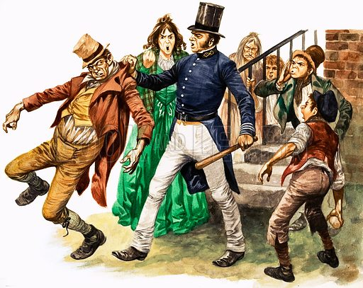 | Enquiry Question:  How has crime and punishment changed over time?  Themes: In this retelling of the Charles Dickins classic set in the dark dangerous streets of Victorian London, Oliver enters the world of people so poor and desperate that they will take any risk and know no mercy. Relentlessly pursued by the menacing criminal world, who should Oliver trust? Are his true friends strong enough to resist the determined plotting of desperate villains?  Extended Written Piece: Newspaper Report  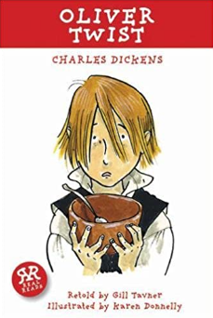  - Using headings and subheadings.  - Using the 5 Ws (What, where, when, who, why)  - Using information to present main events.  - Write in the third person  - Write in the past tense  - Using direct and reported speech.  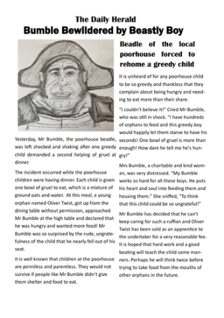  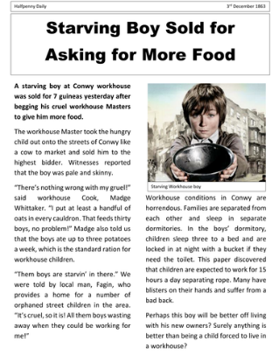  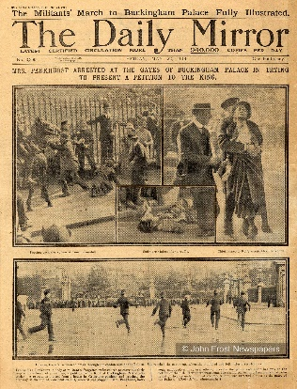  R.E  Christianity: Prayer and Worship: Do people need to go to church to show they are Christians?  ICT  Computer Science: Scratch Maze Game: Develop a Scratch Desktop Maze Game.  SMSC and PSHE:  Relationships: Building positive, healthy relationships and Changing Me: Coping positively with change  D&T Focus: Food Healthy and varied diet. | Develop Ideas:  - Become familiar with artists who create sculpture based on food.  - Use a sketchbook to jot down quick drawings, words about how they feel, similarities and differences between the artist’s work, and any other thoughts.  - Show what they can see by creating observational drawings from film / life.  - Consider shape, colour, texture, and composition whilst using a variety (and combination) of materials.  Master Techniques:  - Explore Modroc as a new material to make a sculptural feast which will contribute to a class meal.  - Lay out a picnic, including food which contributes colour, texture, pattern, and form to inspire lots of creative drawings.  Artist Spotlight: Claes Oldenburg and Lucia Hierro  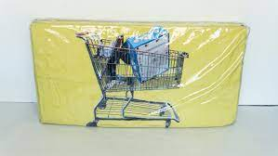  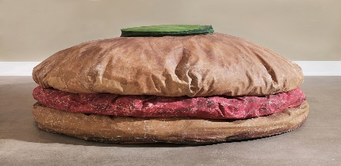
Science: Chemistry – Animals including Humans.  Work scientifically to:  - Identify that animals, including humans, need the right types and amounts of nutrition and that they cannot make their own food and they get nutrition from what they eat.  - Construct and interpret a variety of food chains, identifying producers, predators and prey.  - Describe the simple functions of the basic parts of the digestive system in humans.  - Identify the different types of teeth in humans and their simple functions. |  | Cross Curricular Opportunities  English:  Use the Suffragette movement to create a leaflet about a meeting supporting votes for women. Enquire historically to find factual information to design a leaflet and communicate historically to present information.  Maths:  Statistics: use charts and graphs to show changes in crime and punishment from Victorian England to present day. Use charts and graphs to show nutritional values of foods related to healthy eating.  D&T  Work scientifically to find food that provides the best nutritional value for the body and create a healthy picnic through art work for a final presentation piece.

