Geography Focus - Threshold Concepts | Y6 – Our World in the Future | Art and Design - Threshold Concepts
Geography  In this unit, the children will:  - describe and understand key aspects of:  − physical geography − human geography  - learn geographical skills and fieldwork: use maps and symbols to build their knowledge of the UK  - use fieldwork to observe, measure, record and present features in the local area using a range of methods, including sketch maps, plans and graphs, and digital technologies.  All children can:  • explain why their local area is special  • plan and carry out fieldwork  • describe different types of local industry  • list local public services  • locate local public services  • understand that the location of public services is important  Most children can:  • understand how developments can be sustainable  • explain how local industry has changed over time  • understand that future needs of the community may affect local industry  • choose an appropriate format to present their geographical learning  • understand how to take the needs and views of others into account. Some children can:  • understand how to make their designs sustainable  • generate sustainable development ideas that meet the needs of the community  • understand that the design of communities can help or hinder community relations | Enquiry Question:  How will our world look in the future?  In this unit, as the children move towards the end of their primary school careers and prepare to move to secondary schools, they will consider the past, present and future of their local area. This unit helps them see change as positive and to feel optimistic about the changes that lie ahead.  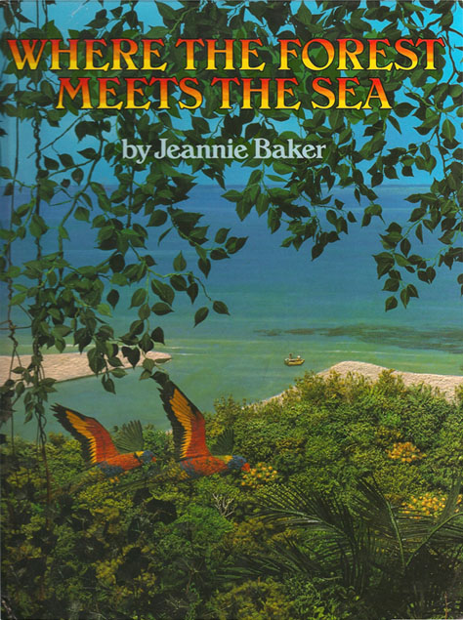  Class Text  Choice Rationale  Where the Forest Meets the Sea by Jeannie Baker is a fascinating picture book that encourages children to consider the impact humans have on the environment. The setting of this thought-provoking story depicts where the Great Barrier Reef meets the Daintree Rainforest in Australia.  Themes  Ancient Civilisations  Around the World  Art and Design  Family, Forests and Rainforests  R.E  Theme: Beliefs and Meaning  Key Question: Does belief in Akhirah (life after death) help Muslims lead better lives?  Religion: Islam  SMSC and PSHE:  RL (Relationships)  Building positive, healthy relationships  D&T  Celebrating Culture and Seasonality  P.E  Striver: Handball | Keeping It Real: A study of futurism  Develop Ideas  - Develop and imaginatively extend ideas from starting points throughout the curriculum.  - Collect information, sketches and resources and present ideas imaginatively in a sketch book.  - Use a range of quality materials to enhance ideas.  - Comment on artworks with a fluent grasp of visual language.  Master Techniques  - Sketch before painting to combine line and colour.  - Create a colour palette based upon colours observed in the natural or built world.  - Use the qualities of watercolour and acrylic paints to create visually interesting pieces.  - Combine colours and tones to enhance the mood.  - Develop a personal style of painting, drawing upon ideas from other artists.  Take inspiration from the greats  Artist Spotlight: Umberto Boccioni  - Give details including own sketches about the style of some notable artists, artisans and designers.  - Show how the work of those studied was influential in both society and to other artists  - Create original pieces that show a range of influences and styles
Science – Biology  Work scientifically  This concept involves learning the methodologies of the discipline of science.  Understand Evolution and Inheritance  This concept involves understanding that organisms come into existence, adapt, change and evolve and become extinct.  - Recognise that living things have changed over time and that fossils provide information about living things that inhabited the Earth millions of years ago.  - Recognise that living things produce offspring of the same kind, but normally offspring vary and are not identical to their parents.  - Identify how animals and plants are adapted to suit their environment in different ways and that adaptation may lead to evolution. |  | Cross Curricular Opportunities  - English: writing surveys/questionnaires (Week 1), reports (Weeks 2 and 5–6), captions (Week 3), a job advert (Week 3), persuasive speech (Week 5), diary entry (Week 5); annotating maps (Weeks 2 and 4).  - Maths: interpreting a line graph (Week 3). • Art & design: artwork (Week 3); exploring the work of L.S. Lowry (Week 3).  - Computing: researching online (Week 3); using a mapping tool (Week 4); creating an app or website (Week 6).  - Design & Technology: learning about architecture and housing design (Weeks 2 and 5).  - History: learning about local history (Weeks 2–4 and 5).  - PSCHE: considering the needs of others (Weeks 1–4); developing community spirit (Week 5).

