Geography Focus – Enquiry Question  How will our world look in the future? | Y6 – Our World in the Future  How will our world look in the future? | The Curriculum – Threshold Concepts
Geographically  Communicate Geographically  - Explain why their local area is special  - Explain how local industry has changed over time  - Describe different types of local industry  - Choose an appropriate format to present their geographical learning  Mapping  - Plan and carry out fieldwork  - List local public services  - Locate local public services  - I can understand that the design of communities can help or hinder community relations  Study Location  - To be able to understand that the location of public services is important  - To be able to understand how developments can be sustainable  - To be able to understand that future needs of the community may affect local industry  - I can understand how to take the needs and views of others into account.  Enquire Geographically  - Research and generate sustainable development ideas that meet the needs of the community.  - Identify key aspects of the local community to make their designs sustainable. | 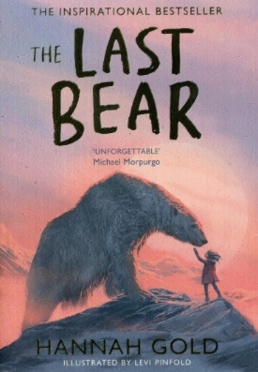  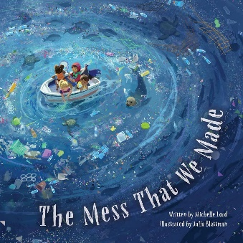  English Focus text: The Mess That We Made  Explanation text – Thinking of a more sustainable planet, the children will write an explanation text focusing on a specific example of renewable energy. Supported by our enquiry question from September we will look back at how our planet is damaged in different ways and what we can do to future-proof its existence.  Link Reading:  The Last Bear – Hannah Gold: We can wait to return to this engaging tale of a lone polar bear and a young girl. Looking at climate change through a beautifully told story, we begin to understand the plight of this endangered species. Thinking of her experiences on Bear Island, the children will write a letter home, as the character April, to Granny Apples where they will describe their adventures so far.  Maths: White Rose  Shape  Position and Direction  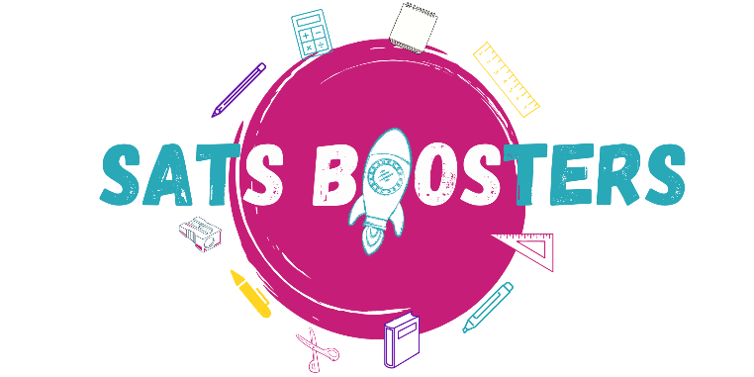  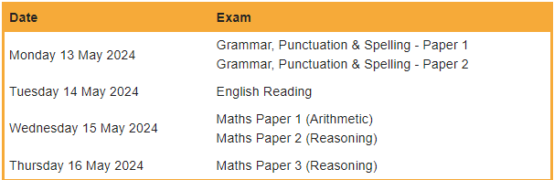 | P.E  Rounders  Throw and catch a ball consistently.  Strike a bowled ball consistently.  Stop and field a moving ball using various techniques.  Understand and demonstrate the key rules in rounders.  Demonstrate all the relevant skills in a match and compete as a team.  ICT  E-Safety: Health, Well Being and Lifetsyle Online.  - Introduction to HTML.  - Python Coding  - Photo Editing  - Video Creation (iMovie)  RE  Religion: Christianity  Key Question: For Christians What kind of king was Jesus?  In this unit, pupils will find out about parables from the Bible and learn that most Christians believe that Jesus told some parables to share what the Kingdom of God  is like and to invite people to join God’s kingdom by letting God rule in their hearts.  PSHE  Jigsaw – Healthy Me  - Take responsibility for my health and well being.  - Find a way to be happy and cope with life’s situations  - Understand that some people can be exploited  - Know why people join gangs and the risk this involves.  - Understand what it means to be emotionally well.  - Recognise stress and the triggers that cause this.  MUSIC  Year 6 Leavers Concert  The island that Rocks  MFL  Spanish - Las estaciones  - Learn the four seasons of the year along with a key feature for each season  - Say which is their favourite season and why.  Art  Take a Seat  - Explore how crafts people and designers bring personality to their work.  - Make a small model of a chair which is full of personality.  DT  Food – celebrating culture and seasonality  - Know how to use utensils and equipment including heat sources to prepare and cook food.  - Understand about seasonality in relation to food products and the source of different food products.
Science
Biology - Understand Evolution and Inheritance

Work scientifically
This concept involves learning the methodologies of the discipline of science. To understand that organisms come into existence, adapt, change and evolve and become extinct.

- Recognise that living things have changed over time and that fossils provide information about living things that inhabited the Earth millions of years ago.
- Recognise that living things produce offspring of the same kind, but normally offspring vary and are not identical to their parents.
- Identify how animals and plants are adapted to suit their environment in different ways and that adaptation may lead to evolution.

