Geography- Our Wonderful World | Year 2- Our Wonderful World | Art and Design – Threshold Concepts
Geography –  What are the wonders of our world?  Milestones-  • name, locate and identify characteristics of the seven continents and oceans  • use world maps, atlases and globes  • understand geographical similarities and differences when studying both human and physical geography  • identify the locations of hot and cold areas around the world  • use basic vocabulary to refer to physical and human features  • develop knowledge about the world.  Science  Animals including Humans.  . Notice that animals, including humans, have offspring which grow into adults.  • Find out about and describe the basic needs of animals, including humans, for survival (water, food and air).  • Describe the importance for humans of exercise, eating the right amounts of different types of food, and hygiene.  Linked texts:  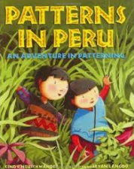  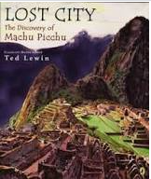 | English Focus. Narrative  English focus text: The day the crayons quit  Extended writing outcomes: Rewrite the story  Shorter writing outcomes:  Story mapping  Apostrophes for possession  Using suffixes  Supporting Texts  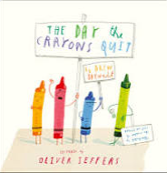 | Artist Spotlight: John Constable  Art Period:18th Century  Art Style: Love for Landscapes  To master techniques:  • Make a quick sketch, marking the locations of key objects.  • Use a big brush to apply washes for the sky and land features. Let these blend with each other.  • Once the wash is dry, use smaller brushes to paint the features such as the trees, mountains and buildings.  • Add more definition by painting any shadows.  • Make any final details and corrections.  Take inspiration from the greats:  Jacob van Ruisdael (c. 1629-82) Dutch painter Katsushika Hokusai (1760-1849) Japanese painter and printmaker John Constable (1776-1837) English Romantic painter Camille Pissarro (1830-1903) French Impressionist painter John Ndambo (born 1967) African painter from Kenya
Curriculum coverage:
DT: Textiles- Templates and Joining Techniques.
PSHE: Jigsaw- relationships.
RE: Judaism- The Covenant.
Key Question: How special is the relationship Jews have with God?
Music: Charanga- Friendship song.
I.C.T: Taking and using photos.
P.E: Striver- Games 2

