Geography Focus - Threshold Concepts | Y6 South America – The Amazon | Art and Design - Threshold Concepts
Geography  Investigate Places  - Collect and analyse statistics and other information in order to draw clear conclusions about locations.  - Identify and describe how the physical features affect the human activity within a location.  - Use a range of geographical resources to give detailed descriptions and opinions of the characteristic features of a location.  - Use different types of fieldwork  - Analyse and give views on the effectiveness of different geographical representations of a location  - Name and locate the countries of North and South America and identify their main physical and human characteristics.  Investigate Patterns  - Understand some of the reasons for geographical similarities and differences between countries.  - Describe how locations around the world are changing and explain some of the reasons for change.  Communicate Geographically  - physical geography, including: climate zones, biomes and vegetation belts, rivers, mountains, volcanoes and earthquakes and the water cycle.  - human geography, including: settlements, land use, economic activity including trade links, and the distribution of natural resources including energy, food, minerals, and water supplies. | Enquiry Question:  What is life like in the Amazon?  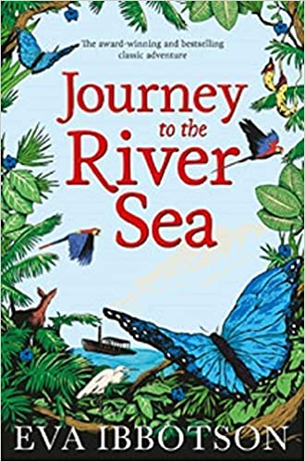  Class Text  Themes: an exciting adventure story with themes of family and class, each individual's responsibility for their own actions, the importance of embracing new experiences and of choosing your own outlook on life.  Supporting Text  Themes: A tale of survival and perseverance with an appreciation of the natural environment. An exploration of love, friendship, self-discovery and emotional development.  R.E  Focus: Pilgrimage. Understand practices and lifestyles. Understand beliefs and teachings across religions.  SMSC and PSHE:  Focus: My year ahead. Identifying goals for the year, understanding emotions and knowing how to express them. Understand and value the importance of community and how to promote the positive values.  D&T  Focus: Textiles. Master techniques and design processes. Understand and develop skills using textiles. | Exploring Expressionism  Develop Ideas  - Develop and imaginatively extend ideas from starting points throughout the curriculum.  - Collect information, sketches and resources and present ideas imaginatively in a sketch book.  - Use a range of quality materials to enhance ideas.  - Comment on artworks with a fluent grasp of visual language.  Master Techniques  - Sketch before painting to combine line and colour.  - Create a colour palette based upon colours observed in the natural or built world.  - Use the qualities of watercolour and acrylic paints to create visually interesting pieces.  - Combine colours and tones to enhance the mood.  - Develop a personal style of painting, drawing upon ideas from other artists.  Take inspiration from the greats  Artist Spotlight: Henri Matisse  - Give details including own sketches about the style of some notable artists, artisans and designers.  - Show how the work of those studied was influential in both society and to other artists  - Create original pieces that show a range of influences and styles
Science  To understand light and seeing  - Understand that light appears to travel in straight lines.  - Use the idea that light travels in straight lines to explain that objects are seen because they give out or reflect light into the eyes.  - Use the idea that light travels in straight lines to explain why shadows have the same shape as the objects that cast them, and to predict the size of shadows when the position of the light source changes.  - Explain that we see things because light travels from light sources to our eyes or from light sources to objects and then to our eyes. |  | Cross Curricular Opportunities  English: speaking and listening; poetry; research skills, note-taking, non-chronological reports.  Extended Writing Process – Informal Letter, diary entry, narrative and autobiography.  Mini Process – (Reading to writing) note taking, summaries, questioning and predictions.  Maths: direction and compass points, distance  Science: habitats and adaptation, states of matter – properties of liquids  Computing: coding - making an animation; e-safety – using the internet safely and effectively for research  History: exploration; food and farming.

History Focus - Threshold Concepts | Y6 The Maya Civilisation | Art and Design - Threshold Concepts
History  Investigate and interpret the past  - Use sources of evidence to deduce information about the past.  - Seek out and analyse a wide range of evidence in order to justify claims about the past.  - Understand that no single source of evidence gives the full answer to questions about the past.  - Refine lines of enquiry as appropriate.  Build and overview of world history  - Describe the social, ethnic, cultural or religious diversity of past society.  - Describe the characteristic features of the past, including ideas, beliefs, attitudes and experiences of men, women and children.  Understand Chronology  - Describe the main changes in a period of history (using terms such as: social, religious, political, technological and cultural).  - Use dates and terms accurately in describing events.  Communicate Historically  - Use appropriate historical vocabulary to communicate, including: dates, time period, era, chronology, continuity, change, century, decade and legacy.  - Use literacy, numeracy and computing skills to a exceptional standard in order to communicate information about the past.  - Use original ways to present information and ideas. | Enquiry Question:  Why should we remember the Maya?  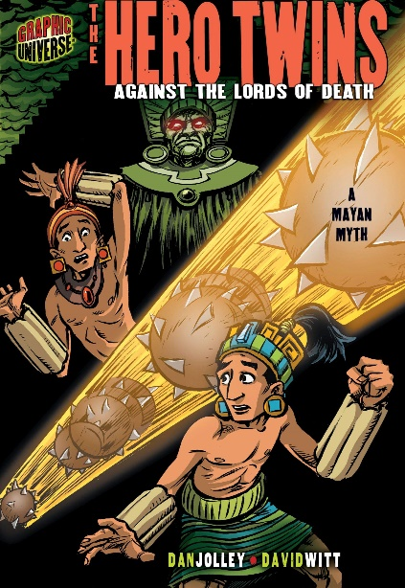  Class Text  Themes: an exciting adventure story, a Mayan folktale detailing Based on an ancient Mayan Myth, this tale is of two brothers who discover they are destined to compete in a game called Poke a Poke with inhabitants of an underground city.  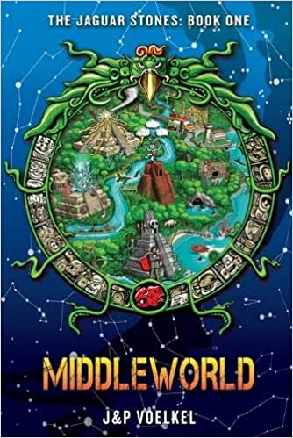  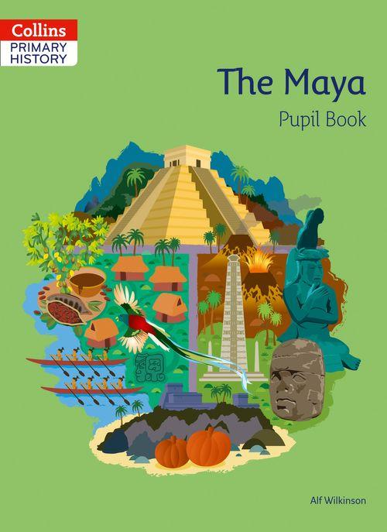  Supporting Texts  The Maya  Packed with information, source materials, questions and activities, allowing children to explore, interpret and develop knowledge of the Mayan Civilisation  Middle world  Links the Mayan folklore and traditions to a modern-day story focused on a young boy who rescues his parents from the Mayan underworld.  R.E  Focus: Theme: Christmas Concept: Incarnation Key Question: How significant is it that Mary was Jesus’ mother? Religion: Christianity  PSHE:  Focus: (Celebrating Difference) Respect for similarity and difference. Anti-bullying and being unique  D&T  Focus: Textiles. Master techniques and design processes. Understand and develop skills using textiles. Making pots in the style of the ancient Maya | Exploring Art and Religion  Develop Ideas  - Develop and imaginatively extend ideas from starting points throughout the curriculum.  - Collect information, sketches and resources and present ideas imaginatively in a sketch book.  - Use a range of quality materials to enhance ideas.  - Comment on artworks with a fluent grasp of visual language.  Master Techniques  - Sketch before painting to combine line and colour.  - Create a colour palette based upon colours observed in the natural or built world.  - Use the qualities of watercolour and acrylic paints to create visually interesting pieces.  - Combine colours and tones to enhance the mood.  - Develop a personal style of painting, drawing upon ideas from other artists.  Take inspiration from the greats  Artist Spotlight El Greco  - Give details including own sketches about the style of some notable artists, artisans and designers.  - Show how the work of those studied was influential in both society and to other artists  - Create original pieces that show a range of influences and styles
Science – Biology  To investigate living things and their habitats  - Describe the differences in the life cycles of a mammal, an amphibian, an insect and a bird.  - Describe the life process of reproduction in some plants and animals.  - Describe how living things are classified into broad groups according to common observable characteristics.  - Give reasons for classifying plants and animals based on specific characteristics.  - Develop scientific enquiry skills  - Carry out different forms of scientific enquiry |  | Cross Curricular Opportunities  English: speaking and listening; poetry; research skills, note-taking, non-chronological reports.  Extended Writing Process – Informal Letter, diary entry, narrative, character and setting descriptions  Mini Process – (Reading to writing) note taking, summaries, questioning and predictions.  Maths: calculations in different types of number systems  Music: percussion and wind instrument music in the style of the Maya  Computing: Digital literacy – Sketchup  Geography: impact of changes to the climate on a society  P.E: Striver: Gymnastics and body movements

Geography Focus - Threshold Concepts | Y6 – Protecting the Environment | Art and Design - Threshold Concepts
Geography  Investigate Places  - Collect and analyse statistics and other information in order to draw clear conclusions about locations.  - Identify and describe how the physical features affect the human activity within a location.  - Use a range of geographical resources to give detailed descriptions and opinions of the characteristic features of a location.  - Use different types of fieldwork  - Analyse and give views on the effectiveness of different geographical representations of a location  - Name and locate the countries of North and South America and identify their main physical and human characteristics.  Investigate Patterns  - Understand some of the reasons for geographical similarities and differences between countries.  - Describe how locations around the world are changing and explain some of the reasons for change.  Communicate Geographically  - physical geography, including: climate zones, biomes and vegetation belts, rivers, mountains, volcanoes and earthquakes and the water cycle.  - human geography, including: settlements, land use, economic activity including trade links, and the distribution of natural resources including energy, food, minerals, and water supplies. | Enquiry Question:  Are we damaging our world?  In this unit, the children will consider if we are damaging our world and how we can protect it. The children will investigate energy production, the oceans and minerals, as well as conducting an enquiry into how the school can become more sustainable.  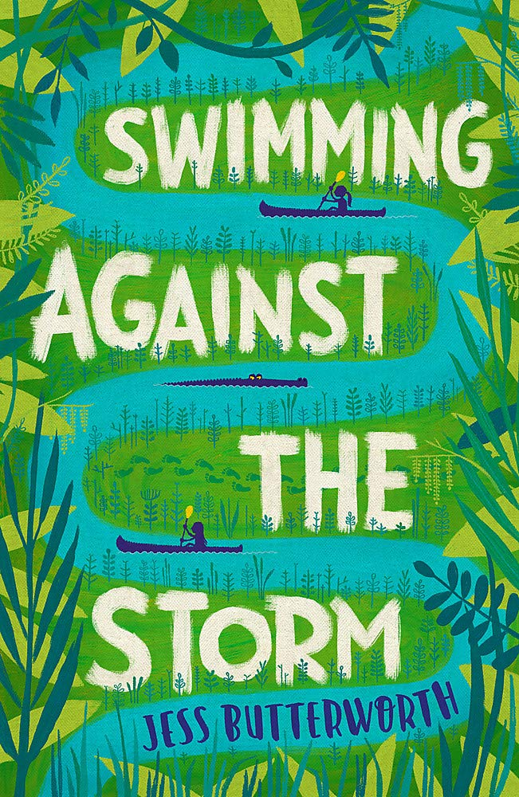  Class Text  Choice Rationale  Ultimately, learning about sustainability challenges us to consider our relationship with nature. Celebrating the extraordinary and wonderful diversity of creation is a good starting point and will lay the foundations for an ethic of caring in later life.  R.E  Theme: Beliefs and Meaning  Concept: Salvation  Key Question: Is anything ever eternal?  Religion: Christianity Add Humanism if appropriate  SMSC and PSHE:  DG (Dreams and Goals)  Aspirations, how to achieve goals and understanding the emotions that go with this  I know my learning strengths and can set challenging but realistic goals for myself (e.g. one in-school goal and one out-of- school goal)  D&T  Focus: Mechanical Systems: Pulleys and Gears.  P.E  Dance: movement, balance, sequencing | A study of Surrealism  Develop Ideas  - Develop and imaginatively extend ideas from starting points throughout the curriculum.  - Collect information, sketches and resources and present ideas imaginatively in a sketch book.  - Use a range of quality materials to enhance ideas.  - Comment on artworks with a fluent grasp of visual language.  Master Techniques  - Sketch before painting to combine line and colour.  - Create a colour palette based upon colours observed in the natural or built world.  - Use the qualities of watercolour and acrylic paints to create visually interesting pieces.  - Combine colours and tones to enhance the mood.  - Develop a personal style of painting, drawing upon ideas from other artists.  Take inspiration from the greats  Artist Spotlight: Salvador Dali  - Give details including own sketches about the style of some notable artists, artisans and designers.  - Show how the work of those studied was influential in both society and to other artists  - Create original pieces that show a range of influences and styles
Science – Physics  Work scientifically  This concept involves learning the methodologies of the discipline of science.  Understand electrical circuits  This concept involves understanding circuits and their role in electrical applications.  - Associate the brightness of a lamp or the volume of a buzzer with the number and voltage of cells used in the circuit.  - Compare and give reasons for variations in how components function, including the brightness of bulbs, the loudness of buzzers and the on/off position of switches.  - Use recognised symbols when representing a simple circuit in a diagram. |  | Cross Curricular Opportunities  English: speaking and listening; poetry; research skills, note-taking, non-chronological reports.  Extended Writing Process – Writing a script (Week 1); producing a factsheet (Week 3); formal letter writing and persuasive texts (Weeks 3 and 5); report writing (Week 4)  Mini Process – (Reading to writing) note taking, summaries, questioning and predictions.  Science: habitats and adaptation, states of matter – properties of liquids  Computing: Understanding, creating and using spreadsheets  History: Changes over time

History Focus - Threshold Concepts | Y6 – The Ancient Greeks | Art and Design - Threshold Concepts
History  - Develop a chronologically secure knowledge and understanding of British, local and world history.  - Develop the appropriate use of historical terms.  - Address and devise historically valid questions about change, cause, similarity, difference and significance.  - Understand how knowledge of the past is constructed from a range of sources.  - Construct informed responses that involve thoughtful selection and organisation of relevant historical information.  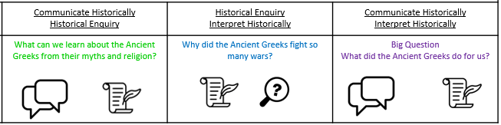  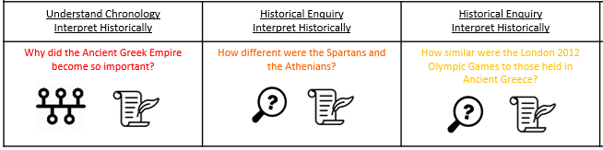  - Learn about the Greeks and the significant developments during this period. | Enquiry Question:  What is the legacy of the Ancient Greeks?  In this unit, the children will learn about aspects of political, social and cultural Ancient Greek life. They will focus on some areas in depth, such as the systems of government, religion and the importance of the Olympic Games. They will examine the legacy of the Ancient Greeks, and will have opportunities for further study of areas of interest. While they will gain an overview of the time period, the main focus will be on the Classical period. Elements of the unit can also be used in a study of post-1066 British history and the legacy of Greek culture.  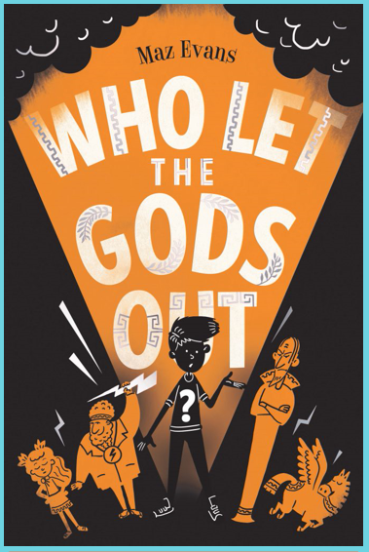  Class Text  Choice Rationale  THEMES  • Greek Mythology  • Humour & wordplay  • Young carers & family illness  • Reimagining  • Friendship & acceptance  • Heroism & quest  A new, exciting and brilliantly British adventure –centered on the Olympian gods.  Linked Texts  ‘Greek Myths’ by Marcia Williams  ‘The Odyssey’ by Gillian Cross  ‘Ancient Greece’ by Rachel Minay (The History Detective Investigates)  ‘Ancient Greece’ by Anita Ganeri (Writing History)  R.E  Theme: Easter Religious Festival  Concept: Salvation  Key Question: Is Christianity still a strong religion 2000 years after Jesus was on earth?  Religion: Christianity Add Humanism if appropriate  SMSC and PSHE:  HM (Healthy Me)  Being and keeping safe and healthy  Taking responsibility for my health and well-being  D&T  Focus: Mechanical Systems: Pulleys and Gears.  P.E  Gymnastics Unit 2 | Keeping It Real: A study of realism  Develop Ideas  - Develop and imaginatively extend ideas from starting points throughout the curriculum.  - Collect information, sketches and resources and present ideas imaginatively in a sketch book.  - Use a range of quality materials to enhance ideas.  - Comment on artworks with a fluent grasp of visual language.  Master Techniques  - Sketch before painting to combine line and colour.  - Create a colour palette based upon colours observed in the natural or built world.  - Use the qualities of watercolour and acrylic paints to create visually interesting pieces.  - Combine colours and tones to enhance the mood.  - Develop a personal style of painting, drawing upon ideas from other artists.  Take inspiration from the greats  Artist Spotlight: Gustave Courbet: Keeping it Real  - Give details including own sketches about the style of some notable artists, artisans and designers.  - Show how the work of those studied was influential in both society and to other artists  - Create original pieces that show a range of influences and styles
Science – Biology  Work scientifically  This concept involves learning the methodologies of the discipline of science.  Investigate living things  This concept involves becoming familiar with a wider range of living things, including insects and understanding life processes.  - Describe the differences in the life cycles of a mammal, an amphibian, an insect and a bird.  - Describe the life process of reproduction in some plants and animals.  - Describe how living things are classified into broad groups according to common observable characteristics.  - Give reasons for classifying plants and animals based on specific characteristics. |  | Cross Curricular Opportunities  • Art and Design: constructing an Archimedes screw, investigating the design of Greek buildings with columns, making Greek pottery and decorating in a traditional style, mask making for Greek theatre  • Computing: researching online  • Drama: Greek mythology and comparative links to others  • English: Aesop’s Fables • Geography: settlements, maps, land use, physical geography and its impact on humans  • Greek language: learning simple words and phrases  • Maths: dates, timelines impact of the Greek mathematicians (Pythagoras and Archimedes)

Geography Focus - Threshold Concepts | Y6 – Our World in the Future | Art and Design - Threshold Concepts
Geography  In this unit, the children will:  - describe and understand key aspects of:  − physical geography − human geography  - learn geographical skills and fieldwork: use maps and symbols to build their knowledge of the UK  - use fieldwork to observe, measure, record and present features in the local area using a range of methods, including sketch maps, plans and graphs, and digital technologies.  All children can:  • explain why their local area is special  • plan and carry out fieldwork  • describe different types of local industry  • list local public services  • locate local public services  • understand that the location of public services is important  Most children can:  • understand how developments can be sustainable  • explain how local industry has changed over time  • understand that future needs of the community may affect local industry  • choose an appropriate format to present their geographical learning  • understand how to take the needs and views of others into account. Some children can:  • understand how to make their designs sustainable  • generate sustainable development ideas that meet the needs of the community  • understand that the design of communities can help or hinder community relations | Enquiry Question:  How will our world look in the future?  In this unit, as the children move towards the end of their primary school careers and prepare to move to secondary schools, they will consider the past, present and future of their local area. This unit helps them see change as positive and to feel optimistic about the changes that lie ahead.  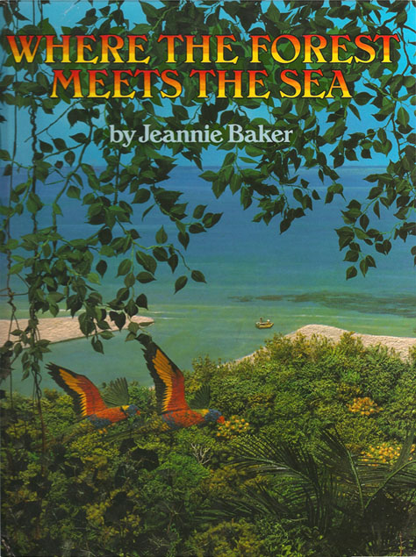  Class Text  Choice Rationale  Where the Forest Meets the Sea by Jeannie Baker is a fascinating picture book that encourages children to consider the impact humans have on the environment. The setting of this thought-provoking story depicts where the Great Barrier Reef meets the Daintree Rainforest in Australia.  Themes  Ancient Civilisations  Around the World  Art and Design  Family, Forests and Rainforests  R.E  Theme: Beliefs and Meaning  Key Question: Does belief in Akhirah (life after death) help Muslims lead better lives?  Religion: Islam  SMSC and PSHE:  RL (Relationships)  Building positive, healthy relationships  D&T  Celebrating Culture and Seasonality  P.E  Striver: Handball | Keeping It Real: A study of futurism  Develop Ideas  - Develop and imaginatively extend ideas from starting points throughout the curriculum.  - Collect information, sketches and resources and present ideas imaginatively in a sketch book.  - Use a range of quality materials to enhance ideas.  - Comment on artworks with a fluent grasp of visual language.  Master Techniques  - Sketch before painting to combine line and colour.  - Create a colour palette based upon colours observed in the natural or built world.  - Use the qualities of watercolour and acrylic paints to create visually interesting pieces.  - Combine colours and tones to enhance the mood.  - Develop a personal style of painting, drawing upon ideas from other artists.  Take inspiration from the greats  Artist Spotlight: Umberto Boccioni  - Give details including own sketches about the style of some notable artists, artisans and designers.  - Show how the work of those studied was influential in both society and to other artists  - Create original pieces that show a range of influences and styles
Science – Biology  Work scientifically  This concept involves learning the methodologies of the discipline of science.  Understand Evolution and Inheritance  This concept involves understanding that organisms come into existence, adapt, change and evolve and become extinct.  - Recognise that living things have changed over time and that fossils provide information about living things that inhabited the Earth millions of years ago.  - Recognise that living things produce offspring of the same kind, but normally offspring vary and are not identical to their parents.  - Identify how animals and plants are adapted to suit their environment in different ways and that adaptation may lead to evolution. |  | Cross Curricular Opportunities  - English: writing surveys/questionnaires (Week 1), reports (Weeks 2 and 5–6), captions (Week 3), a job advert (Week 3), persuasive speech (Week 5), diary entry (Week 5); annotating maps (Weeks 2 and 4).  - Maths: interpreting a line graph (Week 3). • Art & design: artwork (Week 3); exploring the work of L.S. Lowry (Week 3).  - Computing: researching online (Week 3); using a mapping tool (Week 4); creating an app or website (Week 6).  - Design & Technology: learning about architecture and housing design (Weeks 2 and 5).  - History: learning about local history (Weeks 2–4 and 5).  - PSCHE: considering the needs of others (Weeks 1–4); developing community spirit (Week 5).

Focus - Threshold Concepts | Y6 – The Impact of War | Art and Design - Threshold Concepts
History  In this unit, the children will:  - Develop a chronologically secure knowledge and understanding of British, local and world history.  - Develop the appropriate use of historical terms.  - Address and devise historically valid questions about change, cause, similarity, difference and significance.  - Understand how knowledge of the past is constructed from a range of sources.  - Construct informed responses that involve thoughtful selection and organisation of relevant historical information.  - Learn about the WWI and WW2 and their significant impact on Britain today.  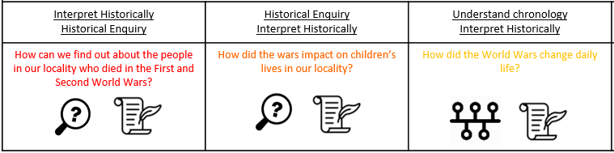  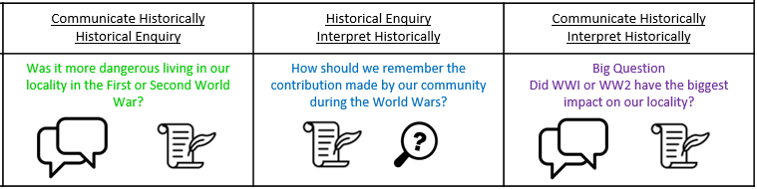 | Enquiry Question:  Did WWI or WW2 have the biggest impact on our locality?  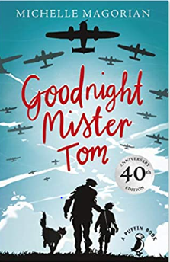  Class Text  Choice Rationale  This book is really a gentle and moving story about the developing relationship of trust and love between Willie and Tom. But it also gives a very clear background picture of life in England during the Second World War, the contrast between life in the country and life in London  Themes  In the book Good Night Mr. Tom, there are many themes that are found throughout the book. These themes include: Friendship, Family, Finding Oneself, Life, Death, Fitting In, Grieving, Motivation, Control, Freedom and Growth  R.E  Theme: Beliefs and Meaning  Key Question: Does belief in Akhirah (life after death) help Muslims lead better lives?  Religion: Islam  SMSC and PSHE:  CM Changing Me  Themes: Life cycles, changing me, my changing body, learning and growing and coping with changes  D&T  Food and Seasonality  P.E  Striver: Outdoor Adventures | Key Concepts:  - That as humans we react emotionally to colour.  - That artists can create immersive environments using colour, light, form and sometimes sound to create a transformative experience for others.  - That we can use colour in a brave and inventive way, trying new colour combinations and exploring the relationship between colour and form.  - That we can test ideas, use our imagination, and share our vision with others by creating 2 and 3 dimensional models.  In this pathway pupils are enabled to explore colour in a very personal and intuitive way.  Recognising pupils growing ability to articulate their thoughts, and understand that we can use art to bring people together through sharing common experiences, such as how our bodies and minds react in certain colourful environments, pupils are empowered to create their own response to simple sculptural challenges.  Medium:  Paper, Card, Paint, Light (coloured filters)  Artists: Olafur Eliasson, Yinka Ilori, Morag Myerscough, Liz West
Science – Biology  Work scientifically  This concept involves learning the methodologies of the discipline of science.  Animals Including Humans  - Describe the changes as humans develop to old age.  - Identify and name the main parts of the human circulatory system, and describe the functions of the heart, blood vessels and blood.  -Recognise the importance of diet, exercise, drugs and lifestyle on the way the human body functions.  - Describe the ways in which nutrients and water are transported within animals, including humans |  | Cross Curricular Opportunities  Art: make wartime-style posters encouraging modern issues, e.g. recycling  Geography: map work  Maths: do sums using old pre-decimal currency and ration coupons  PSHE: equality in the workplace (women working), citizens pulling together for the common good  Writing: Following the Laceby Acres Writing Process (long and short pieces) to create the diary of an evacuee. A non-chronological report (WW1 & WW2). A persuasive argument (rationing).

