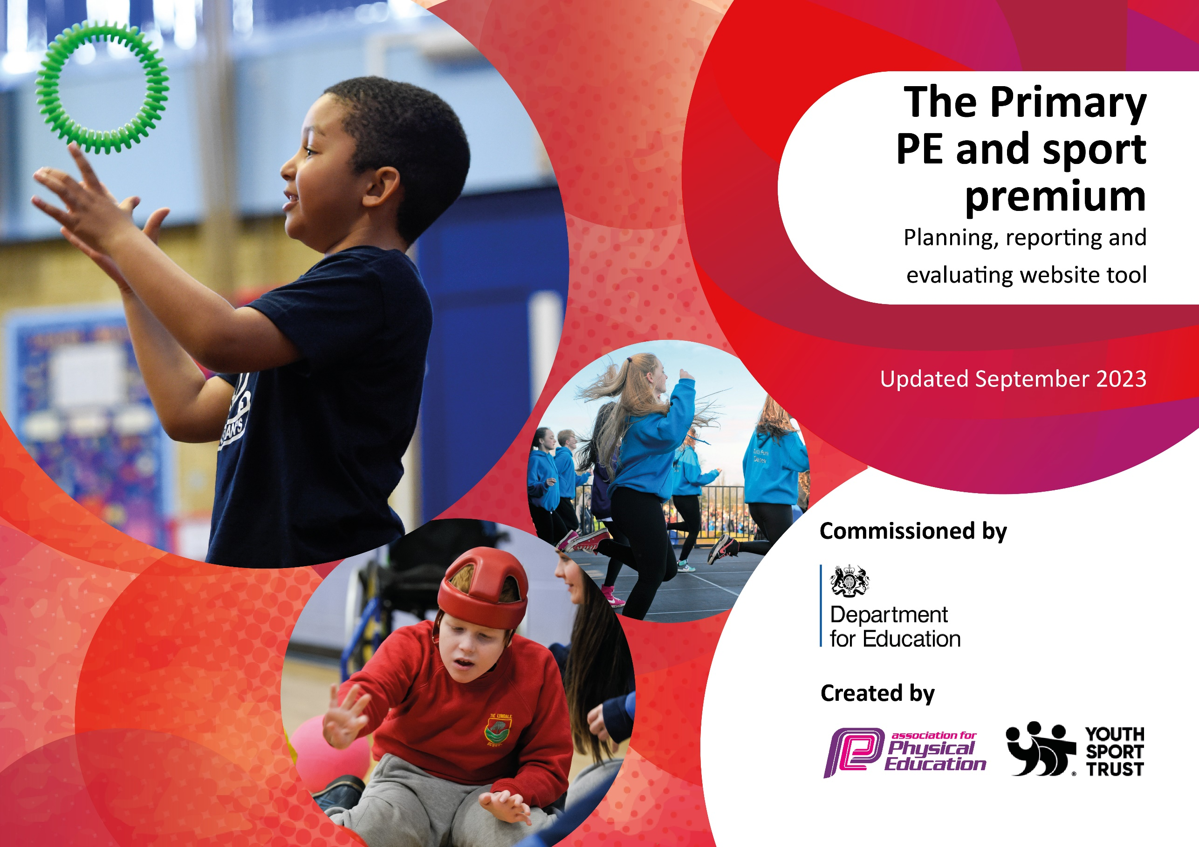

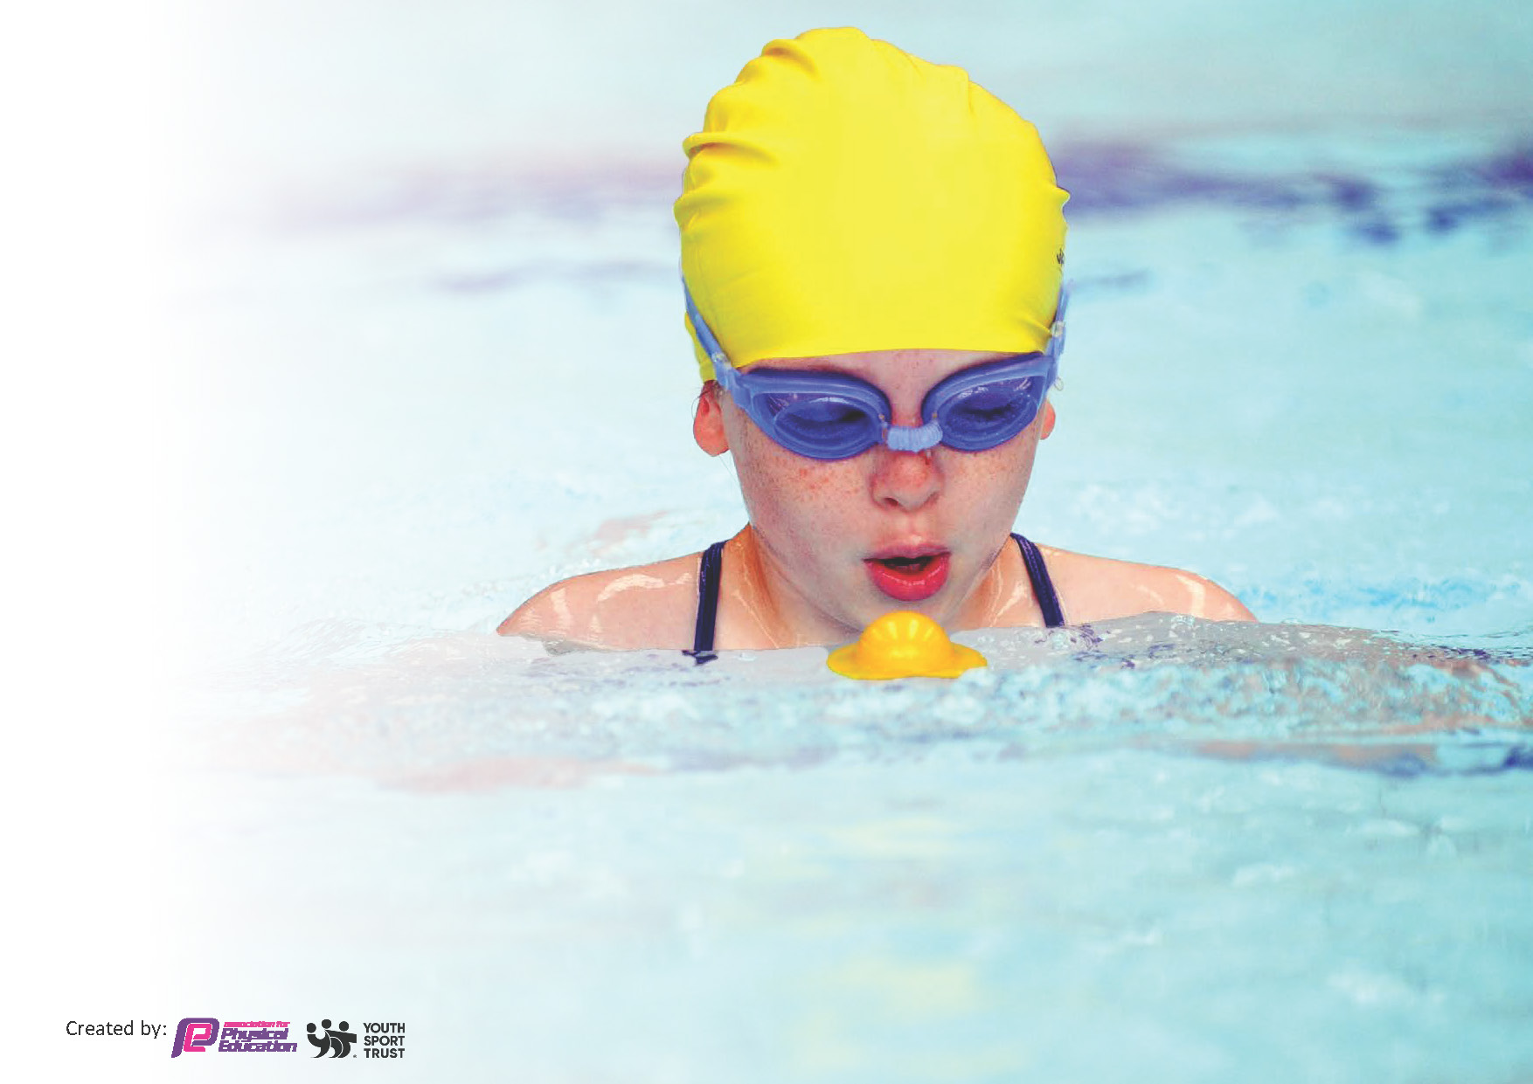
This document has been used to report the swimming results for Year 6 in the school year 2022-2023
by:

Swimming Data
Meeting National Curriculum requirements for swimming and water safety.
Priority should always be given to ensuring that pupils can perform safe self-rescue even if they do not fully meet the first two requirements of the National Curriculum programme of study

Question | Stats: | Further context  Relative to local challenges
What percentage of your current Year 6 cohort can swim competently, confidently and proficiently over a distance of at least 25 metres? | 20% | Use this text box to give further context behind the percentage.  e.g., 30% - we are struggling to get pool space due to our local pool closing so we have had to use a much smaller local school pool. We have had to limit the number of pupils attending swimming lessons during one term which means some pupils have attended fewer swimming lessons than others.
What percentage of your current Year 6 cohort can use a range of strokes effectively [for example, front crawl, backstroke, and breaststroke]? | 27% | Use this text box to give further context behind the percentage.  e.g., Even though your pupils may swim in another year please report on their attainment on leaving primary school at the end of the summer term 2024

What percentage of your current Year 6 cohort are able to perform safe self-rescue in different water-based situations? | 90% | Use this text box to give further context behind the percentage.
If your schools swimming data is below national expectation, you can choose to use the Primary PE and sport premium to provide additional top-up sessions for those pupils that did not meet National Curriculum  requirements after the completion of core lessons. Have you done this? | No
Have you provided CPD to improve the knowledge and confidence of staff to be able to teach swimming and water safety? | No | Professional Swimming Teachers are hired for the delivery of sessions. This is funded outside of the Sports premium.

Signed off by:

Head Teacher: | Sharon Clapson
Governor: | NA
Date: | 25/4/24

