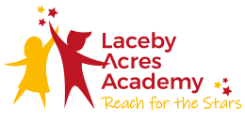
THE GREAT GEOGRAPHY LESSON

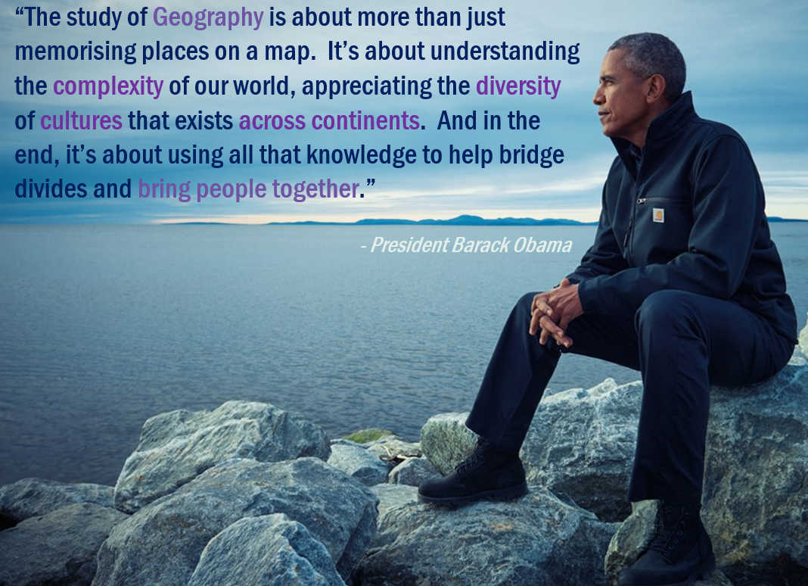

The most recent approach advocated by Margaret Roberts, who gave a lecture during the GA Annual Conference in 2011 suggest that teaching this subject is best done when following the holistic path. It’s an approach which is common sense blend of professional judgments and externally produced lists of standards. Ms Roberts argues that these two approaches work best when combined with each other, rather than solely focused on.

Professional judgement | External list of standards
* years of experience  * flexibility  * ‘common sense’  * ‘best fit’ to the class | * ongoing changes  * open for interpretation  * same across the country (consistency)  * shed light on some lesson aspects otherwise neglected.  * appearance of equal weight

The 3 essential ingredients of an ‘outstanding’ geography lesson (holistic approach) are:

- Geography

- Geographical data – students (especially in primary schools) study the world mainly through the secondary data such as statistics, graphs, maps, texts, quotations from real people. This secondary data which can be found in books, internet, magazines etc is a base for any future generalisations and judgments. Teachers should avoid at all cost referring to hypothetical people / places opting instead for real (and recent / updated) case studies.

- Geographical ideas – geographers make sense of the world through their ideas, concepts, generalisations, models and theories. Therefore, a good lesson should introduce the students to a specific concept (i.e. green energy, migration, development) and theories behind them (i.e. pollution, place of origin, changes in society). Providing students with sound understanding of geographical ideas allows them to generalise, relate facts to one another – simply put, to think geographically. Links to specific vocabulary should be established here.

- Locational contexts – remember that places, regions, countries and continents do not exist in isolation but are all interconnected. It is crucial to keep the studies location in the context of other significant places. Locational knowledge of continents, oceans, countries etc must enable the students to place the newly gained information in the wider context. An approach of zooming out can be used here (TV reporting style) with an application of World maps, globes, google Earth.

- Connecting with students’ minds
As with teaching any other subject planning, the best way to demonstrate progress is to build upon the already existing knowledge (Vygotsky’s Zone of Proximal Development) Initial discussions or ‘cold tasks’ are just some of the ideas as to how it may be possible to ascertain the students’ current capabilities (their knowledge and understanding up to date, opinions and feelings)

Types of ‘light assistance’
- providing the first step in a problem
- Asking a leading question
- Explaining
- Suppling information
- Questioning
- Correcting
- Making the child explain

Ideas for scaffolding (through intervention and dialogue):
- Reducing the number of steps involved in the activity
- Helping learners to risk the next step
- Controlling frustration and risk without creating over dependency on the teacher
- Demonstrating an idealised version
- Whole class / group / paired discussions
- Modelling part of an activity
- Using writing frames to help with structure and sentence starters

- Opportunities to make sense of the newly obtained geographical knowledge.
Every geography lesson must offer students opportunities to make sense of new information through the active construction of knowledge rather than from receiving it (fully formed) from various external sources. It is absolutely crucial to allow all students (possibly with various degrees of freedom) to explore new information for themselves to then relate it to something they already know (or remember through paired / group discussion). It can be argued that geographical information ‘goes through the brain’ and that pupils have time ‘to pass it into and around their consciousness. Since most of us make sense of the world around through the use of language, a good geography lesson should contain meaningful opportunities for discussion, dialogue, sorting data, ranking information, identifying links between concepts, reconstructing information in alternative forms, discursive writing etc.

In conclusion, geography lessons should not be judged looking at their separate elements but instead assessed as a whole. The true goal of an outstanding geography lesson is yes - progress - but not one that can be easily ‘ticked’ on the standards list. In this instance the ‘progress’ must be a clear demonstration of the link between the new geographical knowledge delivered by the teacher and the current subject knowledge already possessed by the pupils.

