

What a good lesson looks like.

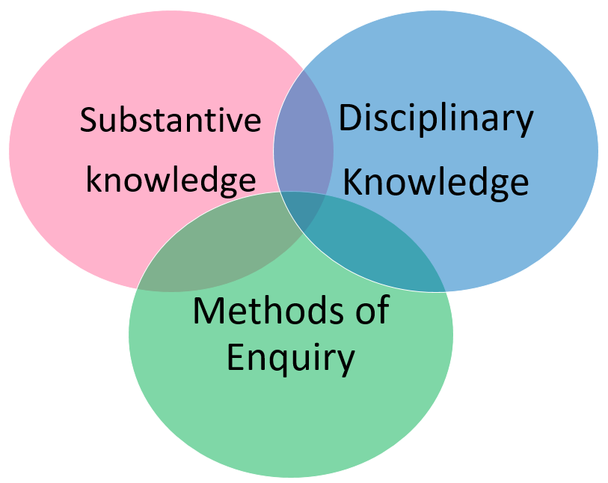

Examples of Excellence

* Carefully considered building blocks of progress.
* Identifying knowledge that is essential to pupils understanding.
* Building pupils substantive knowledge.
* Challenging vocabulary.
* Explicit teaching of concepts
* Assessing pupils knowledge of identified concepts.
* Pupils chronological knowledge.
* Pupils ability to place their learning in context and across subjects.
* Knowledge is regularly revisited.
* Pupils can confidently discuss the periods they had studied.