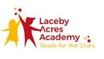
Writing Policy

Planning:
Each half term there should be an overview plan of the extended writing outcome desire for that half term. Our approach for writing planning is to have a clear focused text types/genre as your desired outcome and plan backwards from that starting point. By doing so you can really unpick the key steps the children will need to know and have practiced identifying and using before they are able to write an independent piece of writing for the chosen text type. By planning in this way it will focus each week on the skills needed for each text type.
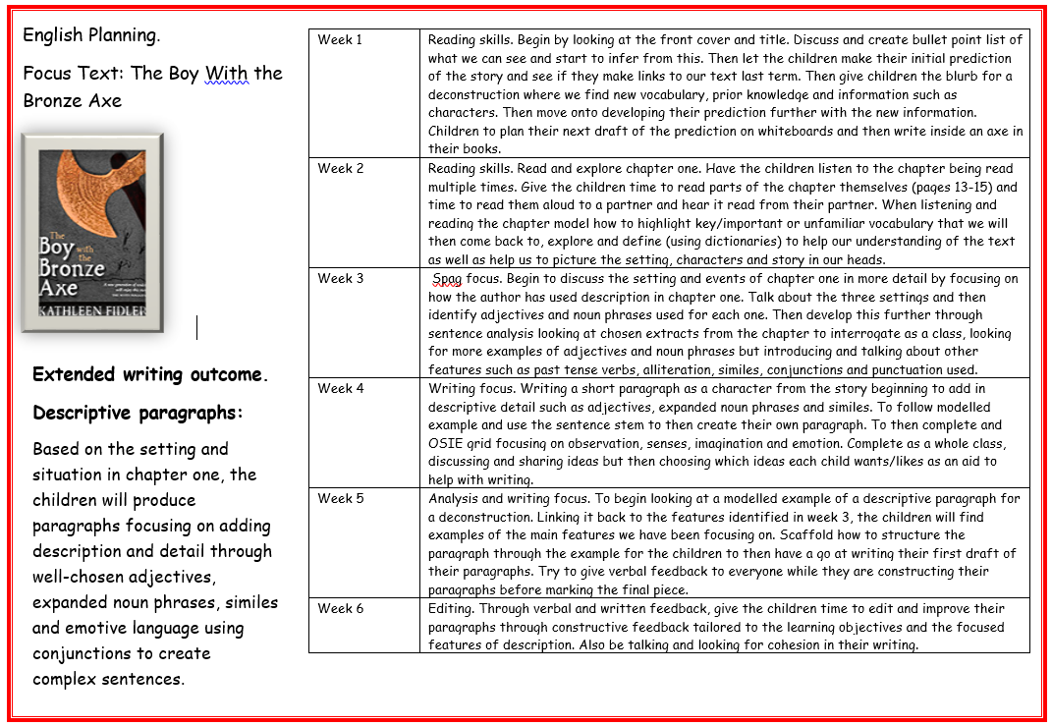
Example.
Model:
Week 1 – Reading skills and understanding of the text/chapter/story being covered and focused on.
Week 2 – Developing those reading skills further and unpicking the text in more detail.
Week 3 – Beginning to think about the SPAG features the children need to identify and know how to use.
Week 4 – Move into a writing focus where the children are completing mini process linked the end writing goal and having time to collect ideas through shared and model sessions.
Week 5 – Start to analyse modelled pieces of work alongside constructing and crafting piece of writing.
Week 6 – Focussing more on the editing of the first draft of writing through constructive in the moment feedback with useful comments relating to the objectives to improve things in their next draft.
Writing:
In each half term it would be ideal if the writing process was split in half (3weeks on skills and 3 weeks on writing and editing). Beginning with reading skills to unpick and understand the text (length of focus to vary for key stages) before using it as a basis for writing. Once the children are aware and understand the events and content of the book/chapter/story they can start to look at the spelling, grammar, punctuation and vocabulary that underpins the text focusing on those skills and features needed for your chosen text type. The reading and skills book will then show a variety of different skills being looked at as the small steps towards the end writing goal. In the writing book you will then move on to interrogating and deconstructing your chosen text type so the children can identify the features and skills they have learnt in previous weeks work before being given time to begin their first draft. Whilst they are writing their first draft is where in the moment feedback and conversations between children and teacher can develop their understanding of how to craft a piece of writing together without it adding to teacher workload and give the children much more useful constructive feedback in which they are being shown how to think about what they are doing through the metacognitive approach. By giving children in the moment feedback, when it comes time to read through every ones first draft you have more of an idea of their own thought process behind their writing and have already begun to have discussions about how they can take their writing forward. A feedback comment then reflecting something they have done well linked to the focus objectives and then some areas to think about in their next draft will minimize the time taken for editing whilst getting more worthwhile critiques of the children’s work, with the children being more included in the crafting process and why they need to make certain changes rather than just being told to.

