Geography Focus – Our Local Area  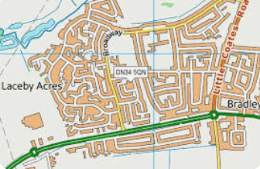  Enquiry Question:What’s it like where we live? | Year 1 – Oi Frog-Kes Gray & Jim Field. | The Curriculum – Threshold Concepts
Geography:  • Identify the significant features (landmarks) of their local area and consider viewpoints in relation to this  • Compare journeys and landscapes and understand near/far, often/ rarely  • Learn about maps, map-making and symbols.  Science-  Biology- Plants  • Identify and name a variety of common plants, including garden plants, wild plants and trees and those classified as deciduous and evergreen.  • Identify and describe the basic structure of a variety of common flowering plants, including roots, stem/trunk, leaves and flowers.  • Observe and describe how seeds and bulbs grow into mature plants.  • Find out and describe how plants need water, light and a suitable temperature to grow and stay healthy. | 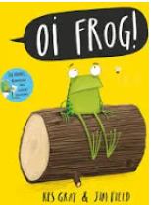  English focus text: Oi Frog.  Extended writing outcomes:  Fact File-  -Research about frogs  -Use research to write factual information  -Present in a fact file  Short writing outcomes:  -To write a poem in the style of our class book ‘Oi Frog’  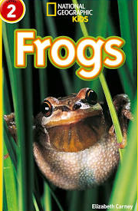  Link Reading:  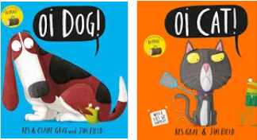  (Non-fiction)  (narrative)  Maths – White Rose  Place Value, Addition and Subtraction and Shape. | P.E: Striver- Games 1  I.C.T: E Safety Using the Internet Safely IT Typing training  RE: Religion: Christianity.  Theme: The Creation Story.  Key Question: Does God want Christians to look after the world?  PSHE: Jigsaw Being Me in My World.  Music: Music Express- Ourselves & Number  MFL: Language Angels- Greetings (E)
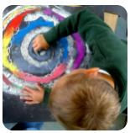
The Curriculum: Access Art

Art and Design: Spirals
Using drawing, collage and mark-making to explore spirals. Introducing sketchbooks.
DT: Structures Freestanding Structures

