History Focus – My Family History.  Enquiry Question:What was life like when our grandparents were children? | Year 1 – Oi Frog-Kes Gray & Jim Field. | The Curriculum – Threshold Concepts
History:  - To be able to describe the similarities and difference between their childhood and their grandparent’s childhood.  - To be able to ask and answer historically valid questions about the life of their grandparents.  - To be able to understand some of the ways in which we can find out about the past.  - To be able to identify different ways information from the past is represented.  - To be able to understand people have different views about the past.  Science- Physics: Seasonal Change.  · Weather can change  · There are lots of different types of weather: Rain, Sun, Cloud, Wind, Snow, etc  · Days are longer and hotter in the summer  · Days are shorter and colder in the winter  · There are four seasons: Spring, Summer, Autumn, Winter | 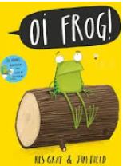  English focus text: Oi Frog.  Extended writing outcomes:  Fact File-  -Research about frogs  -Use research to write factual information  -Present in a fact file  Short writing outcomes:  -To write a poem in the style of our class book ‘Oi Frog’  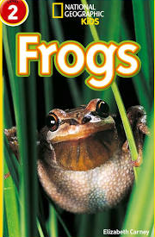  Link Reading:  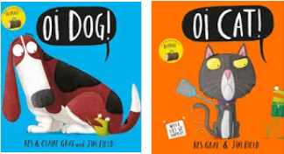  (Non-fiction)  (narrative)  Maths – White Rose  Addition and Subtraction and Shape. | P.E: Striver- Games 1- Invasion games  Throwing and Catching.  I.C.T: E Safety Using the Internet Safely Coding with Tynker.  RE: Religion: Christianity.  Theme: The Christmas Story  Key Question: What gifts might Christians in my town have given Jesus if he had been born here instead of in Bethlehem?  PSHE: Jigsaw: Celebrating Differences.  Music: Music Express- Animals and Weather  MFL: Language Angels: Superheroes.
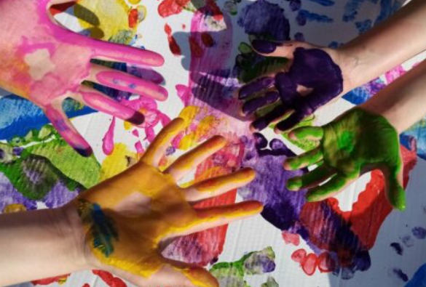
The Curriculum: Access Art

Art and Design: Simple Print Making. Children use their own bodies, then things they collect around them, to create a variety of prints. They use their hands and feet to make prints, and they take rubbings of textures from the environment around them. They make “plates” by making impressions in plasticine, and then by using printing foam.

DT: Structures Freestanding Structures

