Geography Focus – People and their Communities. | 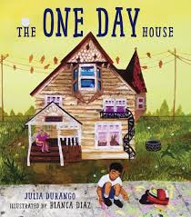  Year 1 – The One Day House. | The Curriculum – Threshold Concepts
Geography:  Place knowledge - Understand geographical similarities and differences through studying the human and physical geography of a small area of the United Kingdom, and of a small area in a contrasting non-European country.  Human and physical geography - use basic geographical vocabulary to refer to: § key physical features, including beach, cliff, coast, forest, hill, mountain, sea, ocean, river, soil, valley, vegetation, season and weather § key human features, including; city, town, village, factory, farm, house, office, port, harbour and shop.  Geographical skills and fieldwork - use aerial photographs and plan perspectives to recognise landmarks and basic human and physical features; devise a simple map; and use and construct basic symbols in a key.  Science- Chemistry: Everyday Materials.  · Distinguish between and object and the material from which it is made.  · Identify and name a variety of everyday materials,  including wood, metal, plastic, glass, water and rock,  · Describe the simple physical properties of a variety of  everyday materials.  · Compare and group together a variety of everyday  materials based on their simple properties. | English focus text: City Shapes  by Diana Murray  Extended writing outcomes:  Re-Write of the story.  Short writing outcomes:  To write a description of the setting.  Sequence the events that take place.  Little Wandle daily spelling words for new GPC’S and weekly sentence dictation for review of Little Wandle GPC’s taught.  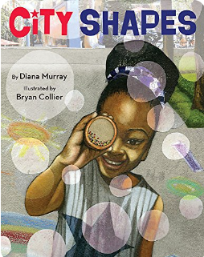  Link Reading:  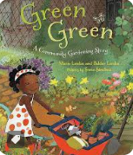  Maths – White Rose  Shape, Place Value and Addition and Subtraction (within 20)  DT: Mechanisms- Sliders and Leavers | P.E: Striver- Dance.  I.C.T: Project Evolve, Privacy & Security and Digital Literacy: Using a computer.  RE: Religion: Christianity.  Theme: Jesus as a friend.  Key Question: Was it always easy for Jesus to show friendship?  PSHE: Jigsaw: Dreams and Goals.  Music: Music Express- Machines and Seasons.  MFL: Language Angels: In my town.
The Curriculum: Access Art

Art and Design: Playful making.

In this pathway children are introduced to what sculpture can be and invited to explore the work of other sculptors whilst taking a playful and inventive approach to making their own sculptures.

