Geography Focus – Our Local Area  Enquiry Question: What’s it like where we live? | Year 1– Beegu | The Curriculum – Threshold Concepts
Geography  Investigate places  - Ask and answer geographical questions about the physical and human characteristics of a landscape  - Explain own views about locations, giving reasons.  - Use maps, atlases, globes and digital/computer mapping to identify countries, continents and oceans.  - To know that some of the continents have significant hot and cold areas.  Investigate patterns  - Understand geographical similarities and differences through studying the human and physical geography of their local area.  Communicate geographically  - Use appropriate geographical vocabulary to communicate key physical and human features.  - Use simple fieldwork and observational skills.  Science  Work Scientifically  - To perform simple tests  - Ask simple questions  - Observe closely, using simple equipment  - Gather and record data  Investigate materials  - Identify and name a variety of common plants.  - Identify and describe the basic structure of a plant.  - Observe and describe how seeds grow and what plants need to survive. | 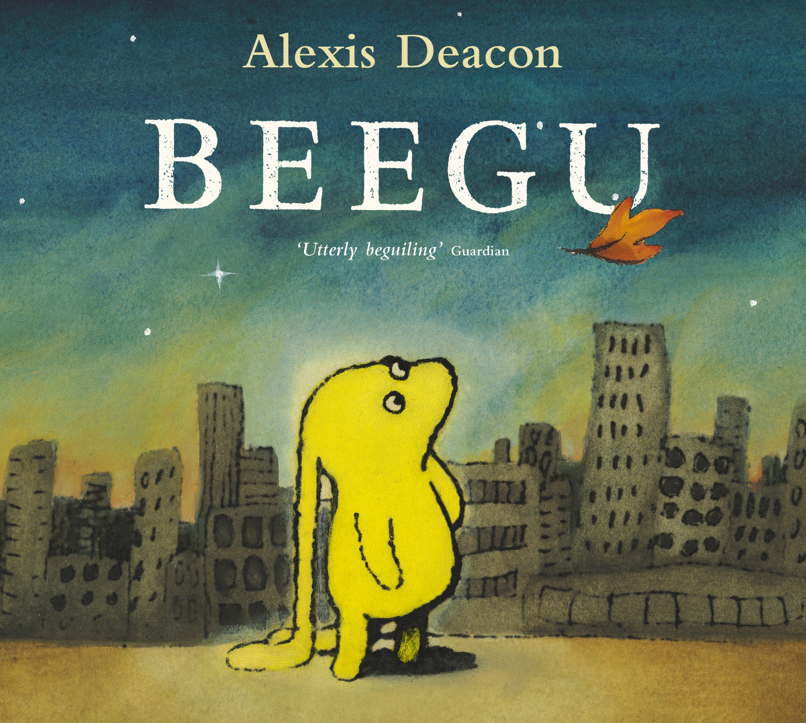  English focus text: Beegu by Alexis Deacon  Extended writing outcomes:  Diary entry by Beegu concentrating on the emotions she has felt up to a particular point in the story.  To write a goodbye letter to Beegu.  Short writing outcomes:  To write a character description for a friend they have made for Beegu.  Link Reading:  Fishing with Grandma – Susan Aingog  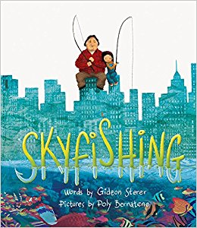  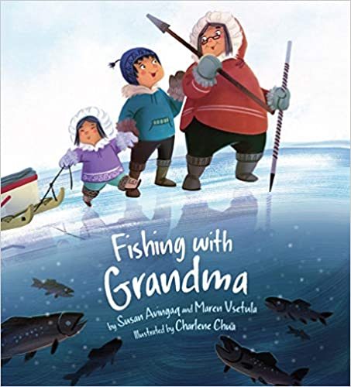  Skyfishing –  Gideon Steer  Maths – White Rose  Place Value  Addition and Subtraction | P.E: Games- key basic games skills with emphasis on spatial awareness when in motion, maintaining balance when in motion and ball skills.  - Use the terms ‘opponent’ and ‘team-mate’  - Use rolling, hitting, running, jumping, catching and kicking skills in combination  - Develop tactics  - Lead others when appropriate  I.C.T: to identify technology  - Explain how these technology examples help us  - Explain technology as something that helps us  - Locate examples of technology in the classroom  RE: Theme: The Creation Story  Concept: God/Creation  Key Question: Does God want Christians to look after the World?  Religion: Christianity  • Present the key teachings and beliefs of a religion.  • Refer to religious figures and holy books to explain answers  PSHE: Jigsaw Being Me In My World.  Music: Music Express.  Musical focus: Exploring sounds  MFL: Greetings
The Curriculum:
Art and Design: Spirals
We are going to use drawing, collage and mark-making to explore spirals. We will be Introducing sketchbooks.
DT: Free standing structures

