History Focus – My Family History  Enquiry Question: What was life like when our grandparents were children? | Year 1– Once there were Giants | The Curriculum – Threshold Concepts
History  Investigate and interpret the past  This concept involves understanding that our understanding of the past comes from an interpretation of the available evidence.  Build an overview of world history  - This concept involves an appreciation of the characteristic features of the past and an understanding that life is different for different sections of society.  Understand chronology  - This concept involves an understanding of how to chart the passing of time and how some aspects of history studied were happening at similar times in different places.  Communicate historically  - This concept involves using historical vocabulary and techniques to convey information about the past.  Science  Work Scientifically  - To perform simple tests  - Ask simple questions  - Observe closely, using simple equipment  - Gather and record data  Understanding the Earth’s movement in Space  - To observe changes across the 4 seasons | 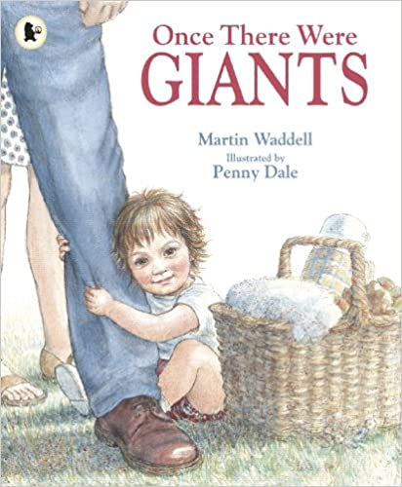  English focus text: Once there were Giants by Martin Wardell  Extended writing outcomes:  Rewrite the story  Short writing outcomes:  To write a character description of the little girl  Link Reading:  The Hello Goodbye Window– Norton Juster  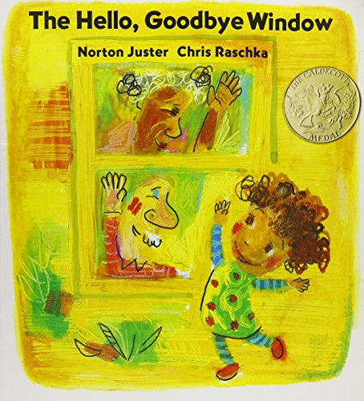  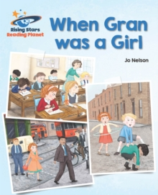  When Gran was a girl – Jo Nelson  Gideon Steer  Maths – White Rose  Addition and Subtraction  Geometry (Shape) | P.E: Dance- Through the theme of colours, pupils select and use a variety of movements to form short dance phrases, building up to a group dance phrase.  - Copy and remember moves and positions  - Move with careful control and coordination  - Link 2 or more actions to perform a sequence  - Choose movements to communicate a mood, feeling or idea.  I.C.T:  - E Safety  - Using the Internet Safely  - Coding with Tynker  RE: Theme: The Christmas Story  Concept: Incarnation  Key Question: What gifts might Christians in my town have given Jesus if he had been born here rather than Bethlehem?  Religion: Christianity  • Present the key teachings and beliefs of a religion.  • Refer to religious figures and holy books to explain answers  PSHE: Jigsaw Celebrating Difference  Music: Music Express.  Musical focus: pitch and exploring sounds  MFL: Greetings
The Curriculum:
Art and Design: Simple Print making
We are going to explore ways to make a print. Use line, shape, colour and texture to explore pattern, sequencing and symmetry.

DT: Free standing structures

