History Focus – The Greatest Explorers  Enquiry Question: Who were the greatest explorers? | Year 1– Tom Crean’s Rabbit | The Curriculum – Threshold Concepts
History  Investigate and interpret the past.  This concept involves understanding that our understanding of the past comes from an interpretation of the available evidence.  Build an overview of world history.  - This concept involves an appreciation of the characteristic features of the past and an understanding that life is different for different sections of society.  - Describe significant people from the past such as: Ibn Battuta, Captain Cook, Roald Amundsen, Captain Robert Falcon Scott and Sunita Williams.  Understand chronology.  - This concept involves an understanding of how to chart the passing of time and how some aspects of history studied were happening at similar times in different places.  Communicate historically.  - This concept involves using historical vocabulary and techniques to convey information about the past.  Science  Work Scientifically  - To perform simple tests  - Ask simple questions  - Observe closely, using simple equipment  - Gather and record data  Understanding the Earth’s movement in Space  - To observe changes across the 4 seasons | 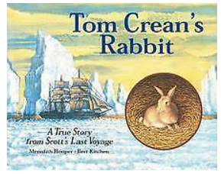  English focus text: Tom Crean’s Rabbit by Meredith Hooper  Short writing outcomes:  Diary writing from sailor’s point of view  Letter to Tom Crean  Procedural writing – what to pack to go exploring  Link Reading:  Journey– Aaron Becker  The Boy Who Sailed The World- Julia Green.  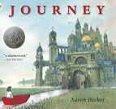  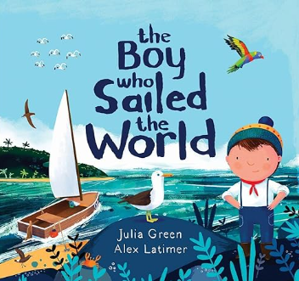  Maths – White Rose  Addition and Subtraction  Place value to 50  Measurement- length and height, mass and volume | P.E: Games 4- Invasion Games  Kicking and Controlling  I.C.T:  IT bug Hunters  Finding, saving, organising, sending and presenting  RE: Theme: Easter – Palm Sunday  Concept: Salvation  Key Question: Why was Jesus welcomed like a King or celebrity by the crowds on Palm Sunday?  Religion: Christianity  • Present the key teachings and beliefs of a religion.  • Refer to religious figures and holy books to explain answers  PSHE: Jigsaw Healthy Me  Music: Music Express:  Our School  Pattern  MFL: Language Angels: Seasons.
The Curriculum:

Art and Design: Exploring watercolour
We are going to enjoy a freeing exploration of watercolour, building our understanding of the properties of the medium, and opening our minds as to how imagery can be created.

DT: Free standing structures- Making a moving story.

