Geography Focus-Threshold concepts | Year 2- Seasons | Art and Design – Threshold Concepts
Geography  Investigate patterns-  - Identify seasonal and daily weather patterns in the United Kingdom and the location of hot and cold areas of the world in relation to the Equator and the North and South Poles.  Communicate geographically-  - Use compass directions (north, south, east and west) and locational language (e.g. near and far).  Science | 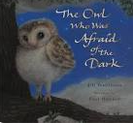  English Focus.  English focus text: The Owl who was afraid of the dark- Jill Tomlinson  Extended writing outcomes:  -Creative writing. Creating a narrative using the structure of the story as a guide. Children to change the main character, the setting and the events that follow the main character falling/going through something.  Shorter writing outcomes:  -Instructions of how to make a moving story book  -Weather report  -Advert advertising the new book  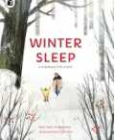  Supporting Texts | Artist Spotlight: Georgia O’Keeffe  Art Period: 1920’s  Art Style: Modernism  To develop ideas:  • Respond to ideas and starting points.  • Explore ideas and collect visual information.  • Explore different methods and materials as  ideas develop.  To master techniques:  Draw lines of different sizes and thickness.  Colour (own work) neatly following the lines.  Show pattern and texture by adding dots and lines. Show different tones by using coloured pencils.  Take inspiration from the greats:  • Describe the work of notable artists,  artisans and designers.  • Use some of the ideas of artists studied to  create pieces.  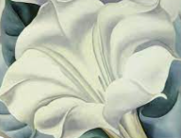  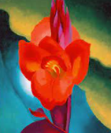
Curriculum coverage:
DT: Mechnanisms- Making books with moving parts
PSHE: Being me in my world. Jigsaw.
RE:
Music: Charanga.
I.C.T: Internet safety
P.E: Gymnastics 1. Striver.

