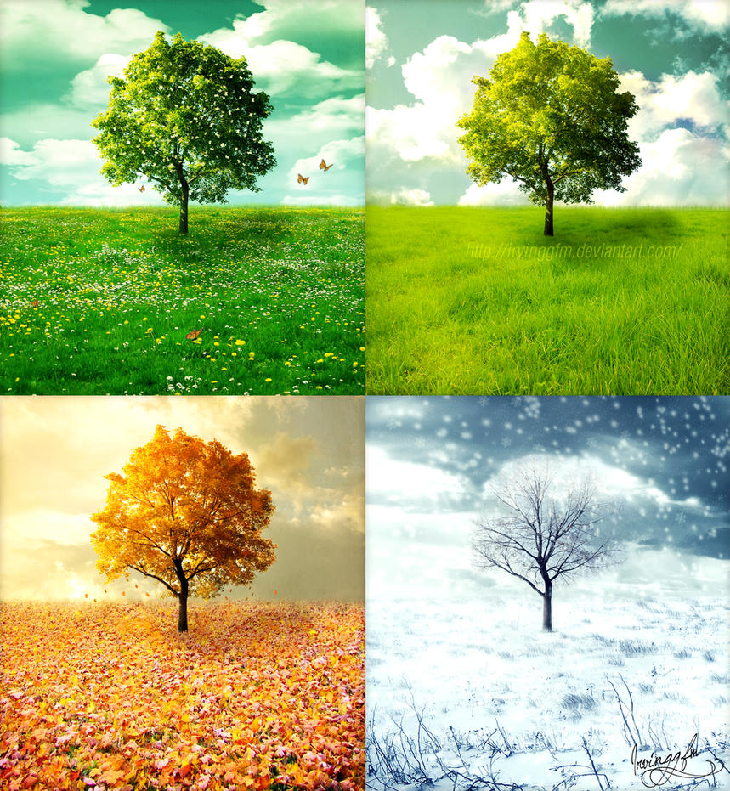  Geography Focus –Weather and Seasons  Enquiry Question: What are seasons? | Year 2 – The Owl Who Was Afraid of the Dark. | The Curriculum – Threshold Concepts
Geography:  • develop locational and place knowledge about their locality, and the UK as a whole  • understand basic subject-specific vocabulary relating to physical geography  • begin to use geographical skills, including first-hand observation, to enhance their locational awareness  • identify seasonal and daily weather patterns in the UK  • use simple fieldwork and observational skills in their school, its grounds and surroundings  • use and construct basic symbols in a key.  Science  Chemistry- Uses of Everyday Materials  - Identify and compare the suitability of a variety of everyday materials, including wood, metal, plastic, glass, brick, rock, paper and cardboard for particular uses.  - Find out how shapes of solid objects made from some materials can be changed by squashing, bending, twisting and stretching. | 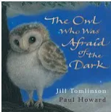  English focus text: Jill Tomlinson.  Extended writing outcomes:  Creative writing. Creating a narrative using the structure of the story as a guide. Children to change the main character, the setting and the events that follow the main character falling/going through something.  Short writing outcomes:  -Instructions of how to make a moving story book  -Weather report  -Advert advertising the new book  Link Reading:  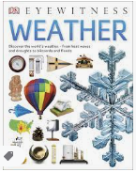  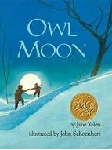  (Non-fiction)  (narrative)  Maths – White Rose  Place Value Addition and Subtraction  Shape | P.E: Hockey  • Maintain possession of a ball (with, e.g. feet, a hockey stick or hands).  • Follow the rules of the game and play fairly.  • Pass to team mates at appropriate times.  • Lead others and act as a respectful team member  I.C.T: Information Technology around us.  To recognise the uses and features of information technology  RE: Religion: Christianity.  Theme: What did Jesus teach?  Key Question: Is it possible to be kind to everyone all of the time?  PSHE: Jigsaw Being Me In My World.  Music: Music Express.  Ourselves- the children discover ways to use their voices to describe feelings and moods. They create and notate vocal sounds, building to a performance.  MFL: Language Angels- I Can (E)
The Curriculum: Access Art
Art and Design: Explore and draw-
In this pathway children are introduced to the idea that artists can be collectors: they go out into the world, look at things in new ways, and bring things back to the studio to inspire their art.

DT: Mechanisms, Wheels and Axles.
.

