  Geography Focus –Weather and Seasons  Enquiry Question: What are seasons? | Year 2 – The Owl Who Was Afraid of the Dark. | The Curriculum – Threshold Concepts
Geography:  • develop locational and place knowledge about their locality, and the UK as a whole  • understand basic subject-specific vocabulary relating to physical geography  • begin to use geographical skills, including first-hand observation, to enhance their locational awareness  • identify seasonal and daily weather patterns in the UK  • use simple fieldwork and observational skills in their school, its grounds and surroundings          • use and construct basic symbols in a key.    Science  Chemistry- Uses of Everyday Materials  - Identify and compare the suitability of a variety of everyday materials, including wood, metal, plastic, glass, brick, rock, paper and cardboard for particular uses.  - Find out how shapes of solid objects made from some materials can be changed by squashing, bending, twisting and stretching.           | 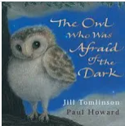  English focus text: Jill Tomlinson.  Extended writing outcomes:  To retell the story of an animal that has a phobia of something within its nature naturally, using ‘The Owl Who is Afraid of the Dark’ as a stimulus.  Link Reading:  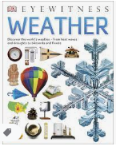  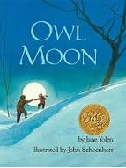  (Non-fiction)  (narrative)  Maths – White Rose  Place Value  Addition and Subtraction  Shape | P.E: Invasion Games – throwing and catching  Pupils will explore kicking skills; underarm and overarm throwing; sending and receiving a ball using a tennis racket and a range of striking and gathering skills. They will have the opportunity to apply striking and gathering skills into small sided games.  I.C.T:  Digital Literacy Health, wellbeing and lifestyle  Self-image and identity  Privacy and security  RE: Religion: Christianity.  Key Question: What is the good news that Christians say Jesus brings? Part 1  In this unit, pupils will learn about the concept of ‘Gospel’ and the good news of forgiveness, peace and love that Christians believe Jesus brings.  PSHE: Jigsaw Being Me In My World.  Music: Music Express.  Out and about  Ourselves- the children discover ways to use their voices to describe feelings and moods. They create and notate vocal sounds, building to a performance.  MFL: Language Angels- Los Saludos
The Curriculum: Access Art
Art and Design: Explore and draw-
In this pathway children are introduced to the idea that artists can be collectors: they go out into the world, look at things in new ways, and bring things back to the studio to inspire their art.

DT: Mechanisms, Wheels and Axles.
.

