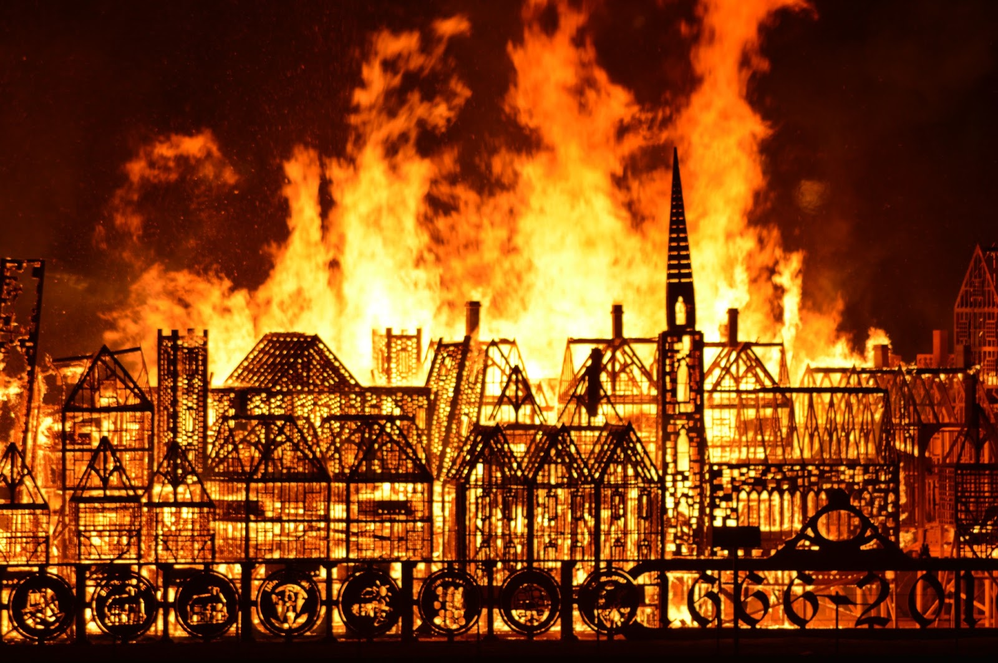  History Focus – Bonfire Night and The Great Fire of London.  Enquiry Question: Should we still celebrate Bonfire Night? Did the Great Fire make London a better or worse place? | Year 2 – Vlad and the Great Fire of London. | The Curriculum – Threshold Concepts
History:  - Develop an awareness of the past, using common words and phrases relating to the passing of time  - Choose and use parts of stories and other sources that they know and understand key features of events  - Understand some of the ways in which we find out about the past  - Identify different ways in which it is represented  - Use a wide vocabulary of everyday historical terms  - Know where events they study fit within a chronological framework.  Science  Biology- Plants  • Identify and name a variety of common plants, including garden plants, wild plants and trees and those classified as deciduous and evergreen.  • Identify and describe the basic structure of a variety of common flowering plants, including roots, stem/trunk, leaves and flowers.  • Observe and describe how seeds and bulbs grow into mature plants.  • Find out and describe how plants need water, light and a suitable temperature to grow and stay healthy. | English focus test:  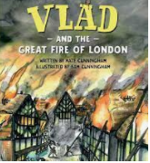  Extended writing outcomes:  - Non chronological report linked to the Great Fire of London.  Link Reading:  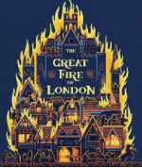  (Non-fiction)  (narrative)  Maths – White Rose  Place Value, Addition and Subtraction  Shape. | P.E: Invasion ball games.  I.C.T: Computer science - Scratch Jnr  RE: Religion: Christianity  Theme: Christmas- Jesus as a gift from God.  Key Question: Why do Christians believe God gave Jesus to the world?  PSHE: Jigsaw: Celebrating Difference.  Music: Music Express. Xylophone  MFL: Language Angels- Mini Beasts
The Curriculum: Access Art

Art and Design: Exploring the world through mono print-

This pathway aims to encourage children to explore the world around them through monoprint. How can we use line, mark, shape and colour to make imagery informed by our own perception of the world?

DT: Mechanisms, Wheels and Axles.

