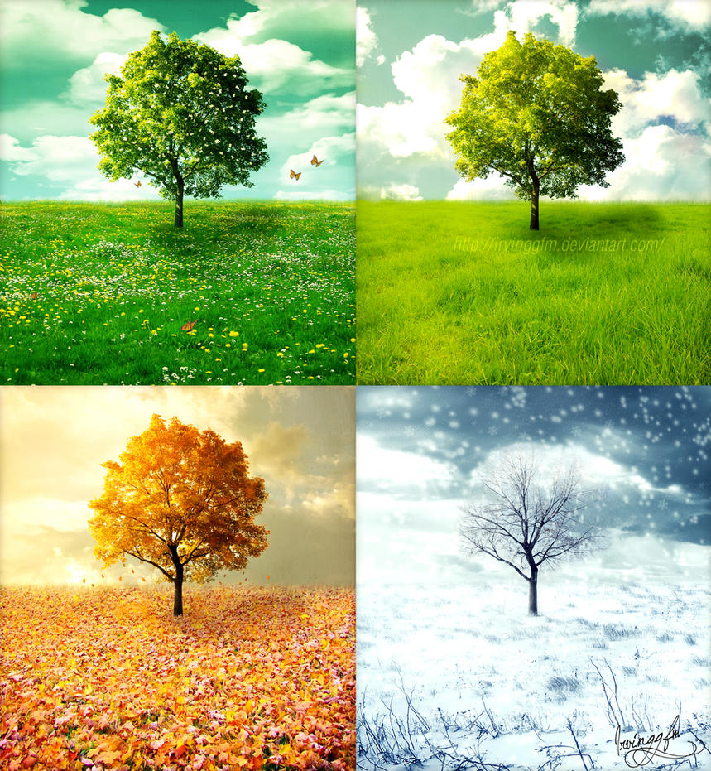  Geography Focus – Weather and Seasons  Enquiry Question: What are seasons? | Year 2 – The Magical Yet. | The Curriculum – Threshold Concepts
Geography:  The children will develop locational and place knowledge about their locality, and the UK as a whole.  Strengthen their understanding of basic subject-specific vocabulary relating to physical geography.  The Children will begin to use geographical skills, including first-hand observation, to enhance their locational awareness  Identify seasonal and daily weather patterns in the UK.  Develop and use simple fieldwork and observational skills in their school, its grounds and surroundings  Science  Chemistry- Uses of Everyday Materials  The children will Identify and compare the suitability of a variety of everyday materials, including wood, metal, plastic, glass, brick, rock, paper and cardboard for particular uses.  Find out how shapes of solid objects made from some materials can be changed by squashing, bending, twisting and stretching. | 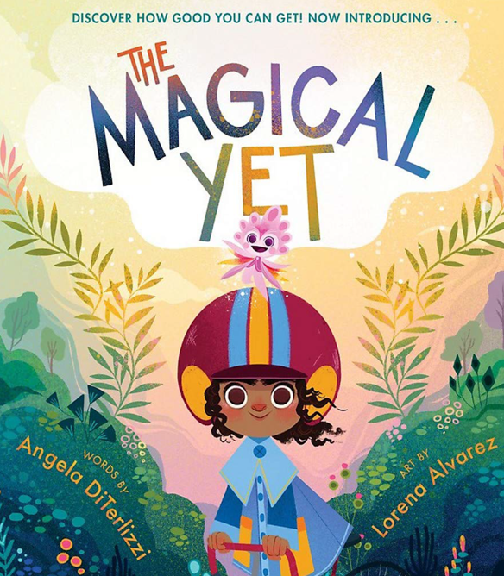  English focus text: The Magical Yet, Angela Diterlizzi  The Magical Yet is a book that teaches us that we have a magical yet inside of us helping us persevere and achieve the things we can’t do yet.  Extended writing outcomes: Journal This scheme of work is designed to introduce students to the fundamental concepts of building sentences. Through engaging and interactive activities, students will progressively learn about the components that make up sentences and develop the skills to construct their own meaningful sentences. The scheme focuses on specific aspects of sentence construction  Link Reading:  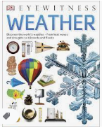  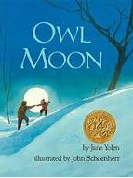  (Non-fiction)  (narrative)  Maths – White Rose  Place Value Addition and Subtraction  Shape | P.E: Gymnastics : Within this unit, pupils will create basic, low and medium level shapes with linking, mirroring and balances. They will also have the opportunity to explore jumping from apparatus. Prior learning Builds on balances, shapes, rolls and routines.  I.C.T: Information Technology around us.  To recognise the uses and features of information technology  RE: Religion: Christianity.  Theme: What did Jesus teach?  Key Question: Is it possible to be kind to everyone all of the time?  PSHE: Jigsaw Being Me In My World.  Music: Music Express.  Ourselves- the children discover ways to use their voices to describe feelings and moods. They create and notate vocal sounds, building to a performance.  MFL: Language Angels- Minibeasts (MO)
The Curriculum: Access Art
Art and Design: Explore and draw-
In this pathway children are introduced to the idea that artists can be collectors: they go out into the world, look at things in new ways, and bring things back to the studio to inspire their art.

DT: Mechanisms, Wheels and Axles.

