History- Holidays | Year 2- Holidays | Art and Design – Threshold Concepts
History – How have holidays changed over time?  Milestones-  • Learn about changes within living memory  • Understand historical concepts such as continuity and change, similarity and difference  • Ask historically valid questions  • Identify similarities and differences between ways of life in different periods  • Ask and answer questions  • Understand some of the ways in which we find out about the past  • Identify different ways in which the past is represented  • Use a wide range of everyday historical terms  • Use parts of stories and other sources to show they know and understand key features of events  • Use sources to show they know and understand the past  • Suggest reasons why changes took place.  Science  Animals including Humans.  . Notice that animals, including humans, have offspring which grow into adults.  • Find out about and describe the basic needs of animals, including humans, for survival (water, food and air).  • Describe the importance for humans of exercise, eating the right amounts of different types of food, and hygiene.  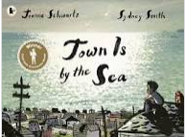  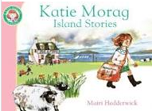  Linked texts:  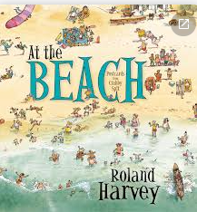 | English Focus.  English focus text: Persuasive Holiday Leaflet.  Extended writing outcomes:  To use holiday leaflets collected from home to create our own persuasive holiday leaflet using our Year 2 class book ‘At the Beach’ for added inspiration.  Shorter writing outcomes:  To write a personal recount of a family holiday-  Using expanded noun phrases and adverbs for description.  Using conjunctions to expand sentences.  To write instructions of how to make a sandcastle-  Using imperative verbs and adverbs to structure time.  Supporting Texts | Pathway: Stick Transformation Project.  Disciplines: Making, Drawing and Sketchbooks.  Medium: Twigs, Construction Materials, Paper, Wool, Drawing Materials  Key Concepts:  - That artists use their creativity to look at the world in new ways, and use their hands to transform materials into new things.  - That making art can be playful and fun. That we can create things for other people to enjoy/use.  - That we can use our imagination to help us shape the world.  Take inspiration from the greats: Chris Kenny  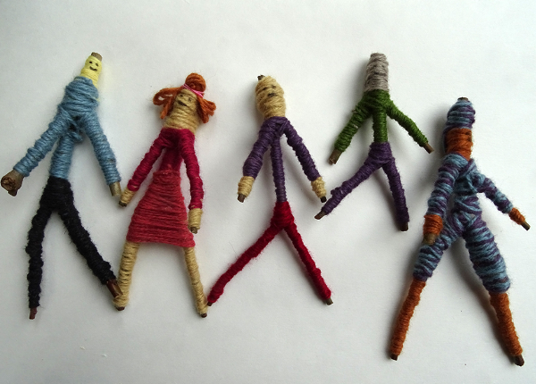
Curriculum coverage:
DT: Textiles-Templates and Joining Techniques.
PSHE: Jigsaw- Changing me.
RE: Islam. Community and belonging.
Key Question: Does going to a Mosque give Muslims a sense of belonging?
Music: Charanga- Reflect, Rewind and Replay.
I.C.T:
P.E: Striver- Games 4 Hockey and Basketball.

