Geography Focus – Journeys.  Enquiry Question: Where does our food come from? | Year 2 – Cloudy with a chance of meatballs. | The Curriculum – Threshold Concepts
Geography:  • Understand geographical similarities and differences through studying the human geography of their local shops, and physical geography through studying nearby food growing or production.  • Use locational and directional language (e.g. near and far) to describe the location of features and routes on a map.  • Name, locate and identify characteristics of the four countries and capital cities of the UK, and its surrounding seas.  • Use world maps, atlases and globes to identify the UK and its countries, as well as the countries, continents and oceans studied at this key stage.  Science  Living things and their habitats.  • Explore and compare the differences between things that are living, that are dead and that have never been alive.  • Identify that most living things live in habitats to which they are suited and describe how different habitats provide for the basic needs of different kinds of animals and plants and how they depend on each other.  • Identify and name a variety of plants and animals in their habitats, including micro-habitats.  • Describe how animals obtain their food from plants and other animals, using the idea of a simple food chain, and identify and name different sources of food. | English focus test:  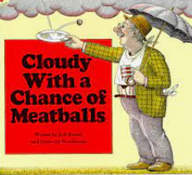  Extended writing outcomes:  - Writing instructions of food preparation  - Recount from personal experience of making their own food.  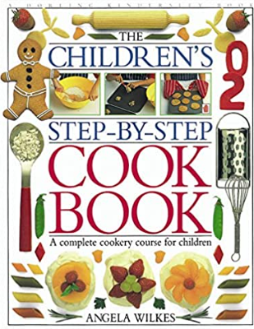  Link Reading:  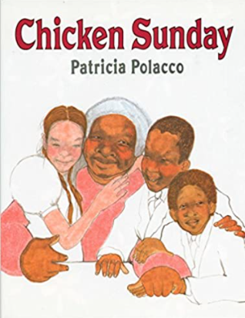  (Non-fiction)  (narrative)  Maths – White Rose  Shape, money, multiplication and division, length and height, mass, capacity and temperature. | P.E: Gymnastics.  I.C.T: Digital literacy- Using a computer.  RE: Religion: Judaism.  Theme: Passover  Key Question: How important is it for Jewish people to do what God asks them to do?  PSHE: Jigsaw: Dreams and Goals.  Music: Music Express.  MFL: Language Angels.
The Curriculum: Access Art

Art and Design: Be an Architect.

This pathway aims to introduce children to the idea that architects design and make buildings, and to give pupils the opportunity to explore architecture around them, and to create their own architectural models.
DT: Food- Preparing fruits and vegetables.

