 | Year 2
History Focus – Our Local Heroes.  Enquiry Question: Who are our Local Heroes?  • Use common words and phrases relating to the passing of time  • Know where the people they study fit within a chronological framework  • Ask and answer questions  • Study significant historical people and places in their own locality  • Understand some of the ways in which we find out about the past and identify different ways in which it is represented  • Choose parts of sources to show that they know and understand key features of events  • Use a wide vocabulary of everyday historical terms.  Science  Living things and their habitats.  • Explore and compare the differences between things that are living, that are dead and that have never been alive.  • Identify that most living things live in habitats to which they are suited and describe how different habitats provide for the basic needs of different kinds of animals and plants and how they depend on each other.  • Identify and name a variety of plants and animals in their habitats, including micro-habitats.  • Describe how animals obtain their food from plants and other animals, using the idea of a simple food chain, and identify and name different sources of food.           | English focus test: Meerkat Mail.  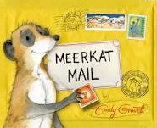  Extended writing outcomes:  Non-Chronological Report:  Write a Non-Chronological Report using a single topic of the Kalahari Desert.  To include relevant information of the chosen location with a focus on habitats in a well-presented report.  The report will use headings, sub-headings and paragraphs for easy reading and order of text.  Post card:  Write an informal letter in the style of the text from the perspective of the main character.  Link Reading:  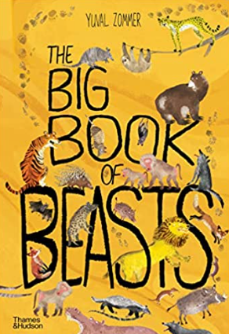  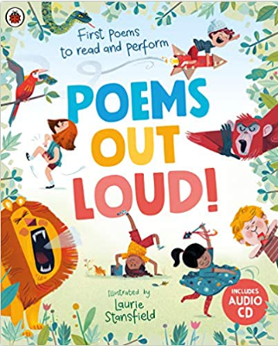  (Non-fiction)  (Poetry)  Maths – White Rose  - Multiplication and Division  - Length and Height  - Mass, Capacity and Temperature. | The Curriculum – Threshold Concepts  P.E: Gymnastics.  I.C.T: Information Technology- word processing and Presentations.  RE: Religion: Christianity.  Theme: Easter - Resurrection  Key Question: Why does Easter matter to Christians?  PSHE: Jigsaw: Healthy Me.  Music: Music Express: Story time.  Music Express: Seasons.  MFL (Spanish): Language Angels: Fruit.
The Curriculum: Access Art

Art and Design: Expressive painting.

In this pathway children are introduced to the idea that they can use paint in an intuitive and exploratory way.

DT: Food- Preparing fruits and vegetables.

Designing, making and evaluating a fruit snack for a class picnic.

