History Focus – Our Local Heroes.  Enquiry Question: Who are our Local Heroes. | Year 2 – Meerkat Mail. | The Curriculum – Threshold Concepts
History:  • Use common words and phrases relating to the passing of time  • Know where the people they study fit within a chronological framework  • Ask and answer questions  • Study significant historical people and places in their own locality  • Understand some of the ways in which we find out about the past and identify different ways in which it is represented  • Choose parts of sources to show that they know and understand key features of events  • Use a wide vocabulary of everyday historical terms.  Science  Living things and their habitats.  • Explore and compare the differences between things that are living, that are dead and that have never been alive.  • Identify that most living things live in habitats to which they are suited and describe how different habitats provide for the basic needs of different kinds of animals and plants and how they depend on each other.  • Identify and name a variety of plants and animals in their habitats, including micro-habitats.  • Describe how animals obtain their food from plants and other animals, using the idea of a simple food chain, and identify and name different sources of food. | English focus test:  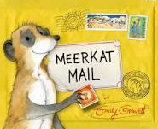  Extended writing outcomes:  Using Pie Corbett’s Talk for Writing sequence the children will produce their own mini-leaflet or newspaper report with a focus of the Year 2 Class book ‘Meerkat Mail.’  Link Reading:  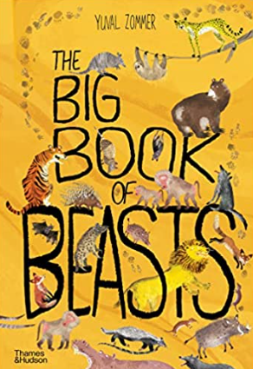  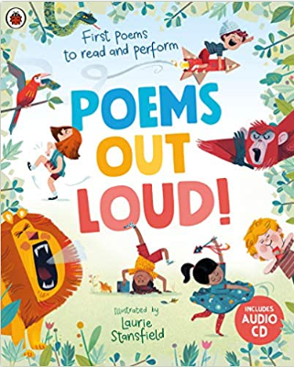  (Non-fiction)  (Poetry)  Maths – White Rose  multiplication and division, length and height, mass, capacity and temperature. | P.E: Hockey.  I.C.T: Information Technology- word processing and Presentations.  RE: Religion: Christianity.  Theme: Easter - Resurrection  Key Question: How important is it to Christians that Jesus came back to life after his crucifixion?  PSHE: Jigsaw: Healthy Me.  Music: Music Express.  MFL: Language Angels.
The Curriculum: Access Art

Art and Design: Expressive painting.

In this pathway children are introduced to the idea that they can use paint in an intuitive and exploratory way.

DT: Food- Preparing fruits and vegetables.

