Geography Focus- Our Wonderful World.  Enquiry Question: What are the wonders of our world? | Year 2 – The Day the Crayons Quit. | The Curriculum – Threshold Concepts
Geography:  • Name, locate and identify characteristics of the seven continents and oceans.  • Use world maps, atlases and globes.  • Understand geographical similarities and differences when studying both human and physical geography.  • Identify the locations of hot and cold areas around the world.  • Use basic vocabulary to refer to physical and human features.  • Develop knowledge about the world.  Science  Animals including Humans.  . Notice that animals, including humans, have offspring which grow into adults.  • Find out about and describe the basic needs of animals, including humans, for survival (water, food and air).  • Describe the importance for humans of exercise, eating the right amounts of different types of food, and hygiene. | English focus test:  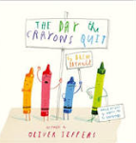  Extended writing outcomes:  To produce a persuasive letter addressed to the children in a year 2 classroom from the perspective of a piece of stationary that the children do not use/treat with respect.  Link Reading:  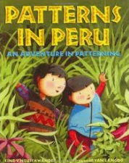  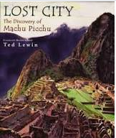  Maths – White Rose  Fractions, Time, Statistics and Position and Direction. | P.E: Striver- Tag Rugby  I.C.T: Taking and using photos.  RE: Religion: Judaism  Theme- The Covenant  Key Question: How special is the relationship Jews have with God?  PSHE: Jigsaw: Relationships.  Music: Music Express. Weather and Pattern.  MFL: Language Angels. Las Estaciones (The Seasons)
The Curriculum: Access Art

Pathway- Stick Transformation Project

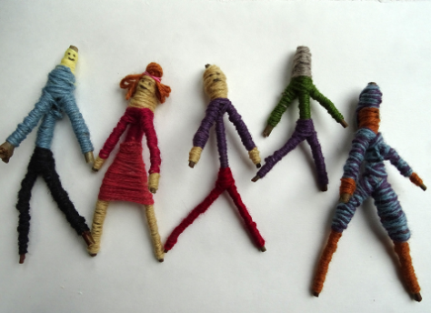
In this pathway children are enabled to use their imagination and transform a familiar object (a stick) into new forms.

DT: Textiles. Templates and Joining Techniques.

