History Focus- Holidays.  Enquiry Question: How have Holidays changed over time? | Year 2 – The Day the Crayons Quit. | The Curriculum – Threshold Concepts
History:  • Learn about changes within living memory.  • Understand historical concepts such as continuity and change, similarity and difference.  • Ask historically valid questions.  • Identify similarities and differences between ways of life in different periods.  • Ask and answer questions.  • Understand some of the ways in which we find out about the past.  • Identify different ways in which the past is represented.  • Use a wide range of everyday historical terms.  • Use parts of stories and other sources to show they know and understand key features of events.  • Use sources to show they know and understand the past.  • Suggest reasons why changes took place.  Science  Animals including Humans.  . Notice that animals, including humans, have offspring which grow into adults.  • Find out about and describe the basic needs of animals, including humans, for survival (water, food and air).  • Describe the importance for humans of exercise, eating the right amounts of different types of food, and hygiene.  Biology- Plants  • Identify and name a variety of common plants, including garden plants, wild plants and trees and those classified as deciduous and evergreen.  • Identify and describe the basic structure of a variety of common flowering plants, including roots, stem/trunk, leaves and flowers.  • Observe and describe how seeds and bulbs grow into mature plants.  • Find out and describe how plants need water, light and a suitable temperature to grow and stay healthy. | English focus test:  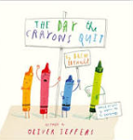  Extended writing outcomes:  To produce a persuasive letter addressed to the children in a year 2 classroom from the perspective of a piece of stationary that the children do not use/treat with respect.  Link Reading:  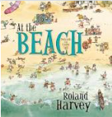  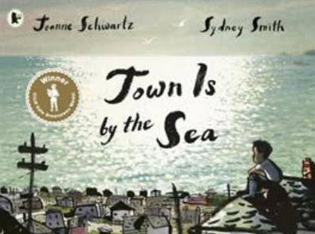  Maths – White Rose  Statistics and Position and Direction. | P.E: Striver- Tag Rugby  I.C.T: Computer Science: Scratch Jnr- Introduction and fundamentals.  RE: Religion: Islam  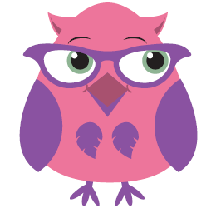  Theme- Community and Belonging.  Key Question: Does going to a Mosque give Muslims a sense of belonging?  PSHE: Jigsaw: Changing me.  Music: Music Express. Water and Travel.  MFL: Language Angels. Ancient Britain.  The Curriculum: Access Art  Pathway- Music and Art.  In this pathway children are introduced to the idea that artists often work in partnership and are often inspired by other art forms – in this case music and the visual arts. Children explore how other artists have used sound to inspire their artwork, and then go on to experiment with how they can use their mark making skills to both be influenced by, and to capture, the expression in music. Children then explore making skills to collage or make inventive instruments, creating a class “orchestra”.  DT: Textiles. Templates and Joining Techniques.

