History Focus – Threshold Concepts | Year 3 – The Stone Age (Class Texts) | Art and Design – Threshold Concepts
History  Investigate and interpret the past:  - construct informed responses that involve the selection of relevant historical information  - understand how our knowledge of the past is constructed from a range of sources  Build an overview of world history:  - regularly address historically valid questions about similarity and difference  - establish clear narratives within and across the periods they study  Understand chronology  - use common words and phrases relating to the passing of time  - develop a chronologically secure knowledge and understanding of British history  Communicate historically:  - develop the appropriate use of historical terms, and note connections and contrasts over time  Science  Rocks:  - compare and group together different kinds of rocks on the basis of their appearance and simple physical properties  - describe in simple terms how fossils are formed when things that have lived there are trapped within a rock  - recognize that soils are made from rocks and organic matter  - explore different kinds of rocks and soils including those in the local environment  - observe how rocks are used in building and other structures and how they might have changed over time and why they change  - discuss the three different types of rocks, igneous, sedimentary and metamorphic. | 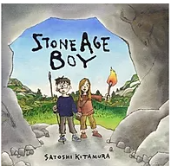  English Focus.  English focus text: Stone Age Boy by Satoshi Kitamur.  Extended writing outcomes:  -Creative writing. Creating a narrative using the structure of the story as a guide. Children to change the main character, the setting and the events that follow the main character falling/going through something.  Shorter writing outcomes:  -Instructions of how to make fire/making and using tools/ preparing and using animals skins  -Job Advertisement for an archaeologist  -Chronological timeline and historical comparison.  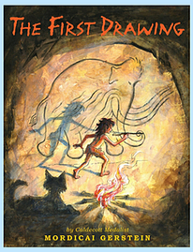  Supporting Texts  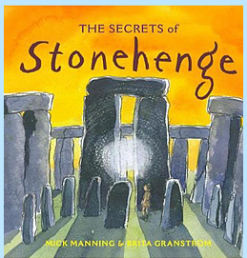 | The Renaissance  Artist Spotlight: Leonardo da Vinci.  Art Period: 1350-1400  Art Style: Humanism.  To develop ideas:  • Develop ideas from starting points  throughout the curriculum.  • Explore ideas in a variety of ways.  • Comment on artworks using visual language  To master techniques:  • Use a number of brush techniques using thick  and thin brushes to produce shapes, textures,  patterns and lines  • Use different hardnesses of pencils to show line, tone and texture.  Take inspiration from the greats:  • Replicate some of the techniques used by  notable artists, artisans and designers.  • Create original pieces that are influenced by  studies of others.  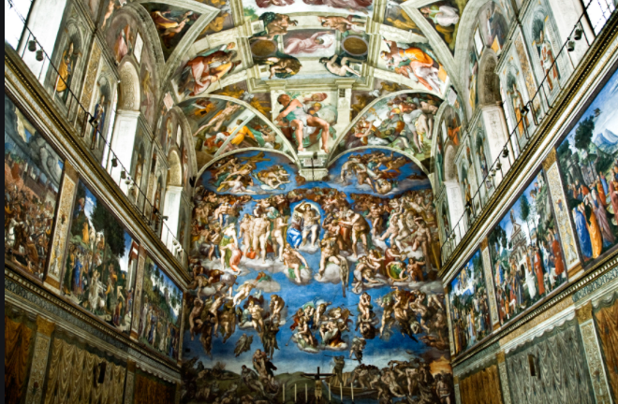  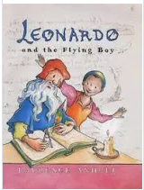
Curriculum coverage:
DT: Structures – shell structures.
PSHE: Being me in my world. Jigsaw.
RE: Gods in Hinduism.
Music: Let your spirit fly. Charanga.
I.C.T: Coding.
P.E: Gymnastics 1. Striver.

