History Focus – The Stone Age | Enquiry Question What was new about the stone age? | The Curriculum
History  - To be able to ask and answer historically valid questions about the Stone Age.  - To be able to understand some of the ways in which we can use science to find out about the past.  - To be able to identify different ways evidence from the past is studied and interpreted through archaeology.  - To be able to understand prehistoric means before written record.  - To be able to understand people have different views about the past based on available evidence.  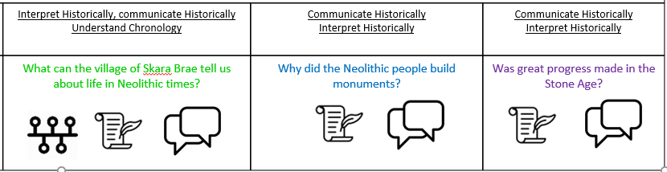  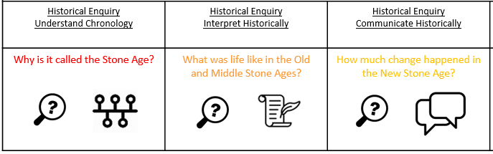  - To be able to communicate in different ways about the past.  Science – Materials Rocks  - Compare and group together different kinds of rocks based on their appearance and simple physical properties  - Describe in simple terms how fossils are formed when things that have lived are trapped within rock  - Recognise that soils are made from rocks and organic matter  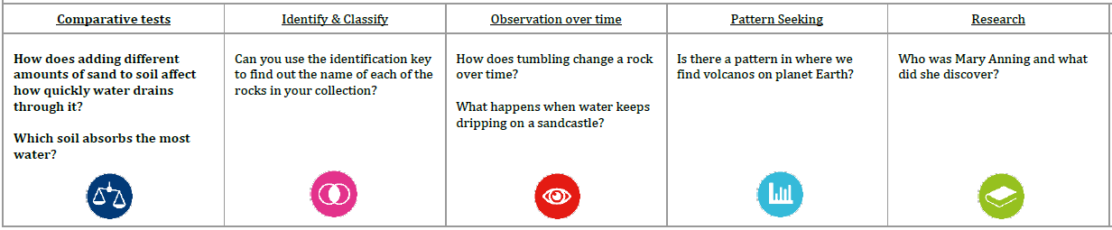 | 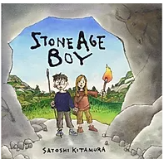  English Focus.  English focus text: Stone Age Boy by Satoshi Kitamur.  Extended writing outcomes:  -Creative writing. Creating a narrative using the structure of the story as a guide. Children to change the main character, the setting and the events that follow the main character falling/going through something.  Shorter writing outcomes:  -Instructions of how to make fire/making and using tools/ preparing and using animals skins  -Job Advertisement for an archaeologist  -Chronological timeline and historical comparison.  Supporting Texts  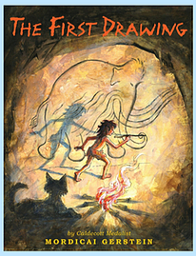  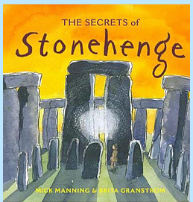  Maths  Threshold: Number  Units: Place Value, Addition and Subtraction | Art and Design  Pathway: Gestural Drawing with Charcoal  Key Concepts:  - That when we draw we can use gestural marks to make work.  - That when we draw we can use the expressive marks we make to create a sense of drama.  - That when we draw we can move around.  - That when we draw we can use light to make our subject matter more dramatic, and we can use the qualities of the material (charcoal) to capture the drama.  Theme:  Cave art, Movement, Human Body, Relationship of Body to Place  Medium: Charcoal, Paper, Body  Artists: Heather Hansen, Laura McKendry, Edgar Degas  D.T: Food Technology  Healthy and varied diet. Designing, making and evaluating a product.
Curriculum coverage:
PSHE: Being me in my world.
Who am I and how do I fit in?
1. Becoming a class team 2. Being a school citizen 3. Rights, Responsibilities and Democracy, Rewards and Consequences
RE: Key Question: Does the joining the Khalsa make a person a better Sikh. Religion: Sikhism.
Music:
I.C.T: To Code This concept involves developing an understanding of instructions, logic and sequences.
P.E: Hockey This unit focuses on stick holding technique, dribbling, passing, receiving, tackling and shooting with accuracy. Pupils will get the opportunity to play in a game situation.
M.F.L: Spanish Learning Spanish Phonetics

