History Focus – The Stone Age | Enquiry Question What was new about the stone age? | The Curriculum
History  - To be able to ask and answer historically valid questions about the Stone Age.  - To be able to understand some of the ways in which we can use science to find out about the past.  - To be able to identify different ways evidence from the past is studied and interpreted through archaeology.  - To be able to understand prehistoric means before written record.  - To be able to understand people have different views about the past based on available evidence.  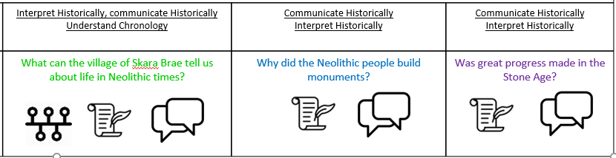  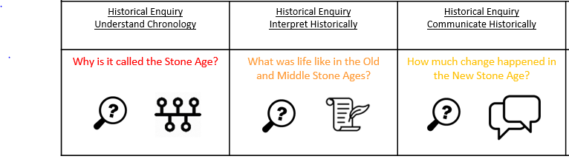  - To be able to communicate in different ways about the past.  Science – Materials Rocks  - Compare and group together different kinds of rocks based on their appearance and simple physical properties  - Describe in simple terms how fossils are formed when things that have lived are trapped within rock  - Recognise that soils are made from rocks and organic matter  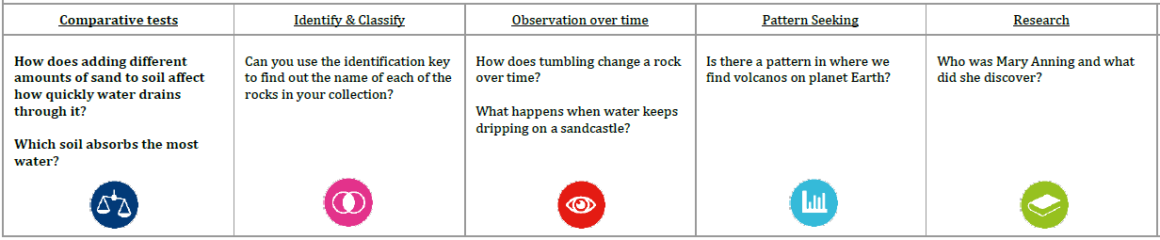 | 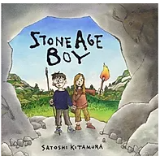  English Focus.  English focus text: Stone Age Boy by Satoshi Kitamur.  Extended writing outcomes:  -Creative writing. Creating a narrative using the structure of the story as a guide. Children to change the main character, the setting and the events that follow the main character falling.  Supporting Texts  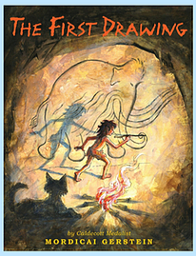  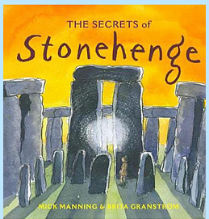  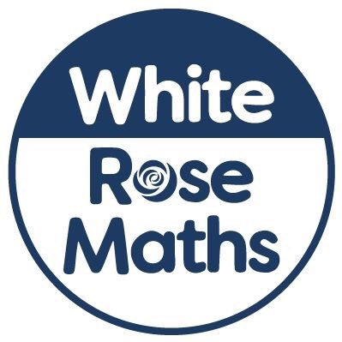  Maths – White Rose Maths  Threshold: Number  Units: Place Value, Addition and Subtraction | 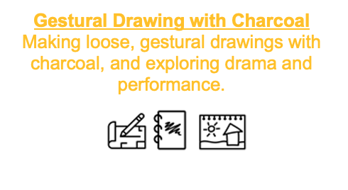  Art and Design  Key Concepts:  - That when we draw, we can use gestural marks to make work.  - That when we draw, we can use the expressive marks we make to create a sense of drama.  - That when we draw, we can move around.  - That when we draw, we can use light to make our subject matter more dramatic, and we can use the qualities of the material (charcoal) to capture the drama.  Theme:  Cave art, Movement, Human Body, Relationship of Body to Place  Medium: Charcoal, Paper, Body  Artists: Heather Hansen, Laura McKendry, Edgar Degas  D.T: Structures – shell structures
Curriculum coverage:

PSHE: Jigsaw - Being me in my world.
Who am I and how do I fit in?
1. Becoming a class team 2. Being a school citizen 3. Rights, Responsibilities and Democracy, Rewards and Consequences

RE: Key Question: What is it like for someone to follow god?

Music: Espresso Music
Environment,
Building,
Recorders.

P.E: Ball games, Netball.
M.F.L: Spanish Phonics 1
I am learning Spanish (E)

