Geography Focus – Threshold Concepts | Year 3 – The Stone Age (Class Texts) | Art and Design – Threshold Concepts
Geography  Investigate places:  - locate some of the world’s climate zones on a globe or map, name examples and have some understanding of them.  - identify the world’s hottest, coldest, wettest and driest locations.  - Ask and answer geographical questions about the physical characteristics of a location.  Investigate patterns:  - extract geographical data (e.g. rainfall, temperature, weather, climate/vegetation zones) from pictorial/graphical representations.  - describe and give examples of the variety of biomes and vegetation belts.  Communicate geographically:  - use appropriate geographical vocabulary to describe weather, climate, climate zones, biomes and vegetation belts.  Science  Biology - Plants:  - identify and describe the functions of different parts of flowering plants: roots, stem, leaves and flowers.  - explore the requirements of plants for life and growth (air, light, water, nutrients from soil, and room to grow) and how they vary from plant to plant.  - Investigate the way in which water is transported within plants.  - explore the role of flowers in the life cycle of flowering plants, including pollination, seed formation and speed dispersal. | 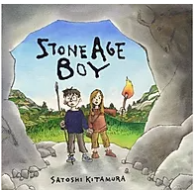  English Focus.  English focus text: Stone Age Boy by Satoshi Kitamur.  Extended writing outcomes:  -Creative writing. Creating a narrative using the structure of the story as a guide. Children to change the main character, the setting and the events that follow the main character falling/going through something.  Shorter writing outcomes:  -Instructions of how to make fire/making and using tools/ preparing and using animals skins  -Job Advertisement for an archaeologist  -Chronological timeline and historical comparison.  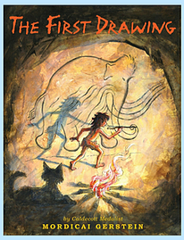  Supporting Texts  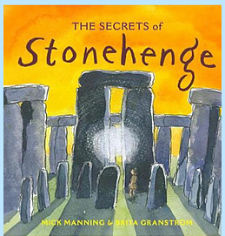 | The Renaissance  Artist Spotlight: Rembrandt.  Art Period: 1600s  Art Style: Portraits.  To develop ideas:  •how would you describe most of the colour used by Rembrandt?  •what is chiaroscuro?  •copy Rembrandt’s mastery of chiaroscuro by using strong light and heavy shadow in your own family picture to emphasise the faces.  To master techniques:  •how might an artist show restraint when using colour?  •what techniques did Rembrandt use to show texture?  •copy this technique by using thick layers of paint and then using a soft brush on top while your paint is still wet.  Take inspiration from the greats:  •compare and contrast how Rembrandt developed his talents with the development of another artist we study.  •give examples of how Rembrandt’s early life was important in the process of becoming a talented artist.  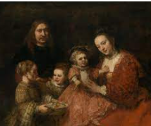  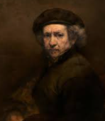
Curriculum coverage:
DT: Structures – shell structures.
PSHE: Celebrating Difference. Jigsaw.
RE: Christianity and Christmas.
Music: Glockenspiel Stage 1. Charanga.
I.C.T: Coding.
P.E: Dance 1. Striver.

