Geography – Weather and Climate | Year 3 | The Curriculum
Geography -  In this unit, the children are introduced to different ways of communicating geographical data, particularly through different styles of maps. They will learn to read weather and climate maps, and learn how weather and climate are generalised into world climate zones. The concept of biomes will be explored, each with distinctive climate, soil, flora, fauna and human activity  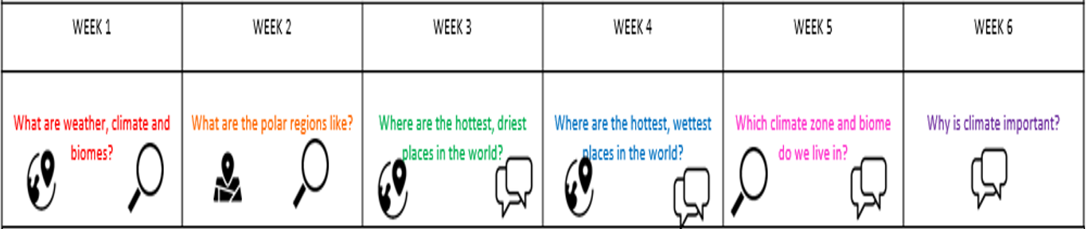  Science – Plants  Identify and describe the functions of different parts of the flowering plant: roots, stem/trunk/leaves and flowers  Explore the part flowers play in a flowering plants life cycle, including pollination, seed formation and seed dispersal  Explain the requirements of plants for life and growth (air, light, water, nutrients from soil, room to grow) and how they vary between plants  Know the way in which water is transported between plants  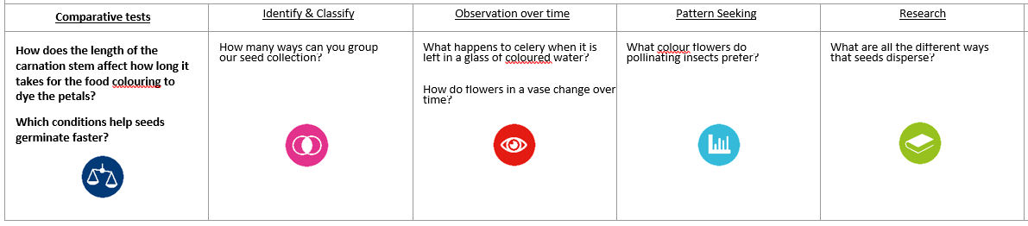 | 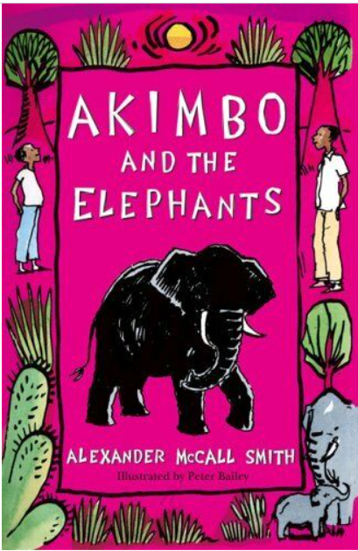  English Focus.  English focus text: Akimbo and the Elephants  Extended writing outcomes:  Persuasive letter  Creative writing - Persuasive letter, Children to write with purpose to create an informative and persuasive letter which focuses on illegal poaching and supporting a charitable cause.  Supporting Texts: The Hunter by Paul Geraghty and Sleep Well Siba and Saba by Nansubuga Nagadya Isdahl.  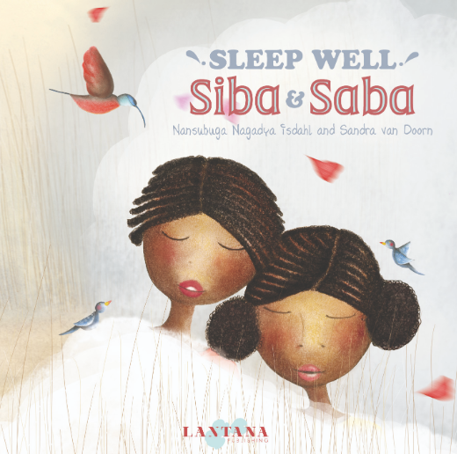  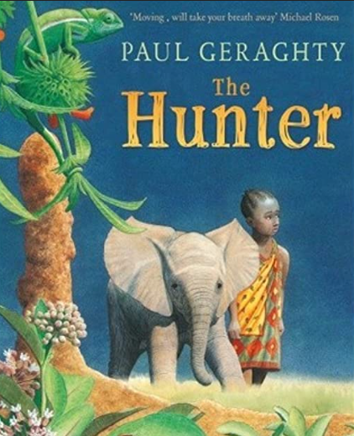  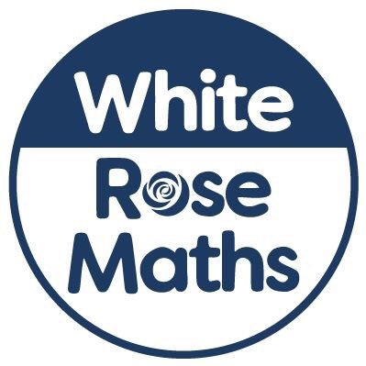  Maths  Threshold: Number  Units: Addition and Subtraction  Multiplication and Division | Art and Design  Key Concepts: Working with Shape and colour  - That when we draw we can use gestural marks to make work.  - That when we draw we can use the expressive marks we make to create a sense of drama.  - That when we draw we can move around.  - That when we draw we can use light to make our subject matter more dramatic, and we can use the qualities of the material to capture the drama.  Pupils will explore how artists use shape and colour to create artworks.  D.T: Shell Structures – Pupils are challenged to look at the composite structures whilst engaging in the creative process.
Curriculum coverage:

PSHE: Jigsaw – Celebrating Differences.
Who am I and how do I fit in?
1. Becoming a class team
2. Being a school citizen
3. Rights, Responsibilities and Democracy, Rewards and Consequences
RE: Key Question: Has Christmas lost its true meaning?
Music: Music Express
Recorder magic
Getting started (x3) Musical notation (x3)
I.C.T: To research and develop a topic
P.E: Dance 1. Striver.
M.F.L: Spanish Phonics 1 recap
I know how… (E)

