History Focus – Enquiry Question:  Which was more impressive – the Bronze Age or the Iron Age? | Year 3 | The Curriculum – Threshold Concepts
History  Enquire historically  In this unit, the children will explore the key features of the Bronze and Iron Ages, and come to conclusions about the developments within the periods. Links will be made to the Stone Age period, which they may have studied in the autumn term.  Communicate historically  - To be able to ask and answer historically valid questions about the periods from Bronze Age to the Iron Age in Britain  - To be able to describe the cultural differences as they appeared during the Bronze Age and why.  Study chronologically  - Develop a chronologically secure knowledge and understanding of British, local and world history.  - Develop the appropriate use of historical terms.  Science  Physics Forces and magnetism  - Compare how things move on different surfaces.  - Know how a simple pulley works and use making lifting an object simpler  - Notice that some forces need contact between two objects, but magnetic forces can act at a distance.  - Observe how magnets attract and repel each other and attract some materials and not others.  - Compare and group together a variety of everyday materials based on whether they are attracted to a magnet and identify some magnetic materials.  - Describe magnets as having two poles.  - Predict whether two magnets with attract or repel each other, depending on which poles are facing. | 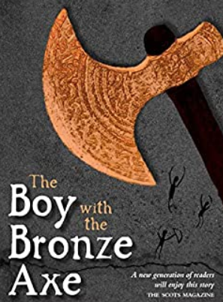  English focus text: The Boy with the Bronze Axe.  A classic story is set in the ancient Stone Age village of Skara Brae on Orkney. This is a fascinating and vividly portrayed story of life nearly 3,000 years ago.  Writing outcome:  Descriptive writing  Short writing outcome:  Explanation text – A written explanation of the key features of life in the Bronze to Iron ages.  Purpose: To compose an engaging (and whenever possible, historically accurate) setting description.  Audience: Year 3  Genre: creative writing  Children will create a variety of descriptive paragraphs focusing on the main characters from The Boy with the Bronze Axe alongside a detailed setting description.  Link Reading:  ‘Wolf Brother’ Michelle Paver ‘Secret Tales from Wales’ Daniel Morden ‘Assassin’ Tony Bradman ‘Magical Celtic Tales’ Una Leavy  Maths: White Rose  Threshold: Number  Unit: Multiplication and Division | P.E:  Gymnastics 2  This unit focuses on developing core strength for rolling and performing forwards and backwards rolls safely with a range of starting and finishing positions. Pupils will also have the opportunity to learn how to turn, twist and spin with confidence.  ICT  - E Safety – Google Be Internet Brave.  - Computer Science – Lightbot - Algorithms  RE:  Religion: Christianity - Theme: Miracles. Incarnation.  Key Question: Is anything ever eternal?  PSHE:  Jigsaw – Dreams and Goals  - Learn about aspirations, how to achieve goals and understanding the emotions that go with this.  Music:  Music Express.  - Growth – Musical Focus:.  - Roots - Musical Focus:.  MFL:  Language Angels - Musical instruments  Art:  Telling Stories through Drawing and Making  DT:  Food - Healthy and Varied Diet.  Children will analyse what alternative ingredients choices they could make to improve their snack or pack lunch to a more balanced and varied diet.

