History Focus – Threshold Concepts | Year 3 – (The Boy With the Bronze Axe) | Art and Design – Threshold Concepts
History – The Bronze and Iron Age  Investigate and interpret the past:  - Address historically valid questions about change, similarity and differences.  -Construct informed responses that involve thoughtful selection and organization of relevant historical information.  Build an overview of world History:  -Address historically valid questions about trends and significance.  Understand chronology:  - Develop a chronologically secure knowledge and understanding of British history.  Communicate historically:  -Use common words and phrases relating to the passing of time.  - Develop the use of historical terms.  Science  Physics - Understand movement, forces and magnets.  - Compare how things move on different surfaces.  - Notice that some forces need contact between two objects, but magnetic forces can act at a distance.  - Observe how magnets attract and repel each other and attract some materials and not others.  - Compare and group together a variety of everyday materials on the basis of whether they are attracted to a magnet, and identify some magnetic materials.  - Describe magnets as having two poles.  - Predict whether two magnets will attract or repel each other, depending on which poles are facing.  Working scientifically:  - Ask relevant questions.  - Set up simple, practical enquiries and comparative and fair tests.  - Record findings using simple scientific language, drawings, labelled diagrams, bar charts and tables.  - Report on findings from enquiries, including oral and written explanations, displays or presentations of results and conclusions. | 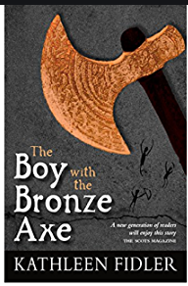  English focus text: The Boy With the Bronze Axe by Kathleen Fidler.  Extended writing outcomes:  - Non-Chronological report based on the stone settlement of Skara Brae.  -Diary entry re-telling the events at the end of chapter one where Kali and Brockan end up stranded and Tenko saves them.  Shorter writing outcomes:  -OSIE grid focusing on writing as a character thinking about observations, senses, imagination and emotion.  -Camp agreement between quarreling members of the village.  Supporting Texts:  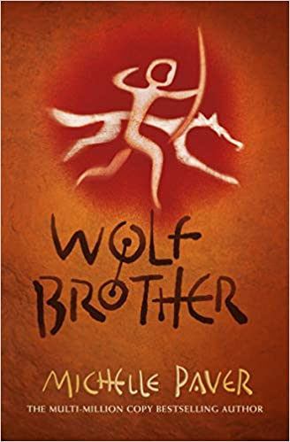  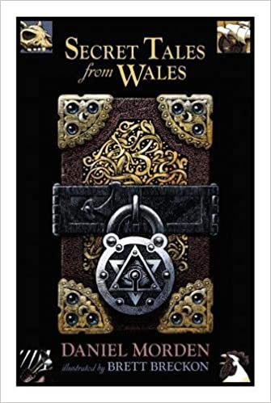  English  History | Myths and Legends  Artist Spotlight: Peter Paul Rubens  Art Period: 1577-1640  Art Style: Baroque  To develop ideas:  -Collect information, sketches and resources.  -Adapt and refine ideas as they progress.  -Explore ideas in a variety of ways.  -Comment on artworks using visual language.  To master techniques:  Drawing:  -Use different hardnesses of pencils to show line, tone and texture.  -Annotate sketches to explain and elaborate ideas.  -Sketch lightly (no need to use a rubber to correct mistakes).  -Use shading to show light and shadow.  Painting:  -Use a number of brush techniques using thick  and thin brushes to produce shapes, textures,  patterns and lines.  - Mix colours effectively.  Take inspiration from the greats:  -Replicate some of the techniques used by notable artists, artisans and designers.  -Create original pieces that are influenced by studies of others.
Cross Curricular Links
DT: Food. A healthy and varied diet.
RE: Christianity. Jesus’ miracles.
I.C.T: touch typing and simulations.
P.E: Strivr Gymnastics 2.
MFL: Introduction into Spanish.
Music: Charanga Three Little Birds.
PSHE: Jigsaw dreams and goals.

