Geography Focus – Threshold Concepts | Year 3 – (The Boy With the Bronze Axe) | Art and Design – Threshold Concepts
Geography – Our World  Investigate places:  -Ask and answer geographical questions about the human and physical characteristics of a location.  -Explain their own views about locations with reasons.  -Use a range of resources to identify they key physical and human features of a location.  Investigate patterns:  -Name and locate the Equator, Northern Hemisphere, Southern Hemisphere, the Tropics of Cancer and Capricorn, Arctic and Antarctic Circle and date and time zones and describe some of these geographical areas.  -Describe geographical similarities and differences between countries.  Communicate geographically  -Use the eight points of the compass to build their knowledge of the wilder world.  -Describe key features of human and physical geography.  Science  Biology – Understanding animals and humans.  -Identify that animals, including humans, need the right types and amounts of nutrition, that they cannot make their own food and they get nutrition from what they eat.  -Construct and interpret a variety of food chains, identifying producers, predators and prey.  -Identify that humans and some animals have skeletons and muscles for protection, support and movement.  -Describe the simple functions of the basic parts of the digestive system in humans.  -Identify the different types of teeth in humans and their simple functions. | 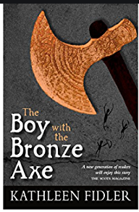  English focus text: The Boy With the Bronze Axe by Kathleen Fidler.  Extended writing outcomes:  A balanced argument based around the disagreement in Chapter 2. A new member of the camp causes some debate between members of the camp. We will look at both sides of the argument and create a balanced argument.  Shorter writing outcomes:  -Note taking. Taking down and making notes for and against our argument title.  -Writing paragraphs in the first person, giving own viewpoints and using well-chosen conjunctions.  Supporting Texts:  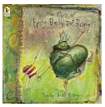  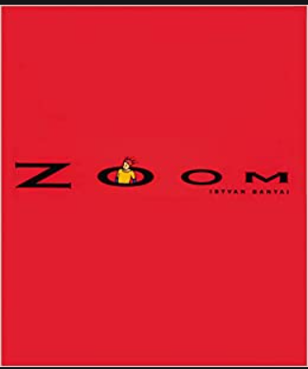  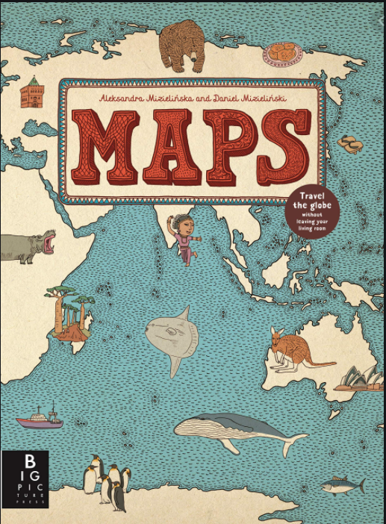  Geography Science | A Journey Into Space  Artist Spotlight: Robert McCall  Art Period: Realism (20th century)  Art Style: Paintings  To develop ideas:  • Develop ideas from starting points  throughout the curriculum.  • Collect information, sketches and resources.  • Adapt and refine ideas as they progress.  • Explore ideas in a variety of ways.  • Comment on artworks using visual language  To master techniques:  Painting:  • Use a number of brush techniques using thick  and thin brushes to produce shapes, textures,  patterns and lines.  • Mix colours effectively.  • Use watercolour paint to produce washes for  backgrounds then add detail.  • Experiment with creating mood with colour.  Take inspiration from the greats:  • Replicate some of the techniques used by  notable artists, artisans and designers.  • Create original pieces that are influenced by  studies of others.
Cross Curricular Links
DT: Food. Healthy and varied diet.
RE: Discovery R.E. Easter – Forgiveness.
I.C.T: Computer Science.
P.E: Striver. Hockey.
MFL: Introduction into Spanish.
Music: Charanga. The dragon song.
PSHE: Jigsaw. Relationships.

