History Focus – Enquiry Question:  Why should we preserve our locality? | Year 3 | The Curriculum – Threshold Concepts
History  Enquire historically  In this unit, the children will explore the concept of a Listed building. What makes a building site special?  Communicate historically  - Can we find a listed building of the future?  - To know how important it is to preserve heritage buildings.  - To know that Grade 1 buildings are those of exceptional interest.  - To know that some Grade 2 buildings are more special than others.  - To know how to present a viewpoint on why a building should be saved.  Study chronologically  - Develop a chronologically secure knowledge and understanding of British, local and world history.  - Develop the appropriate use of historical terms.  - Answer the question, should all listed buildings be preserved?  Science  Physics Light  - How does the distance between the shadow puppet and the screen affect the size of the shadow?  - How would you organise light sources into natural and artificial sources?  - When is our classroom darkest?  - Is the Sun the same brightness all day?  - Are you more likely to have bad eyesight and to wear glasses if you are older?  - How does the Sun make light?  - What is a shadow?  - Which pair of sunglasses will be best at protecting our eyes? | 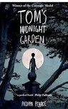  English focus text: Tom’s Midnight Garden.  A story evoking the 1950’s and Victorian settings, based around the relationship between Tom and Hatty.  Writing outcome:  Letter writing  Documentary script writing  Poetry  Diary writing  Persuasive writing  Short writing outcome:  Descriptive writing  Link Reading:  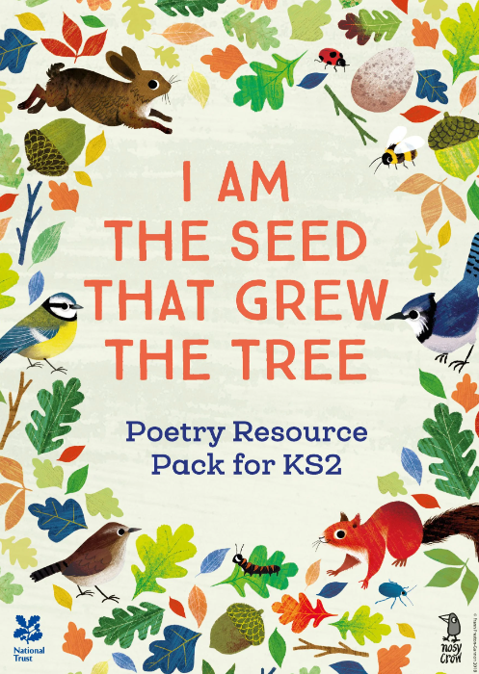  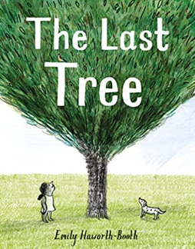  Maths: White Rose  Unit: Mass and Capacity  Fractions  Money | P.E:  Striver – Games  Fielding and Striking  Cricket  ICT  Digital Literacy  Computer Science  Introduction to Scratch Desktop  RE:  This unit focuses on the stories of Creation and the Fall as two parts of the ‘Big Story’ of the Bible. Pupils familiarise themselves with the first Creation story from Genesis and key messages within it for many Christians about the world being good and how Christians are called to look after God’s world. They move on to think about the story of Adam and Eve and how the Fall fits into the ‘Big Story’ of the Bible.  Key Question: What do Christians learn from the Creation Story?  PSHE:  Jigsaw – Relationships  Children will learn about relationships and explore how to be good friend and support others.  Music:  - Communication  - Human Body  MFL:  Language Angels - Fruit  Art:  Making Animated Drawings  In this pathway children are introduced to the idea that animations can be made by sequencing drawings.  DT:  2D shape to 3D shape

