History Focus – Local History | Year 3 – Tom’s Midnight Garden | Art and Design – Threshold Concepts
History  Investigate and interpret the past:  -use evidence to ask questions and find answers to questions about the past.  - understand how our knowledge of the past is constructed from a range of sources.  Build an overview of world History:  -describe the changes that have happened in the locality of the school throughout history.  -construct informed responses that involve a selection of relevant information.  Understand chronology:  -use common words and phrases relating to the passing of time.  -develop a chronologically secure knowledge and understanding of British and local history.  Communicate historically:  -develop the appropriate use of historical terms.  -address and devise historically valid questions about change, cause, similarity, difference and significance.  Science  Physics  Investigating light and seeing and how light and reflection affect sight.  -recognise that they need light in order to see things and that dark is the absence of light.  - notice that light is reflected from surfaces.  - recognise that light from the sun can be dangerous and that there are ways to protect their eyes.  - recognise that shadows are formed when the light from a light source is blocked by a solid object.  - find patterns in the way that the sizes of shadows change.  Working scientifically:  -report on findings from enquires, including oral and written explanations, displays or presentations of results and conclusions.  -identify differences, similarities or changes related to simple, scientific ideas and processes. | 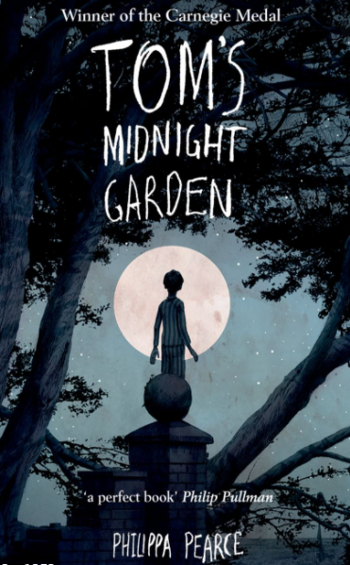  English focus text: Tom’s Midnight Garden by Philippa Pearce.  Extended writing outcomes:  -Non-fiction non-chronological report about grandfather clocks.  -Descriptive piece based on the first time entering the garden.  -Balanced argument about whether it was the fair/right thing to do, to send Tom away to live with his Uncle and Aunt.  Shorter writing outcomes:  -information poster about measles.  -diary entry for the date Tom left home.  -prediction/inference questions  Supporting Texts  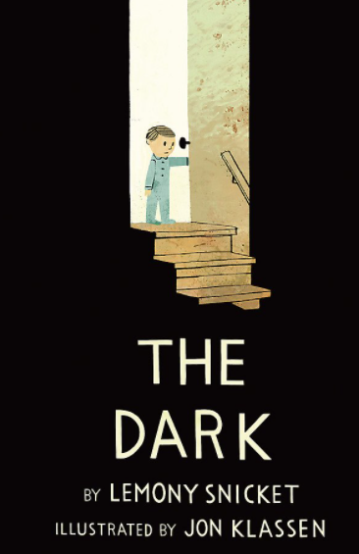  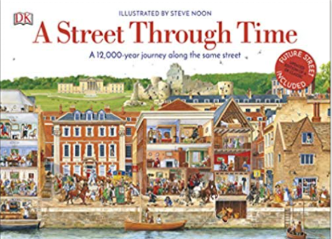  Science History | Cityscape Art  Artist Spotlight: Camille Pissarro  Art Period: 1800-1900  Art Style: Cityscape Photorealism  To develop ideas:  -adapt and refine ideas as they progress.  -explore ideas in a variety of ways.  -comment on artwork using visual language.  To master techniques:  -use a number of brush techniques using thick and thin brushes to produce shapes, textures and patterns.  -mix colours effectively.  -use watercolour paint to produce washes for backgrounds and then add detail.  -experiment with creating mood with colour.  Take inspiration from the greats:  -replicate some of the techniques used by notable artists, artisans and designers.  -create original pieces of artwork that are influenced by the study of others.  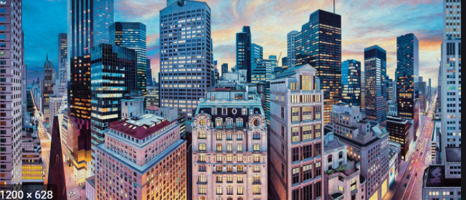  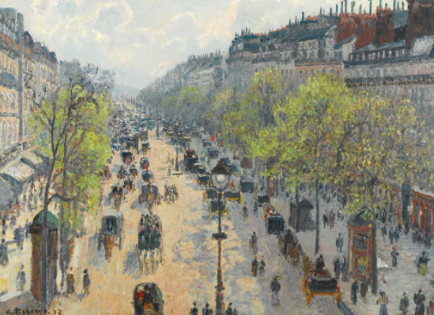
Cross Curricular Links
DT: Creating a 3D product from 2D shapes.
RE: Religion: Hinduism. Theme: Hindu Beliefs.
I.C.T: E-Safety and Computer Science.
P.E: Tag Rugby. Strivr.
MFL: Spanish.
Music: Charanga.
PSHE: Jigsaw. Relationships.

