Geography Focus – Coasts | Year 3 – Song Of The Dolphin Boy | The Curriculum – Threshold Concepts
Geography  In this unit, the children will learn about key topographical or physical features of coasts to understand how some of these aspects developed, are hanging now and have changed over time.  The children will build an understanding similarities and differences through the study of human and physical geography of a region of the UK (SW England) and a region in a European country (Costa Blanca, Spain)  Then go onto describe and understand key aspects of the human geography of coasts, including: types of settlement and land use, economic activity and safety. The children will consider tourism, as both an economic and a pleasurable activity and think about the future and the effects climate change, rising sea levels and pollution, especially by plastics, are already having.  Science  During this unit of work, children will revisit and further explore different rocks and soils. They will classify and group together rocks based on their appearance as well as their physical properties. They will learn how the Earth is made up of different rocks and fossils and begin to explain how some of the different rocks are formed. Children will also look at fossils, what they are and how they are formed in rock. | 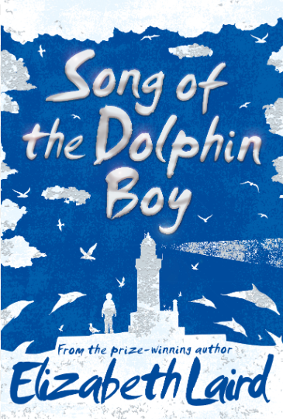  Extended Writing outcomes: The children have two extended writing tasks:Explanation Text and Persuasion Text  Purpose: To compose an engaging and whenever possible historically and scientifically accurate explanation of rock formation using the link texts to gather knowledge  Purpose: To write a persuasive letter informing on the need to take care of our waters.  Many grammar objectives are also covered throughout the term. These include single and plural apostrophes, expanded noun phrases, direct speech, conjunctions of time, causal conjunctions, adverbials of time, fronted adverbials and present tense.  We will also covers many reading objectives, including performance poetry, character profiling using inference, using a dictionary and debating.  Link Reading:  The street beneath my feet  The pebble in my pocket  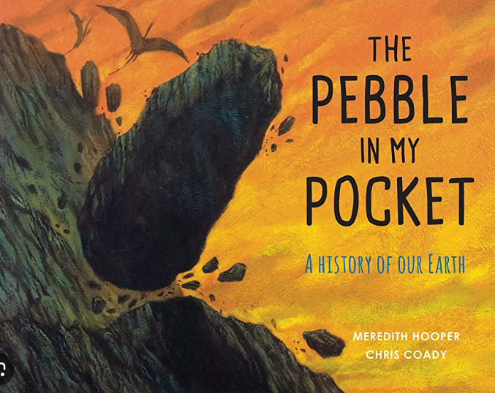  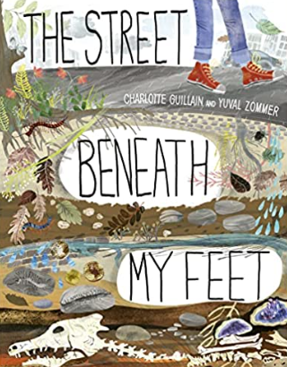  Mathematics – White Rose  Property of shape  Measurement | P.E: Football This unit focuses on controlling, dribbling, turning, passing and receiving a ball. Pupils will develop skills for shooting and playing the position of goalkeeper. There is opportunity for pupils to apply learnt skills into a game of football.  I.C.T:  Computer Science : Tynker – If statements HTML App Coding  RE: Religion: Hinduism  Theme: Pilgrimage to the River Ganges.  Key Question: Would visiting the River Ganges feel special to a non -Hindu?  PSHE: Jigsaw Changing me  Working towards building understanding of ourselves and others and looking forward to change.  Music: Music Express.  Communication – musical focus: composition.  Time – musical focus: beat.  MFL: Spanish  Seasons.  DT: Textiles 2D and 3D product

Art – This pathway encourages children to explore how they can use materials found around them to make images.

Disciplines: Cyanotype, Anthotype, Painting with Natural Pigments, Drawing, Sketchbooks

Key Concepts: That we can use the world around us as “ingredients” with which to make art.
- That photographs are created when a light sensitive surface is exposed to light.
- That we can manipulate the world around us, transforming it into art.

